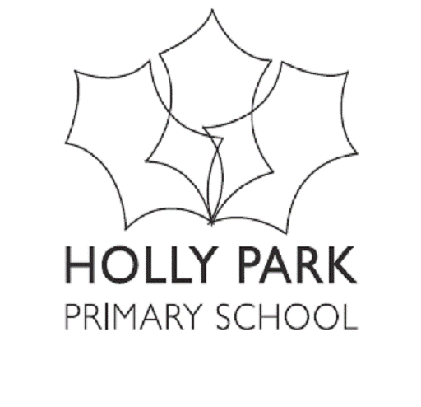
HOLLY PARK NURSERY PRICING
From September 2026

Nursery sessions are based on £9.50 per hour

7.45 – 8.45 | Breakfast | Must be paid for if wanted | £9.50
8.45- 11.45 | Morning Session | Free as part of 15 hours or 30 hours | Can be paid for as an extra if space is available at  £28.50
11.45 – 12.45 | Extra hour to bring the day in line with the normal school day | Must be paid for if wanted  (30 hours children have priority) | £9.50  + cooked lunch at £2.63  Children can bring packed lunch or go home
12.45- 3.45 | Afternoon Session | Free as part of 15 hours or 30 hours | Can be paid for as an extra if space is available at £28.50
3.45 – 6.00 | Nursery  After School Club | Must be paid for if wanted | £21.40 (nursery)  + meal at £2.50  Children can bring packed tea
3.30-6.00 | Reception  After School Club | Must be paid for if wanted | £23.75 (reception)  + meal at £2.50  Children can bring packed tea

