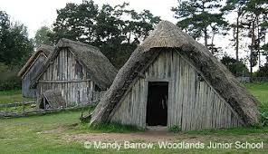 Learning Project - Anglo-Saxons 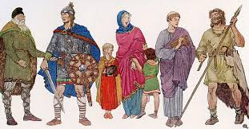
Dear Families,
Best wishes Mrs Mehtar & Mr Bourne
Science | Maths |  | English - writing
Plants  Light | Fractions  Time | Money  Shape  Statistics | Narrative: Myths  Explanation  Poetry Limericks
English - Grammar | Phonics & Spelling | PSHE | RE
Express time, place and cause using conjunctions, adverbs and prepositions.  Inverted commas.  Use fronted adverbials  Use commas after fronted adverbials.  Use of nouns or pronouns for clarity, cohesion and to avoid repetition.  Using a range of prefixes.  Extend sentences by using a wider range of conjunctions.  Using possessive apostrophes.  Use the present perfect form of verbs. | The suffix ly  Endings to the word - hope  The sound ee spelt – ee, ea, e-e, ie, y, ey  Revision of KS1 Vowel digraphs  Homophones  groan / grown  heel / heal / he’ll  rain / rein / reign  plain / plane  The ‘ou’ sound | Smoking  Parts of the body  Different Families  Aspirations  Keeping safe | The Ten Commandments  Pilgrimage
Computing | PE | History | Geography
Data retrieving – branching data bases  Animations | Gymnastics: Travelling with a change of front and change of direction  Athletics: Throwing, Jumping and Running  Striking & Fielding  Games:  Building Cricket Skills  (Cricket)  Team building games  Orienteering  Dance: English country dancing | Anglo Saxons | UK Cities and Counties  Map work  Why was London chosen to be the capital city of England?
Art & Design | Design & Technology | Spanish | Music
Digital Media  Drawing – still life | Sheet Materials – Levers, pivots & pop ups | Fruit  Saying ‘I am hungry/thirsty/cold/hot’  Buying ice cream  Learning about Cuba | Ukulele  Learn all the features of the ukulele.  Learn the C, Am and F chord.  Compose rhythmic and melodic ostinato using a pentatonic scale.  Compose group pieces featuring ostinato and pulse  Learning the D chord  Playing together as an ensemble.
Trips/Curriculum Days/Meetings | Links with Children’s Rights | PE Days & Homework Days | Key Dates for this Term
Mon 27th April – Read Together in Class  Tues 5th May Parent meeting Relational Policy  Wed 6th May Willow Class to Railway Fields  Fri 8th May Hazel to Railway Fields  Thurs 21st & Fri 22nd May KS2 Nerf sessions  Thurs 4th June World Cup Dance  Thurs 11th June Author visit  Thurs 18th June Diversity day – Be yourself Thursday  Thurs 25th & Fri 26th June – Yoga workshops | Article 28: The right to a good quality education  Article 12: The right to be heard  Article 34: The right to be free from sexual abuse  Article 29: The right to use and develop your talents and abilities | Homework is set on Google Classroom on a Thursday and needs to be returned the following Monday.  PE days are Mondays and Tuesdays. | Monday 1st June INSET Day  Wednesday 17th June Class Photos  Tuesday 30th June Copthall Athletics  Friday 3rd July Junior Sports 10.30am  Monday 6th July Reports emailed home across this week  Thursday 9th July Junior Duke Celebration  Friday 10th July New Classes announced for September 2026  Monday 13th July Children to visit new classes and teachers  Friday 17th July End of term at 1.30pm

