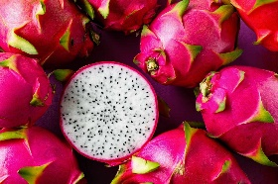
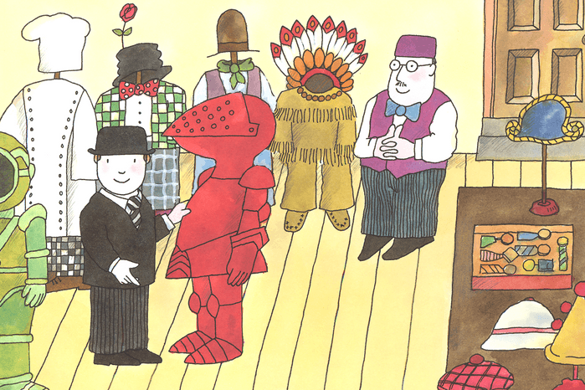
Learning Projects:
Ready Steady Grow
Cut Stitch Sew

Dear Families,
We are nearly at the end of Year Two and have planned lots of fun and exciting learning opportunities for the last term. We will be holding our annual Fashion Show after half term, where the children will be designing, creating and modelling their own T-shirts. We will also be holding our own class Café where the children plan, organise and prepare food to be sold (for money) to parents and carers. These events are always lovely, so please make time to attend if you can. Please continue to support your child’s learning by reading with them every night. Reading will open the door to learning about all other subjects, so please make the time to share a book each day. Many thanks for your continued support!
Best wishes, Sidrah Mir and Lewis Turner

Science | Maths |  | English - writing
Living things and their Habitats  Plants | Multiplication and Division  Addition and Subtraction- 2 Digit and 2 Digit Numbers | Money  Fractions  Time  Position and Direction | Narrative: adventure story.  Letter  Instructions
English - Grammar | Phonics & Spelling | PSHE | RE
How the grammatical patterns in a sentence indicate its function as a command.  Apostrophes for contraction and singular possession.  Formation of adjectives and nouns using suffixes.  Use of suffixes adjectives into adverbs. | Apostrophes for contractions  The possessive apostrophe  Common exception words  Homophones | Money – shopping & saving | Islam Belonging - The mosque  Islam Hajj
Computing | PE | History | Geography
IT Communicating – email, keyboard skills – typing, using computers to create art | Gymnastics: Linking movements together  Games: Athletics  Games: Inventing games involving attacking and defending  Dance: Plants | Fashion Designers | Where in the world does our food come from?  CONTINENTS
Art & Design | Design & Technology | Spanish | Music
Digital Media  Textiles | Food – Veg stir fry  Textiles - T shirts  Food - sandwiches | Parts of the body  Botero  More Fruits  La paella | Work in groups to compose music that responds to abstract graphic images  In groups, carefully select instruments and compose a short piece in Ternary Form  Discuss effects used in Britten’s Storm Interlude
Trips/Curriculum Days/Meetings | Links with Children’s Rights | PE Days & Homework Days | Key Dates for this Term
Monday 27th April – Read Together in Class  Tuesday 5th May – Parent meeting Relational Policy  Thursday 11th June – Author visit  Tuesday 16th June – Y2 to Kew Gardens  Thursday 18th June Diversity day – Be yourself Thursday  Thursday 25th & Fri 26th June – Yoga workshops | Article 12 – you have the right to an opinion and and for it to be listened to and taken seriously  Article 29 – You have the right to an education which tries to develop your personality  Article 30 – You have the right to practice your own religion | Elm Class PE days:  Wednesday and Friday  Rowan Class PE days:  Thursday and Friday  Homework:  Homework will be set on a Friday and handed in on a Thursday. | Monday 1st June INSET Day  Wednesday 17th June Class Photos  Wednesday 1st July Infant Sports 10.30am  Monday 6th July Reports emailed home across this week  Friday 10th July New Classes announced for September 2026  Monday 13th July Children to visit new classes and teachers  Friday 17th July End of term at 1.30pm

