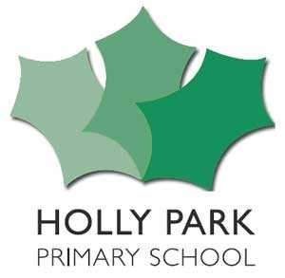 Holly Park Chargeable extras
Description | Unit | Unit price | Total per week
Free entitlement hours –either 15 or 30 hours per week | Weekly | Free | Free
Additional hours purchased –Extra hour to bring the day in line with the normal school day (within 30 hours) | Daily | £9 | £45
Additional hours purchased – for buying extra nursery hours | Daily | £9 per hour | As required
Breakfast Club 7.45-8.45 | Daily | £9 | £45
After School Club 3.45-6pm  *This can be purchased by the hour(£9) and on nominated days | Daily | £20.25 | £101.25
After School Club Tea if required  *parents can provide a packed lunch or children can go home to eat | Daily | £2.50 | £12.50
School lunch in the middle of the day if required  *parents can provide a packed lunch or children can go home | Daily | £2.50 | £12.50
Consumables (for example, nappies and sun cream) * We expect parents to provide their own consumables if necessary | Daily | N/A | N/A
Additional contributions for school trips | Ad Hoc | TBC | TBC

*If you want information onTax Free Childcare or want to use Universal Credit Childcare and are looking to claim back some of the costs please speak to the school office for information.

