PE Funding

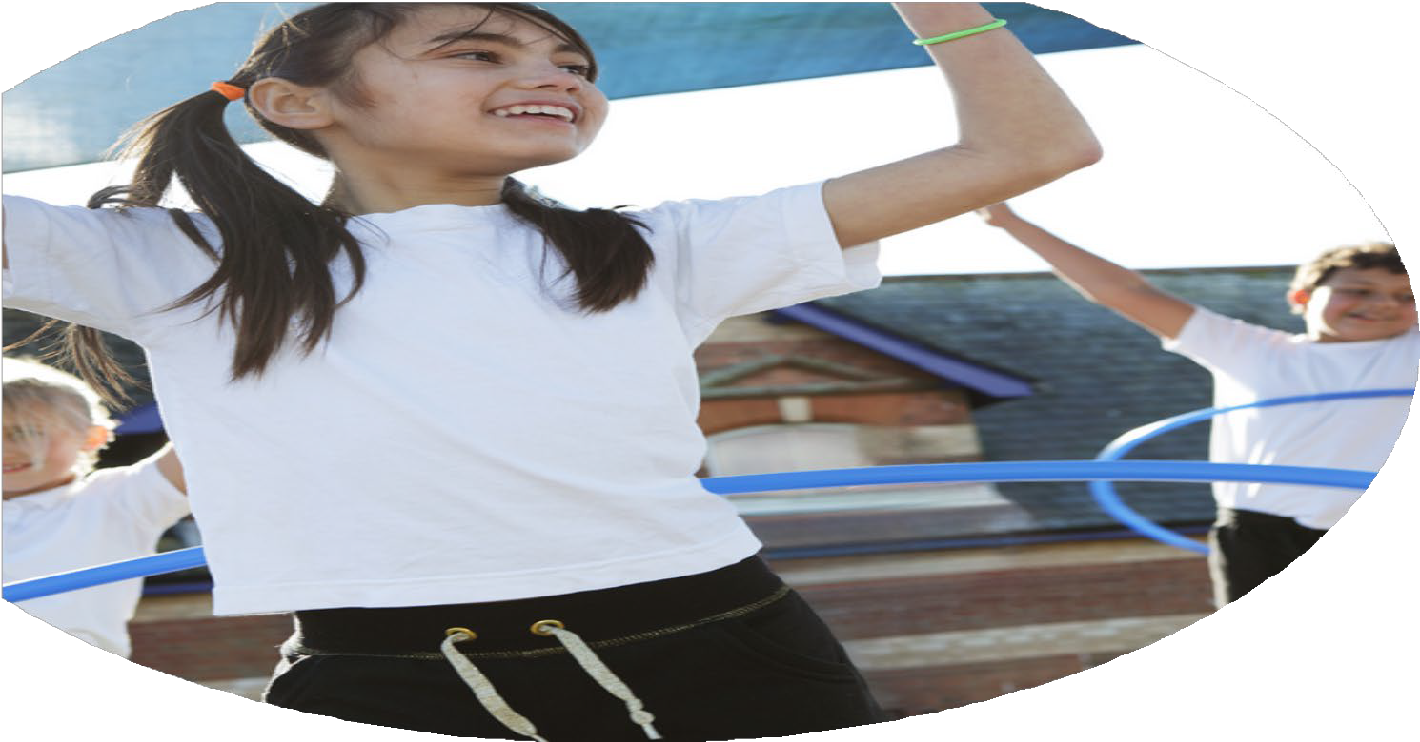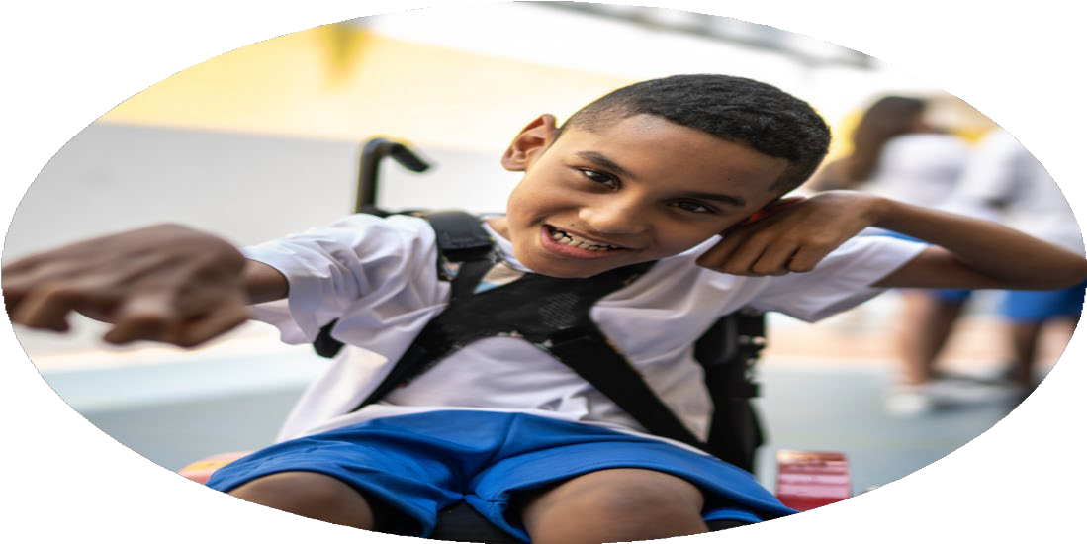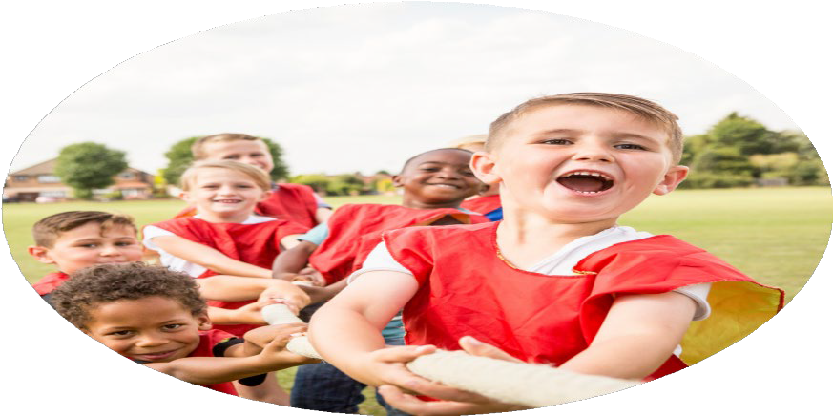

Evaluation Form

**Commissioned by**

**Created by**

Images courtesy of Youth Sport Trust

**PE Funding Evaluation Form**

 It is intended that this template should be used as preparation for the completion of the statutory digital reporting tool being introduced this academic year. You can upload data (including swimming) from this template onto this platform once it becomes accessible.

 Before you decide how you are going to use the funding for this academic year you should reflect and evaluate the impact of your use of the funding in 2023/24.

 All spending of the funding must conform with the terms outlined in the Conditions of Grant document.  The template is a working document that you can amend/update during the year.

 Based on your evaluation of last year’s funding you should decide what you intend to do this academic year, how you will do it, and what impact you expect it to have.

It is important that the funding is used effectively and based on your school’s needs.

 You must use the funding to make additional and sustainable improvements to the PE and sport in your school.  You must develop and add to the PESSPA activities that your school already offers.

*Summative digital reporting from June 2025 will continue to include swimming and water safety information therefore funding can be used to provide top-up lessons where necessary to ensure pupils meet national curriculum swimming requirements.*

**We recommend that you start by reflecting on the impact of current provision and reviewing your previous spend**

|  |  |  |  |
| --- | --- | --- | --- |
| What went well? | How do you know? | What didn’t go well? | How do you know? |
| Creating an active playground  Catch up swimming for Y5 children  PE coaches across the year to deliver CPD for outdoor PE  Upgrade and enhance Sports equipment  BPSS membership  Forest School sessions | Observation of children playing – active and engaged  Behaviour issues – less at lunchtimes  Ofsted march 2024 – observation of children at play  Children who had not met national expectations by end of Y4 were given extra chance to achieve this – many did  Teacher voice & feedback  Pupil voice  Coach assessment of pupils  Observation  Hall PE equipment serviced and repaired as necessary  Enough equipment to resource lessons  PE lead voice  Competitions entered across the school year  High quality Forest school sessions for Y1 and Y5  Teacher voice  Pupil voice  Parent helper voice  Feedback from Forest school teacher  Pupil case study | Getting through the equipment – constant use makes the equipment damaged or lost quite quickly  Perhaps don’t need it all year long as staff are experienced | Topping up across the year  Teacher voice and feedback  Observation |

|  |  |
| --- | --- |
| What are your plans for 2024/25? | How are you going to action and achieve these plans? |
| Intent | Implementation |
| £900 for swimming catch up Y5 and Y6 (1 term summer)  School funded swimming to support children who haven’t achieved KS2 Swimming National Curriculum.  £5,100 Non-Stop Action weekly teaching and staff CPD (half a year Sept-Feb)  Use PE coaches to teach some units of work for outdoor PE  £5,000 for KS2 extra sporting opportunities – curric days  PE leads to research different companies and to plan for sport curriculum days Spring/summer 2025 to increase the range of sports that children are exposed to and can try while at primary school  £1,560 Barnet Partnership for School Sports  £ 700 for supporting competitions (supply cover)  Barnet Partnership for School Sport (BPSS) membership will help PE lead to attend CPD courses to develop their subject knowledge, confidence. And will also support PE lead to further train and support staff in school with PE.  £ 6,000 Forest School weekly sessions for Y5 and Y1 (12 weeks Autumn 12 weeks summer) Total is £8,400 – but £ 1,680 in parental contributions  Continue with Forest School provision with Four Seasons Forest School to provide opportunities for healthy and active lifestyles as well as promoting importance of mental health and wellbeing.  £350 for playground equipment to ensure active children  Create an active playground for all children by providing opportunities for children to undertake activity. This will further develop PE skills and gross motor skills.  £400 for PE hall equipment inspection and repairs as necessary  £ 320 for PE resources  Continually upgrade and enhance our sporting equipment to ensure our children get the highest quality education. This will support teachers and PE specialist to provide the best education in lessons.  Continue to use money to replace play equipment. Ensure that anything that is broken or has run out is replenished  Swimming Catch up and Support will carry on.  Continue to use PE grant to keep PE stocks replenished and high quality  PE leads to look through equipment regularly to see if anything needs to be replenished.  Continue with teacher CPD through NON stop Action – half year or full year (to be decided)  Continue to buy into BPSS  PE lead to continue attending CPD courses  Continue with Forest School | Catch up swimming lessons Y5  Identify children who will not meet the KS2 Swimming National Curriculum. We will ensure they will have extra Swimming lessons in the summer term 2023  Non - Stop Action weekly teaching and staff CPD  Each year group Y2 to Y6 to have a curriculum day of sport – with a sport that they have never tried before – e.g sailing, archery, fencing, Bollywood dance etc  School buy in into BPSS – This is to attend CPD courses throughout the academic year.  Supply cover for supporting competitions so that PE staff can attend  Forest School weekly sessions for Y5 and Y1  Buy playground equipment to ensure active children  It is important to have a variety of playground equipment for children to use to develop their sporting skills outside of PE lessons too.  PE leads to Audit what equipment is needed to support teachers in teaching their lessons. PE resources  PE hall equipment repairs – to regularly maintain equipment |

|  |  |
| --- | --- |
| What impact/intended impact/sustainability are you  expecting? | How will you know? What **evidence** do you have or  expect to have? |
| 900 for swimming catch up Y5 and Y6 (1 term summer) School funded swimming to support children who haven’t achieved KS2 Swimming National Curriculum. Achieve KS2 National Requirements of Swimming.  £5,100 Non-Stop Action weekly teaching and staff CPD (half a year Sept-Feb) Use PE coaches to teach some units of work for outdoor PE. Access to a broad outdoor PE curriculum. Teachers have increased confidence in teaching PE units as relevant    £5,000 for KS2 extra sporting opportunities – curric days PE leads to research different companies and to plan for sport curriculum days Spring/summer 2025 to increase the range of sports that children are exposed to and can try while at primary school Wider sporting opportunity – increase variety of sport on offer  £1,560 Barnet Partnership for School Sports £ 700 for supporting competitions (supply cover)  Barnet Partnership for School Sport (BPSS) membership will help PE lead to attend CPD courses to develop their subject knowledge, confidence. And will also support PE lead to further train and support staff in school with PE. Participated in Barnet borough-wide tournaments and competitions  £ 6,000 Forest School weekly sessions for Y5 and Y1 (12 weeks Autumn 12 weeks summer) Total is £8,400 – but £ 1,680 in parental contributions Continue with Forest School provision with Four Seasons Forest School to provide opportunities for healthy and active lifestyles as well as promoting importance of mental health and wellbeing.  Physically active developing their physical strength and creativity as well as enjoying the freedom and excitement of outdoor learning  £350 for playground equipment to ensure active children Create an active playground for all children by providing opportunities for children to undertake activity. Children keen to play with all playground equipment. Children are staying active during playtime and excited to play with different equipment  £400 for PE hall equipment inspection and repairs as necessary £ 320 for PE resources  Continually upgrade and enhance our sporting equipment to ensure our children get the highest quality education. This will support teachers and PE specialist to provide the best education in lessons. Access to high-quality appropriate equipment - to help them achieve their best learning. | Meet national expectations  Staff voice  Pupil voice Staff voice  Maintain engagement in Borough competitions – competitions entered  Pupil voice staff voice parent volunteer voice  Staff and pupil voice Observation Behaviour logs  Lesson observation staff voice |

|  |  |
| --- | --- |
| What **impact/sustainability** have you seen? | What **evidence** do you have? |
|  |  |