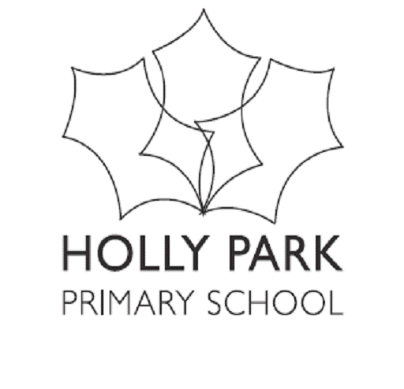
SEND Information Report for Holly Park Primary School
2023 – 2024
At Holly Park Primary School we are committed to providing, for each pupil, the best possible environment for learning. We believe that all children, including those identified as have additional educational needs are entitled to a broad and balanced academic and social curriculum, which is fully accessible to them. We value the abilities and achievements of all our pupils, and we strive to eliminate prejudice and discrimination. We work to develop an environment where all children can flourish and fees sage. We aim to engender a sense of community and belonging, and to offer new opportunities to learners who may have experienced previous difficulties. This policy describes the way in which we meet the needs of children who experience barriers to their learning, ensuring we comply with the duties and responsibilities under the Equality Act 2010 and Special Education Needs Disability Regulations 2014.
The following process will be followed for children whom there is a concern regarding learning or behaviour.
At all stages parents will be informed and involved
Stage 1: Classroom Monitoring/strategies
If a teacher/parent have any concerns about a child:
E.g. slow progress/poor concentration/communication/behaviour/emotional

Class teacher/SENDCO to discuss with parent to find out if there are any special circumstances and reassure parent that the child will continue to be monitored.
Class teacher to implement strategies (e.g. targeting for questioning, good listening chart, rearrange seating position.)
Child to be included in interventions.
NB: child may already be receiving intervention as part of their learning following a pupil progress meeting.
Stage 2: SEND register
If, after some time, concerns continue a child will now be put on the SEND register after a discussion with the parents.

Child will receive more tailored interventions.
Referral to outside agencies may be needed (e.g. EP, SALT)
Regular meetings between teacher and SENDCO to track progress.
An observation of the child may take place by SENDCO to highlight next steps to support the child at school.

Stage 3: SEND Support plans
If concerns still continue, a child will move onto a SEND support plan
This is a plan where targets will be set with the class teacher/SENDCO/parents and any other adults involved.
Further interventions for child.
Further referrals made to outside agencies if necessary (e.g. educational psychologist/CAMHS/Inclusion advisory team)
SEND support plan reviewed termly.
Stage 4: Application for Education & Health and Care Plan.
If concerns continue and the child is making limited progress and school is providing above ordinarily available, school and parents will consider evidence for EHCP application.

*This process is not always linear and there are times when, due to a child’s needs, stages may not be needed.

What’s our approach to teaching children with SEND at Holly Park?
- All our children have access to Quality First Teaching in all our classes.
- Children may also access targeted small group interventions, 1:1 work with the inclusion team and/or access to direct therapies from outside professionals.
What kind of SEND is provided for at Holly Park?
We are a very inclusive London Primary School providing for the following areas of SEND:
- Communication and Interaction
- Cognition and Learning
- Social, Emotional and Mental Health needs
- Physical and sensory needs.

What kind of school is Holly Park?

Holly Park is an inclusive and welcoming London, 2 form entry mainstream, school for children aged 3 – 11 years.
How do we identify children with SEND and assess their needs?
- Families can talk to the class teacher or SENDCO at any time.
- Class teachers meet termly with the SENDCO to discuss children
- If a concern about a child is made, the SENDCO may observe the child in class, use standard assessment tools and/or refer to outside professionals for further advice.
How do we support children between phases of education and changes of placements?
- Meetings with previous settings and parents.
- Transition meetings with staff
- EHCP and support plan meetings.
- Attend visits with children to new setting.
How do we support children’s social, emotional and mental wellbeing?
- Children at Holly Park have access to our learning mentor, HEWS and CAMHS.
- Our Learning mentor provides sessions for children which include emotional literacy and mindfulness
- Zones of regulations used throughout the school.
How are adaptations made to the learning environment/curriculum for children with SEND?
- The school seeks advice from advisory teams where necessary e.g. hearing impairment.
- Children with SEN have access to visual timetables, workstations, PECS, Now and next boards etc
What expertise and training is available to support children with SEND?
- We have a school SENDCO and learning mentor.
- We have a team of TAs who work with our SEN children.
- All staff have access to specialist advice from outside professionals
- All staff have ongoing access to in school and borough training.
How does Holly Park handle complaints about the provision for children with SEND?
- The SENDCO is available to discuss any concerns you may have about your child.
- The school’s complaints policy can also be accessed on the school website.
How does Holly Park involve outside organisations in meeting the needs of children with SEND?
- SENDCO meets regularly with SLT, OT, CAMHS, EP, Paediatrics, Autism Advisory Team, Inclusion advisory team and social care to meet the needs of children with SEND.
How do we ensure children with SEND are able to fully engage with everything at school and interact with children without SEND?
- Holly Park is a fully inclusive primary school, and we make every effort to ensure all children with SEND are able to access breakfast club, after school clubs and educational off-site visits if possible.
Useful links:

Barnet Local offer

Barnet Local Offer :: Home

