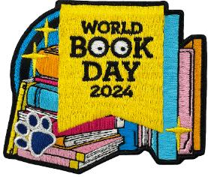
Holly Park’s World Book Day 2024!

This year, World Book Day is on Thursday 7th March and we have lots of exciting activities planned!
- All children are invited to dress up as their favourite character or in a way that represents a book or character.
- Ms Sampson will be leading KS1 & KS2 book-based assemblies.
- The whole school will be taking part in a shared reading session.
- Pupils will receive their book tokens that can be used to buy special World Book Day books in shops (or £1 off a preferred book).
- All pupils will be asked to create a ‘book jar’ at home (details below) that will be used to create a museum in our hall.
- Children will be taking part in various creative activities in class inspired by an image and a poem.
If you would like to get involved with further activities at home then there are many suggestions on the World Book Day website: https://www.worldbookday.com/.
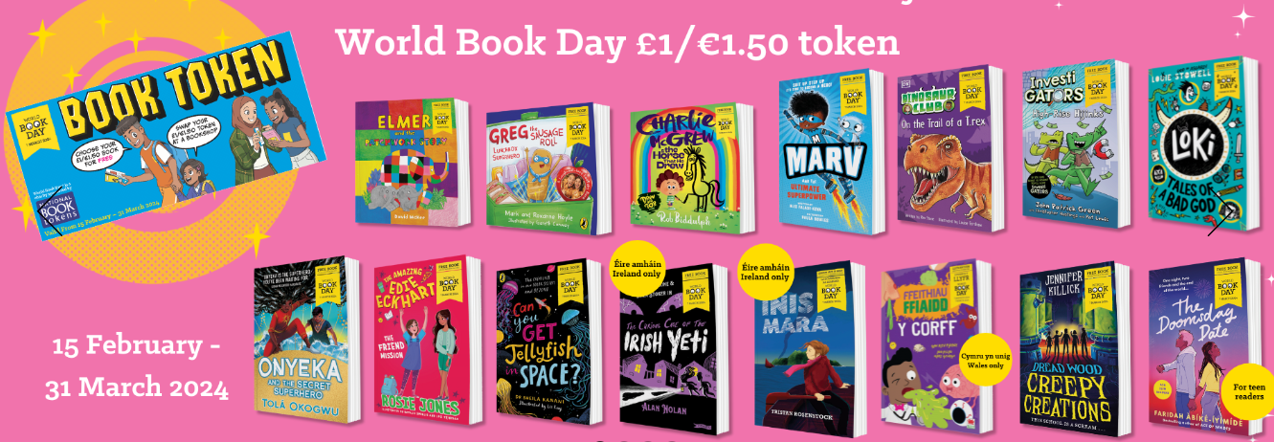
If you have any queries then I can be contacted by email, via the school office. In the meantime, we look forward to celebrating all things books and reading with our pupils on the 7th March.

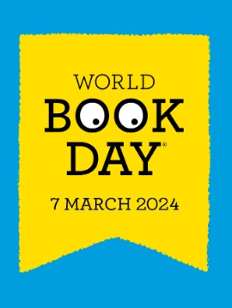

Holly Park’s World Book Day Museum 2024!
Similar to our ‘Shoe Box Books’ made in 2022, this year we are asking pupils to create a ‘Book Jar’ to bring in to school on World Book Day. They will be collected and curated in to an exhibition – every class will be given the opportunity to visit during the day.
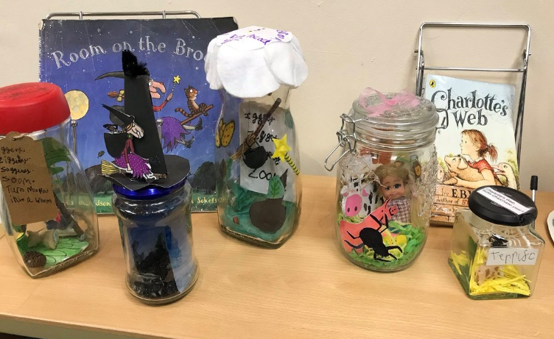
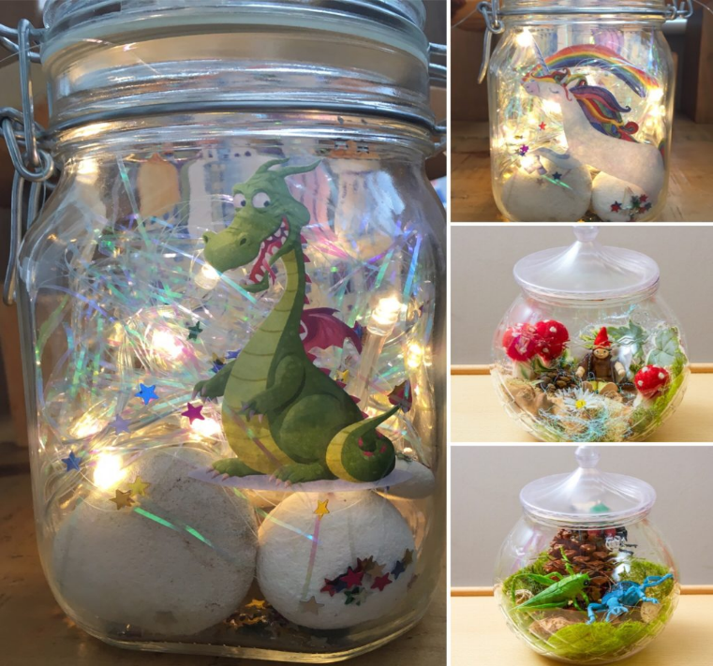
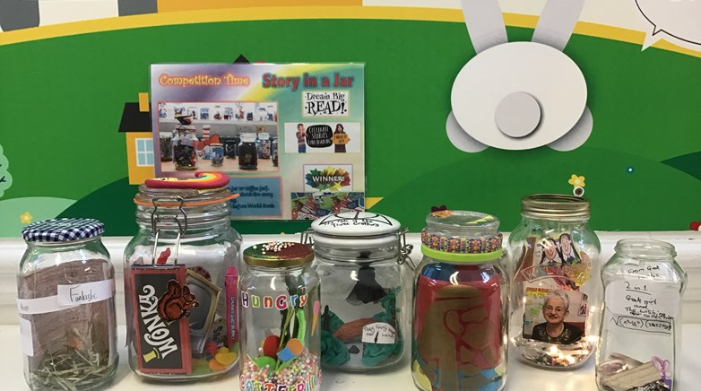
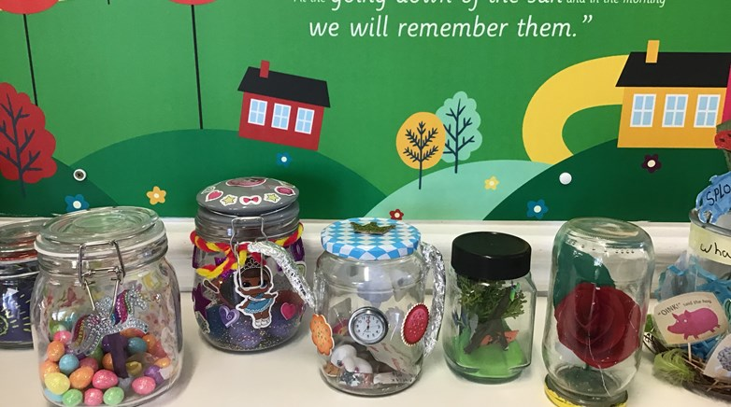
Using as much creativity or imagination as possible, children should either decorate or fill a jar (recycled is absolutely fine) to represent a book. They should bring them (carefully) to the hall on World Book Day, before going to class. They will be able to take them home with them. Please see below for inspiration:

