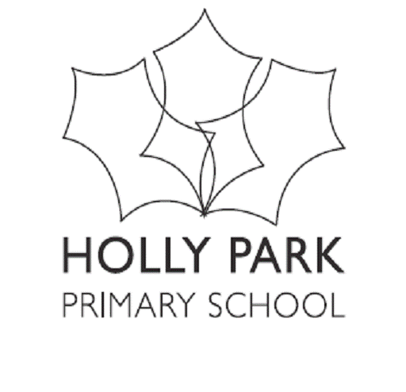
HOLLY PARK SCHOOL
PHSE
Briefing Sheet for Parents on Relationships, Health and Sex Education
- Introduction
Relationships, Health and Sex Education are an integral part of our Personal, Social, Health and Economic (PSHE) education curriculum throughout the school. We have a responsibility to prepare our pupils for life in 21st Century Britain including recognising and being able to form healthy relationships and having the skills to keep themselves safe.
These lessons will continue to reflect our school values and link with our statutory duties to actively promote British Values, comply with the Equality Act, keep our children safe and meet the changing needs of all families in our school community. These lessons also support our constant challenge to prevent bullying. We value the relationship we have with our parents and will continue to inform them with regard to our PSHE curriculum. We see these lessons as the continuation of conversations that will have started at home.
Our PHSE Policy and Sex and Relationship Policy can be found on our school website.
- Statutory Elements
All schools have a statutory obligation to deliver the elements of Relationships and Sex Education which fall under the National Science Curriculum for KS1 and 2 and the Early Learning Goals for Reception, these are as follows:

Early Years including Reception (age 2-5) – Statutory Early Learning Goals
Physical Development
- Health and Self-Care
Personal, Social and Emotional Development
- Self-Confidence and Self-Awareness / Managing Feelings and Behaviour and Making Relationships
Understanding of the World
- People and Communities

Key Stage 1 (age 5-7 years) - Statutory Science Curriculum
Year 1 pupils should be taught to:
- Identify, name, draw and label the basic parts of the human body and say which part of the body is associated with each sense
Year 2 pupils should be taught to:
- Notice that animals, including humans, have offspring which grow into adults
- Describe the importance for humans of exercise, eating the right amounts of different types of food, and hygiene

Key Stage 2 (age 7-11 years) - Statutory Science Curriculum
Year 5 pupils should be taught to:
- Describe the life process of reproduction in some plants and animals
- Describe the changes as humans develop to old age
Year 6 pupils should be taught to:
- Recognise that living things produce offspring of the same kind, but normally offspring vary and are not identical to their parents

From the Summer term 2021, all primary schools will also have a statutory obligation to deliver Relationships Education and Health Education. Our basic PSHE curriculum will therefore include the following:
Relationships Education - By the end of Primary School children will be taught about:

- Families and people who care for me
- Caring Friendships
- Respectful Relationships
- Online Relationships
- Being Safe

Health Education - By the end of Primary School children will be taught about:

- Mental Wellbeing
- Internet Safety and Harms
- Physical Health and Fitness
- Healthy Eating
- Drug, Alcohol and Tobacco
- Health and Prevention
- Basic First Aid
- The Changing Adolescent Body (Puberty)

- Sex Education – Non statutory
The Department for Education continues to recommend that all primary schools should have a sex education programme tailored to the age and the physical and emotional maturity of the pupils. The school will engage with parents (via a letter and meeting in Year 6) about the content of the sex education programme, which only happens, in Year 6. It is only the Year 6 lessons on conception and birth, which are classed as sex education and therefore separate to Relationships and Health Education.
- Parental Right to Withdraw
From September 2020 Parents only have the right to withdraw their child from Sex Education (two/three lessons in Year 6).
From September 2020 parents do not have the right to withdraw their child from lessons on Relationships or Health Education or the Science Curriculum which are covered in all other year groups – this includes lessons on puberty.
- School and home working together
The role of parents in the development of their children’s understanding about relationships is vital. Parents are the first teachers of their children. They have the most significant influence in enabling their children to grow and mature and to form healthy relationships.
In Year 6, Parents will be invited to a meeting about the sex education aspect of the curriculum. This will be an opportunity to find out how the lessons will be taught, what the content will be and how the class teachers have prepared to deliver the lessons.
Ann Pelham
Headteacher

