 Learning Project –The Artist by Ed Vere 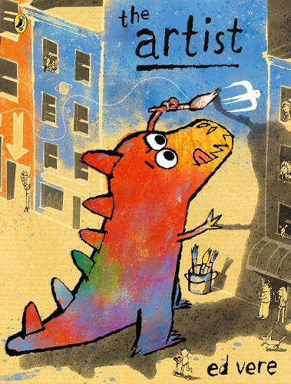
‘A Joyful Celebration Of The Artist In All Of Us!’
Dear Parents/Carers,
Welcome to the Autumn term.
For the first two weeks back at school, we will be using a whole school book called ‘The Artist’
During the first two weeks lessons on PHSE, Art and Writing will be based on the whole school book. Maths lessons will still continue daily. Music, PE, Spelling, Reading, Handwriting and Spanish will continue as normal. After our Inset day later in September, you will receive the usual curriculum letter for what each year group will be learning for the rest of the term.
Maths |  | English
The teachers will be assessing where the gaps are and using the ready to progress criteria. They may begin the place value unit of work. |  | Writing will be based on the book.  Spelling and Handwriting lessons will begin  Daily class reading will begin
The Artist: ‘A heart-warming story of how mistakes can make beautiful things happen’
Art lessons may include:
- ‘Sometimes we’re too busy to notice it’ – why sometimes? What are we doing? Do we pay enough attention to the world around us? Why/why not? Why do artists see it all? What do they do differently? Sketches outdoors looking around - us in the playground or at the park.
- Create a display… a ‘Wonder Wall’ of ideas that give children that feeling of wonder, joy and beauty
- What is in your head? things ‘fizzing, buzzing, bumping together’. Children create individual versions of what is in their head
- Create a 3d exhibition of a city
- Create a sketch of themselves, in the style of the artist
- Create a story board, drawing the artist or sketching blocks of colour – linking feelings to the different colours Ed Vere uses.
- Draw themselves and fill their pictures in with the colours they would paint inside themselves.
- Sketch their own city scape and illustrate the buildings
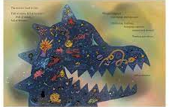

PHSE lessons may include:
- Discussions on - What is an artist? Can you define it? Is there a right or wrong way to describe an artist? Is there a particular way of being an artist?
- A debate – ‘Where should The Artist go and why to find joy and beauty?’
- ‘Mistakes are how you learn!’ - is that true? Can children think of their own examples of when they have made mistakes – could be linked to learning or to life. Have any of their actions ever been a mistake? How can we correct mistakes? How can we make things right?
- ‘Your art is full of heart’. How is this true? What is in the artist’s heart and what did she set out to achieve? Is this true of art in general? Link to other artists including musicians, films, other books. What do they seek to achieve and how are they ‘full of heart’?
- How do the changing colours depict feelings at each stage of the story?
- Feelings and the zones of regulation.
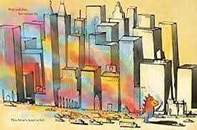

Writing lessons may include:
- Turn ideas (of what is in their heads) in to poems. They could make a list poem.
- What could they say to the artist to help her be brave? What words of advice could they give to her? Write a card to her. Write poems – about a brave artist, setting sail to share her pictures with the world…
- Write a diary entry as the girl describing what she saw in the city. What impact will it have?
- Write letters or cards to try and make the girl feel happy. They could include reference to Zones of regulation and the tool boxes to help her get out of the blue zone!
- Write to the artist or write what they would say to her about how we learn from our mistakes
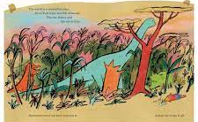
Links to Rights:
- Article 13 (freedom of expression) Every child must be free to express their thoughts and opinions and to access all kinds of information, as long as it is within the law.
- Article 29 (goals of education) Education must develop every child’s personality, talents and abilities to the full.
- Article 31 (leisure, play and culture) Every child has the right to relax, play and take part in a wide range of cultural and artistic activities

Key Dates |  | Other Information
Wednesday 6th September Y1 Meet The Teacher  Thursday 7th September Y6 Meet the Teacher  Tuesday 12th September Y2 Meet the Teacher  Wednesday 13th September Y5 Meet the Teacher  Thursday 14th September Y3 Meet the Teacher  Friday 15th September Y4 Meet the Teacher  Monday 19th September INSET Day |  | PE Kit needs to be worn on PE days  Book bags need to come to school every day  Children should bring a named water bottle daily

