HOME – SCHOOL AGREEMENT

The parents, children and staff working together can be the most powerful force to help children learn and reach their potential. By signing up to this agreement we can build on the strong partnership that already exists at Holly Park School.

Mrs. Ann Pelham

Head Teacher

Child’s Name: ………………………………………………………….. Date: ……………......

The Holly Park Staff will:

- Provide a secure learning environment for all children
- Encourage children to do their best at all times
- Encourage children to respect and care for their surroundings and each other
- Inform parents about what the teachers aim to teach the children each term
- Keep parents informed about school activities through regular communication
- Inform parents of the children’s progress through consultations and an annual report
- Provide homework according to school policy
- Mark and give feedback on each pupil’s work in line with our marking policy.
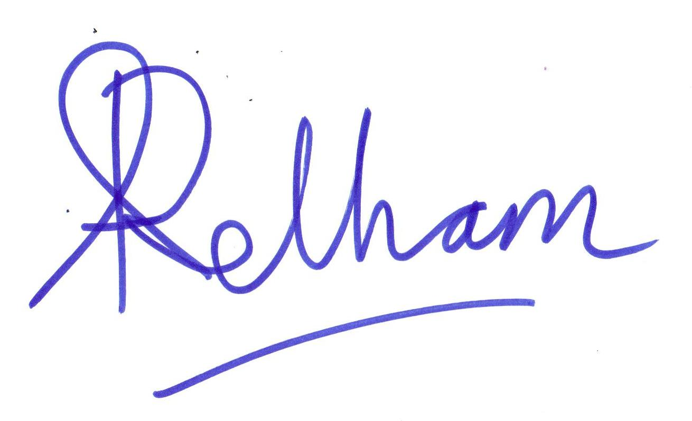
Headteacher’s signature

The Family will:

- Make sure their child arrives at 8.55 a.m. and is collected promptly at the end of their school day
- Ensure that uniform is worn and a school PE kit is provided
- Make sure their child attends regularly and provide a phone call of explanation if the child is absent. Families must phone the school office by 9.15 on first day of absence
- Support and encourage homework and ensure that books and equipment are returned on time
- Attend Parent/Teacher consultations to discuss their child’s progress each term and support other open evenings and functions whenever possible
- Demonstrate a commitment to the wider opportunities offered by the school, including extra-curricular activities, concerts and performances

Parent’s Signature ……………………………………………………………….......

The Child will:

- Try their best at all times
- Respect all adults in school and the other children
- Try to be friendly and helpful at all times
- Take good care of the equipment and the school’s buildings
- Follow their class charter

Child’s Signature ……………………………………………….………………........

