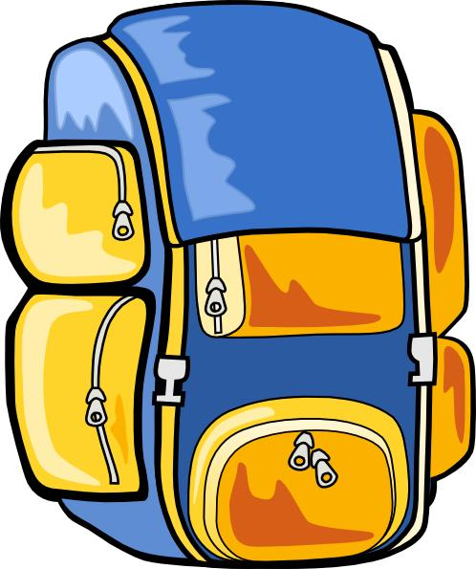 What to pack

Here’s a list of things you’ll need to pack – along with a few that aren’t essential but could be useful.

Things you need:

- Sleeping bag and pillowcase
- A water bottle (essential in the summer)
- Torch
- Rucksack
- Toiletries etc (please note deodorants must be roll-on, no aerosols)
- Old clothes for activity sessions – long-sleeved shirts/jumpers, trousers / jogging bottoms, appropriate length shorts. T-Shirts and closed-toe shoes are required for nearly all sessions so bring plenty. Clothes, shoes and underwear for other times. NO DENIM JEANS.
- Waterproof clothing (jacket / trousers)
- Large plastic bag for dirty clothes
- Bath towels x 2
- Sunglasses, sun cream and hat in the summer
- Pyjamas and slippers
- Hard wearing waterproof watch
- COMPULSORY – a teddy
- Books, playing cards and other quiet activities
- Small electronic devices for the journey there and back (mobile phones MUST NOT have a SIM card and children will not be allowed to access the internet)

Useful notes:
- Wet suit (not compulsory - please note, we do not supply wet suits)
- No wellies
- Please name all clothing
- Denim jeans are not suitable for any of the activities

Manor Adventure can’t accept liability for the loss of any personal property brought to our centres – so please don’t bring any valuable items, expensive clothing and footwear, mobile phone, handheld games consoles etc. We’re unable to store them and they won’t be insured whilst on centre.

