**Year 4**

Start Of Year Information Pack

**September 2021**

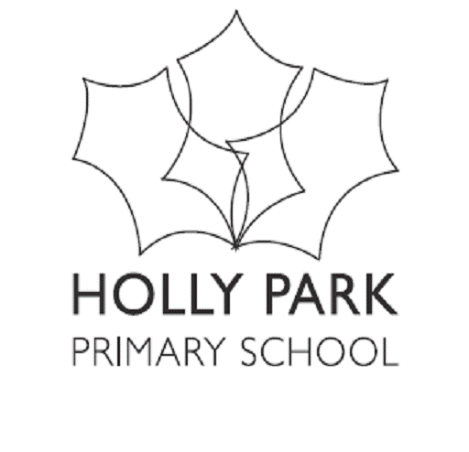

**Bellevue Road, Friern Barnet, London N11 3HG**

t: 020 8368 1434 e: [office@hollypark.barnetmail.net](mailto:office@hollypark.barnetmail.net)

**www.hollyparkschool.co.uk**

September 2021

Dear Families,

Welcome back to a new academic year at Holly Park. We are pleased to see the children. We are looking forward to what we hope will be another busy and exciting year ahead at school. The start of a new academic year is always important for your children but this year more so than ever. We hope that this year will run smoothly in terms of the virus and that it will be as close to a normal school year as possible.

**Parent Workshops**

This year, we will be continuing with our parent workshops as best we can. We are not sure yet if these will be in person or remotely.

This year there will be:

* A nursery and reception curriculum meeting.
* A Y1 phonics meeting.
* Y2 will have sessions on maths, SPAG and end of year expectations
* Y3, 4 & 5 will all have 3 sessions over the year on different subjects
* There will be an online safety session for parents later in the year.
* There will be meetings for Y2 and Y6 parents about national tests.
* Meetings for Y5 and Y6 parents about residential trips.
* A meeting for Y6 about sex and relationship education.
* A meeting for Y5 parents about secondary transfer.

**Our Website**

Our website has continued to flourish under the careful watch of Fiona Quinton. Do keep a regular eye on the website. It gives a very full picture of our school. You can access term dates, letters etc and information about what your children are learning from the website. Can I remind you that information about what your children are learning goes on the website on your year group page. Curriculum information is updated termly.

**The PTA**

Last year - despite COVID 19 - was a very successful year for the PTA. There were still lots of events and creative ways to continue to raise money. There were bags2schools, second hand uniform sales, ice lolly sales, quizzes, T towels, Amazon Smile, The HPS lottery, trails, PTA days, match funding and several others. Amazingly the PTA raised £9,279.21. I am very grateful to all of the committee members and people who have helped at events who work tirelessly as volunteers for the greater good of the children. The PTA raise money for the ‘extras’ but also hold events that bring our community together. Thank you particularly to Nathalie and Marilena for their organisation and hard work. Remember, you are all members of the PTA. Please do show your support by either attending events or volunteering to help at the events.

**Clubs**

Football and netball club will start again this term. Non Stop Action clubs will also be starting again.

**Partnerships**

Our school partnership with other local schools continues to work well and we have met regularly as a group of Headteachers. This has been very useful particularly last year to compare notes and share ideas about school lockdwn, home learning, Key Worker Hubs, safe procedures catch up learning etc. This academic year we plan to work together on a couple of projects for Year 4 and Year 5. A reminder that our partnership schools are St John’s, St Paul’s, Coppetts Wood, Hollickwood and All Saints.

**Governors**

The school governors continue to give their support and advice to help drive the strategic vision of the school. As well as meetings in the evenings that they attend and training courses they go to, governors also come into school regularly to attend school events but also to support our school improvement plan. They have opportunity to go on frequent learning walks, talk to staff and children and see some of the work of the school in action and to give constructive feedback. Even during lockdown governors were still very much engaged and involved with school business and attended Zoom meetings and looked at documentation relating to school opening.

**National Assessments**

There were no National assessments last year due to COVID 19. Therefore, there will be no published league tables.

**Summer Works**

We had a busy summer holiday.

Cedar, Beech, Maple and Juniper Classes were all redecorated and look lovely. There was a new gate fitted to part of the playground to keep litter out and to use as a storage area for the netball posts. An outdoor area was refreshed with paint and holes filled in – ready to become a wellbeing garden. The front office was revamped to allow space for two people to work in there instead of one. Various white paint areas were repainted to look clean and bright including the packed lunch trolley shelter ready to be used again this year,

All of the school buildings have had a deep clean including the kitchen.

**Equipment**

We continue to ask the children to bring in a minimum of equipment from home into school – they do not need to bring in pencil cases and stationery, and the only bag that they need to bring in is their school book bag. Please **do not bring in rucksacks**. This helps us keep classrooms and shared areas tidier and prevents property from being lost.

Children need to remember to bring a named water bottle each day.

Children also need to bring in a snack for morning break.

**Charities**

As you will be aware, we organise several activities across the year to raise funds for a variety of local, national and international charities. In 2021-22 we will support:

* National Charity - Ability Dogs 4 Young People
* Local Charity - A local food bank
* International Charity - Unicef

**House Challenges**

We will also be continuing the tradition of our termly house challenges for the children in Y1-6. We try to vary the style and focus of these each term.

**Values**

We continue with our work on values. A Value is a principle that guides our thinking and our behaviour.

|  |  |
| --- | --- |
| September | Respect |
| October | Friendship |
| November | Equality |
| December | Generosity |
| January | Hope |
| February | Love |
| March | Honesty |
| April | Excellence |
| May | Determination |
| June | Courage |
| July | Politeness |

**School Trips**

We hope that each class will continue to have two school trips in the year, two curriculum days and one trip to a place of worship. During the Autumn term there will be no school trips.

In addition, we hope to be able to go ahead with our normal extra programme for KS2. Y3 will have a team building day, Y4 will have a Friday night pyjama party at school, Y5 will have a 3 day residential trip and Y6 will have a 5 day residential trip.

At Holly Park our trips always relate to something that the children are learning and therefore they enhance and enrich our curriculum. We believe that trips are a very important part of the curriculum. We think very carefully about where we will take the children and also about the cost. We try wherever possible to keep the cost at no more than £15 per trip but this is not always possible. School trips are generally excellent value for money. There is always an expectation that parents have to pay for trips as this is not included within our school budget. Payments and permissions are all done via our online payment system – this makes things easier for you.

**Teachers**

During the year, you will find that your children will sometimes be taught by other teachers. Absences can happen for several different reasons: the teacher may not be well, or they may be on a training course; they may be having time out of class for monitoring, or for planning, preparation and assessment (‘PPA Time’). In KS1, the teachers covering PPA (planning time) will be continuing with the activities that the teachers would have been doing had they been in the classroom. The teachers covering PPA in KS2 will be doing handwriting and spelling. In the Y4 bulge year group this will also include times tables.

We use a very good supply agency which we have used for the last four years. Wherever possible, we try to use supply teachers who have visited us before, to cover. Teaching Assistants also cover classes for up to half a day due to teacher absence. This works well as the teaching assistants know the children and know the school procedures. I want to assure you that every effort is made to make this the best possible experience for the children.

**Assemblies, Shows and Concerts**

We will continue to hold class assemblies for the year groups who do not perform a show during the year – this will be Reception, Year 4 and Year 5. We will need to assess later in the year to see if we can have parents attend these.

A reminder about our school performances - our Nativity will be performed by Y3 in December.

Our Infant Show will be performed by Y1 and 2 just before February half term.

Y6 will perform an end of year show as a finale to their time at Holly Park.

At the moment we have no idea if parents will be able to come along to watch or if we will need to revise or suspend some performances.

**Poppy The School Dog**

Poppy has now been coming into school for several years now and the children and staff love her. She even has her own dog blog on our website where you can find out about the week from her point of view. If you haven’t already – take a look! Last year Poppy was awarded a PDSA award for supporting children with emotional issues and being a great comfort and support to both staff and children.

**Parent Code of Conduct**

At Holly Park we have a code of conduct for our pupils – ‘The Holly Park Way’. I would also like to remind you that we also have a Code of Conduct for parents while they are on school property. This is included in the ‘Meet the Teacher’ packs. I would be very grateful if you could please read it and abide by it. The parent code of conduct is also clearly displayed on our school website. The purpose of this Code of Conduct is to provide a reminder to all parents, carers and visitors to our school about the expected conduct. This is so we can continue to flourish, progress and achieve in an atmosphere of mutual understanding. The Code of Conduct explains clearly that parents should not tell another child off, speak to them directly about an event that happened in school or contact their parent about it. The matter should be dealt with through the school.

At Holly Park we cannot and will not tolerate staff being shouted at or spoken to without courtesy and respect. This includes on the telephone and emails that may be written. May I remind you that all staff have a right to work in an environment free from abuse which includes verbal abuse. Please speak to staff in a way that you would be happy to be spoken to yourself. The school governors very much support this view.

**GDPR**

It is importantl that you have read and understood the school privacy notice. The Privacy notice is inside this pack and is also accessible all year round on the school website. If your contact information changes over the year – then please do let the office know. We also are required to have two emergency contact numbers in addition to parent contact details.

The year has begun on a positive note and children are settling into new routines and systems. We are all looking forward to a successful year.

I look forward to seeing you at the drop off point at the start of the school day and in the playground at the end of the day.

Thank you for your continued support.

Yours sincerely,

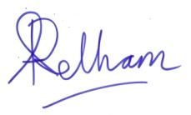

Ann Pelham

Head Teacher

**The Year 4 Team**

 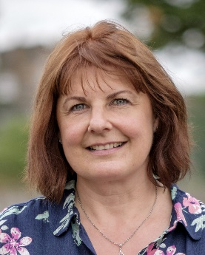 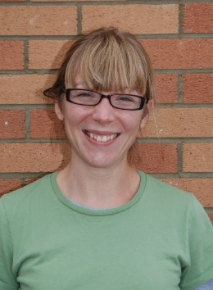 

Miss Biggs Ms Owen Mrs Bawcombe Mrs Tsenti

**Larch Class Sycamore Class Mulberry Class Mulberry Class**



Mrs Spann

**Year 4**

**Teaching Assistant**

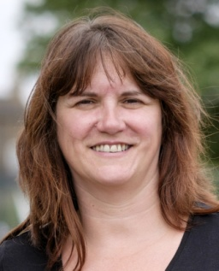   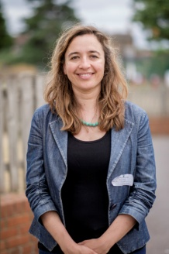

Mrs Thomas Miss Michael Mr Hogan Mrs Echanove

**PPA Teacher PPA Teacher**  **Music Teacher Spanish Teacher**

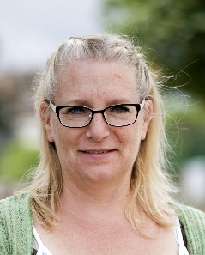 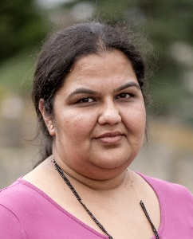  

Caroline Giles Jigna Popatia Pina Domizi Renske Reima

**Year 4 SEN Teaching Assistants**

**Whole School Start Of Year Project**

|  |  |  |
| --- | --- | --- |
| *CC2CC17D*  *Learning Project – Dreams Of Freedom CC2CC17D*    Dear Parents/Carers,  Welcome to the Autumn term. For the first two weeks back at school, we will be operating a whole school project. The purpose of this is to settle the children back at school happily into their new classes and for the teachers to get to know the children before they begin their year group curriculum. Music, PE and Spanish will continue as normal. After our Inset day on 20th September, you will receive the usual curriculum letter for what each year group will be learning for the rest of the term. | | |
| **DREAMS OF FREEDOM: In words & pictures.** | | |
| Dreams of Freedom combines the words of human rights heroes such as Nelson Mandela, the Dalai Lama, Anne Frank, Chief Standing Bear and Malala Yousafzai with beautiful illustrations from international artists including Oliver Jeffers and Chris Riddell. The book aims to empower children to explore the idea of freedom, build empathy and develop their knowledge and understanding of human rights. Award-winning author Michael Morpurgo writes in the foreword: ‘Dreams of Freedom is a feast of visual stories – brave words and beautiful pictures, woven together to inspire young readers to stand up for others and to make a difference.’  Picture books empower young readers to chart their own course through a story, to explore, pause, examine detail, question, flick back and forth, reread. The interplay of pictures and words makes abstract ideas and complex issues accessible, even to very young children. Looking at the world from different viewpoints nurtures understanding. Great picture books show children how to stand up for themselves and others, the essence of human rights.  Teachers may use lots of the book or choose a couple of the quotations to build their block of work around.  Learning may be based around – Freedom to learn, Freedom to dream, Freedom to have a home, Freedom to have your own ideas, Freedom from fear, Freedom from slavery, Freedom to be a child, Freedom to enjoy life and liberty, Freedom to be yourself.  Every child in the school will make a kite that will hang in the school. Kites celebrate the fact that human rights are universal; they belong to all of us. Kites are often a symbol of hope and freedom, flying high.  This book links so well with our work on rights at Holly Park as we are a Rights Respecting Silver Award school.  6D860D93 A7A13019 5B43228F | | |
| **Key Dates** | | **Other Information** |
| Y1 Meet the Teacher – 6th September  Y4 Meet the teacher – 7th September  Y6 Meet the teacher – 8th September  Y3 meet the teacher – 9th September  Y2 Meet the teacher – 10th September  Y5 Meet the teacher – 15th September  Meeting for nursery & Reception parents about the curriculum - 22nd September  Y6 Cake sale – 24th September  Phonics meeting for Reception parents – 1st October  Y6 School Journey Meeting – 5th October  Y5 Cake sale – 15th October  Junior Quiz – 19th October  Harvest Festival – 20th October  House Challenge – 22nd October  Y5 School Journey Meeting – 9th November | Y3 workshop – 10th November  Y5 workshop – 12th November  Y4 workshop – 16th November  International Charity – UNICEF – 19th November  Y4 Cake Sale – 19th November  Parent consultations KS1 – 24th November  Parent Consultations KS1 & KS2 – 25th November  Christmas Lunch – 8th December  Upper KS2 parties – 10th December  Y3 Nativity 2.30pm – 13th December  EYFS parties – 14th December  Y3 Nativity 6.30pm – 14th December  Lower KS2 parties – 15th December  KS1 parties – 15th December  Final day of term – 17th December at 1.30pm | PE Kit needs to be worn on PE days  Book bags need to come to school every day |

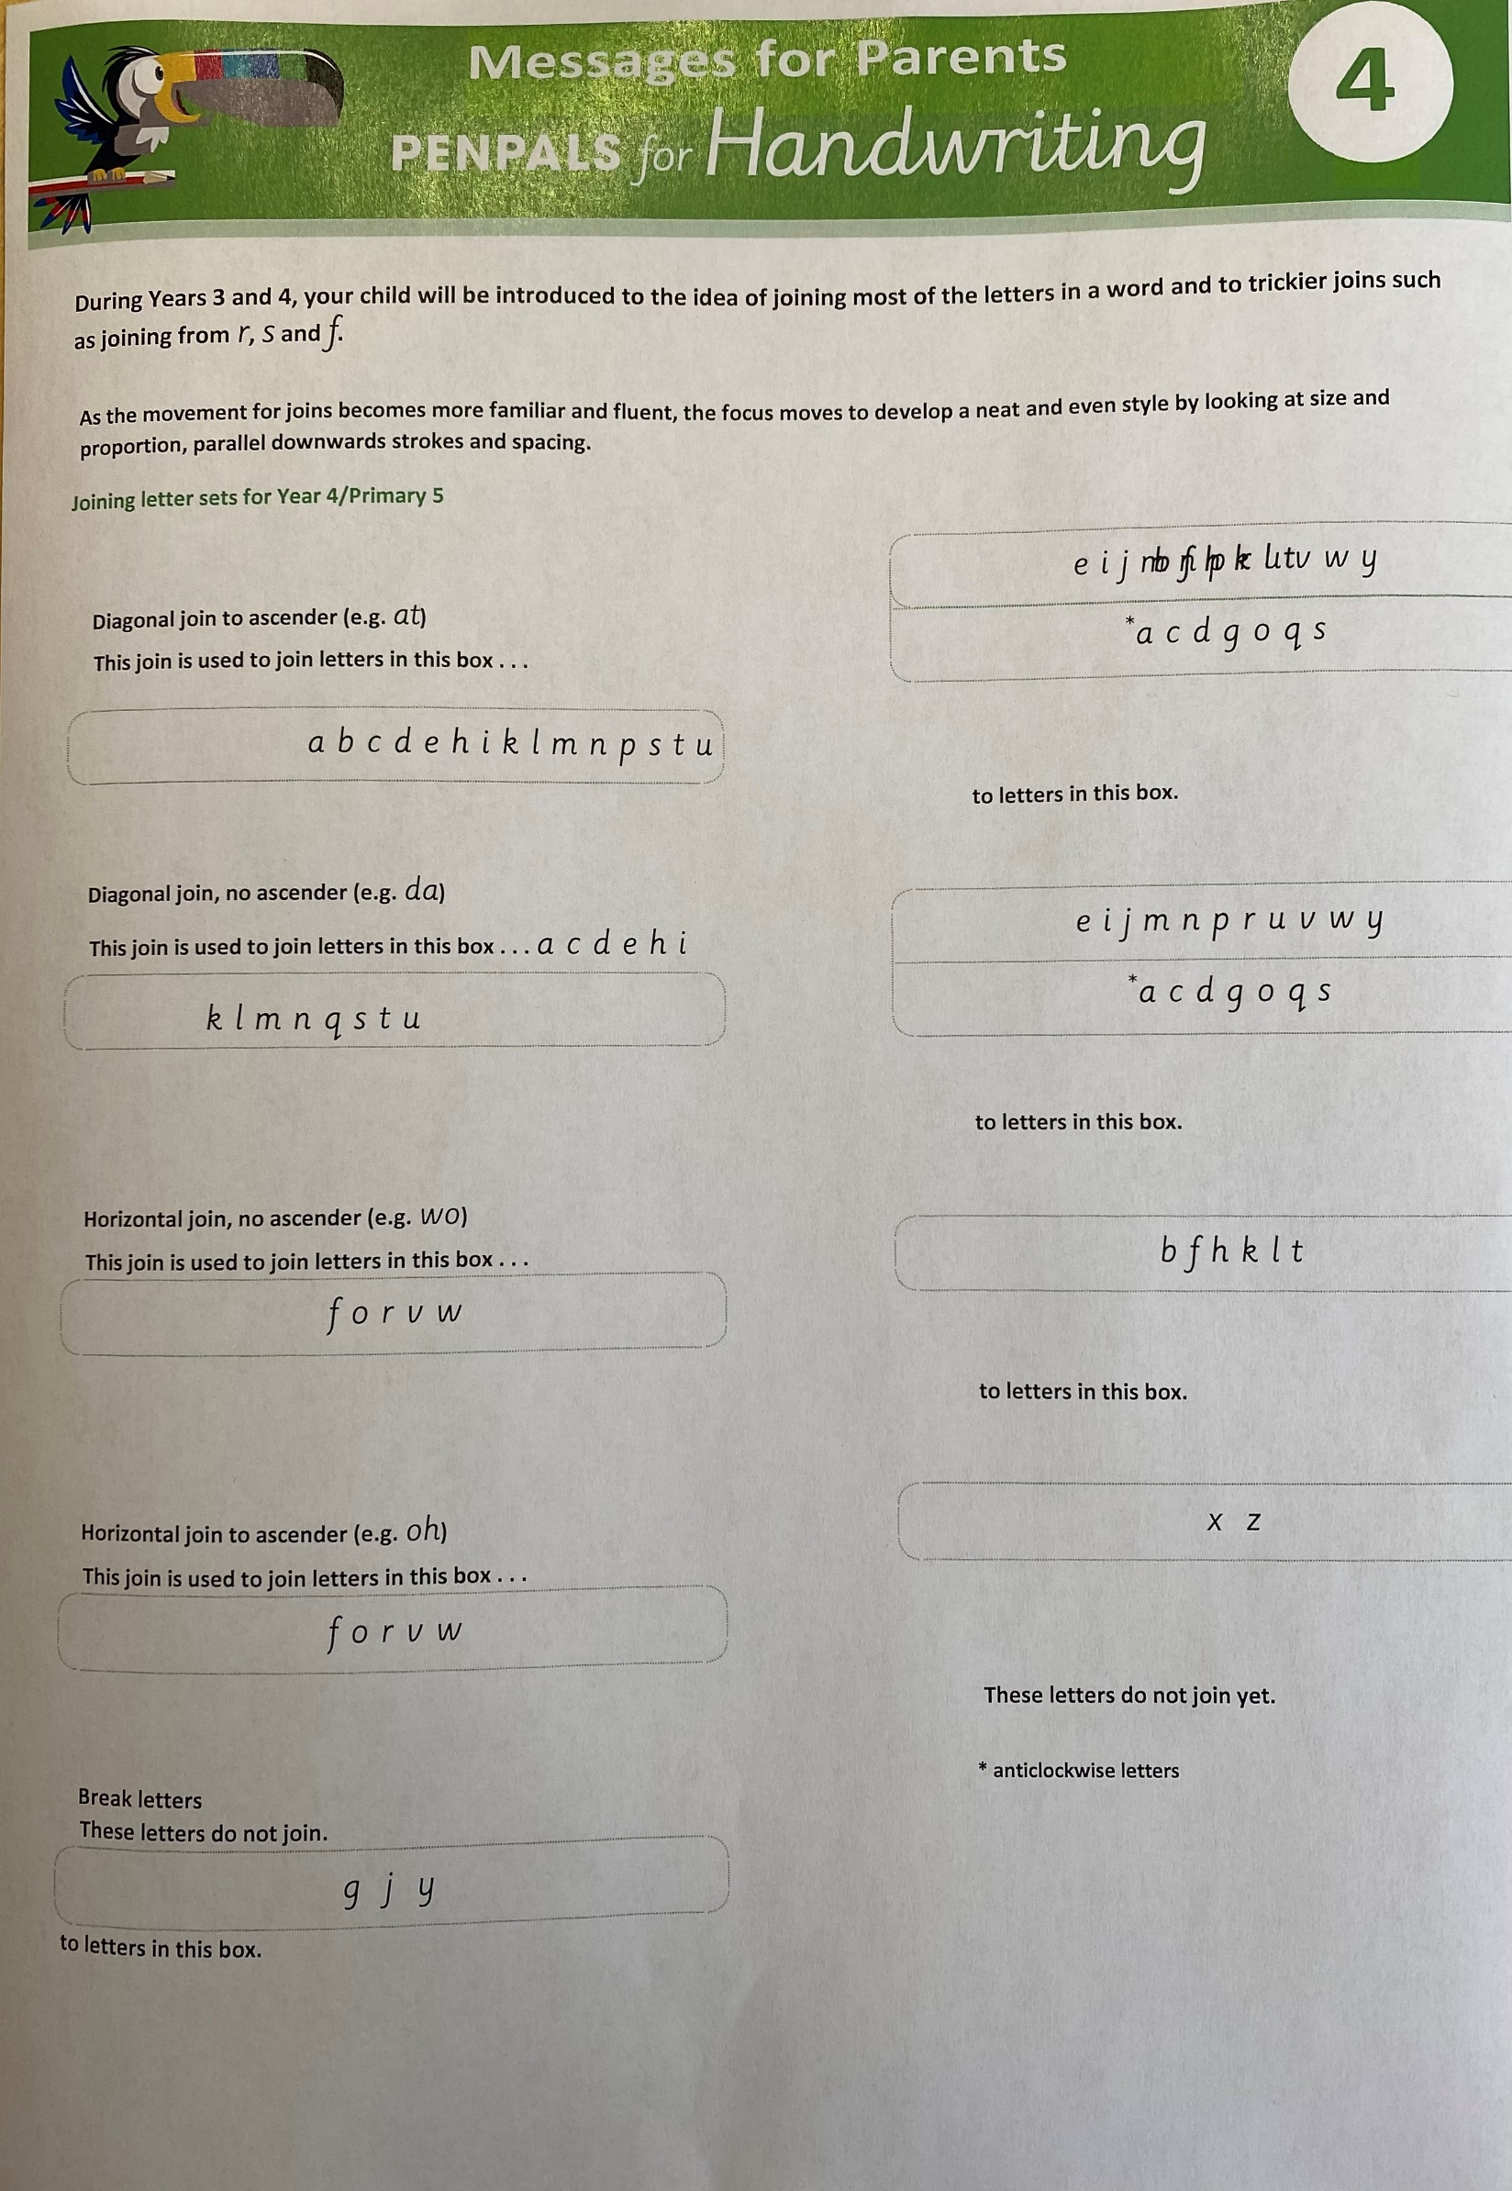

**Key Staff Members**

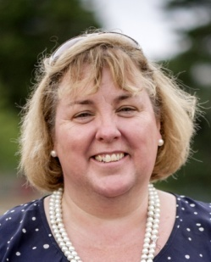   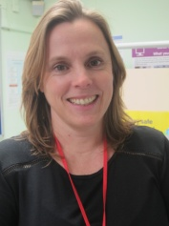 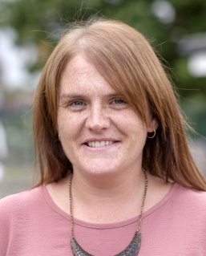

Mrs Pelham Miss Michael Mrs Kelly Mrs Needham Miss Hounslow

**Head Teacher Deputy Head Children’s Pupil Support Office Manager C Co-ordinator Officer**

    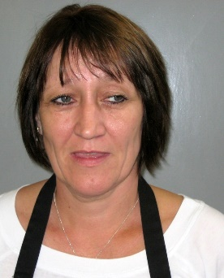

Mrs Szymanska Mr Reid Mrs Puzey Adam Rampley Julie Disbrey

**Senior MTS**  **Site Manager Learning Mentor Kitchen Manager Kitchen Assistant**

**Office Admin**

  

Mrs EchanoveMr French Mrs Fitzpatrick

**Spanish KS2 phase leader EYFS/KS1 phase leader**

**Key Leaders**

  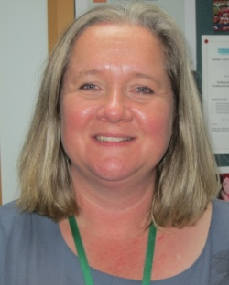 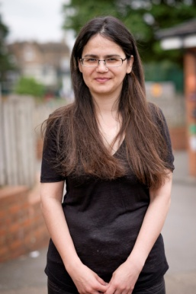 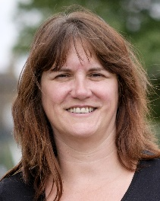 

Mr Turner & Miss Mountford Ms Sampson Mrs Mir Mrs Thomas Mrs Walton

Mr Carini

**Innovation &**  **Writing Reading Maths Disadvantaged Early Years**

**New technology**  **Pupils & LAC**

 Holly Park Primary School – Year Four Information

What To Expect In Year Four

Welcome To Year Four!

The move from Year Three to Year Four is not a big one and many of the things that parents and children have become used to last year, remain the same in Year Four. As well as the class teachers, there is a teaching assistant who will work in the Year 4 classes at various times across the year.

**Start Of The Normal School Day.**

The start of the school day will run with a soft start time, which means that children come in to school and go straight to class with no waiting around needed in cold or wet weather. It enables a lovely calm and peaceful start to the school day makes the children – even those in Reception – very independent and confident.

Mr Reid will open the main gates at 8.45am and children will enter between 8.45am and 9.00am.

Parents/carers will not be coming on to the school site and will say goodbye either at the main gates or will walk down to where there are staff waiting and say goodbye there. This is actually the tarmac line where the new playground ends.

Children will walk in to their classrooms independently.

**Start Times:**

Reception to Year 6 – a soft start between 8.45am and 9.00am

If your child is late (after 9am), then they must go to the school office to be signed in and to get a late card to take to their teacher.

If you need to speak to the class teacher you can drop them a note, send an email to the school office to be sent to them or call the school office. You can also speak to them at home time when they have a bit more time. Please be aware however, that they may have a meeting they need to attend at the end of the school day – so you may need to make an appointment agreed with them. Thank you for your cooperation with this.

**Home Times:**

All parents/carers will be able to come on to the school site to collect their children.

Parents/carers will enter down the path to the buzzered gate. The gate will open at 3.20pm.

Parents/carers will then come on to the school site and will wait outside their child’s classroom.

EYFS and Infant teachers will let children out one at a time to their parents/carers.

KS2 teachers will bring their classes outside into the playground as a group to be collected.

Reception to Year 6 will finish at 3.30pm.

For safety and safeguarding reasons, parents are NOT allowed inside the Junior building at any time of the school day.

**School Dinners**

Just as in Y3, you have to pay for your child’s school lunch. We are a cashless school so you will have to pay for this online. We do recommend that your child has a school cooked lunch as they are excellent.

If your child has a packed lunch please be aware that they must not bring a drink as water is available for all children. They must also not bring chocolate or sweets. All food provided must be nut free. KS2 packed lunch boxes should be left on the correct year group trolley in the packed lunch shelter.

**Snacks**

It is quite a long morning from breakfast to lunchtime so we do suggest that your child brings in a healthy snack for morning break. We suggest fruit or vegetables or rice crackers. Children cannot have crisps, chocolate, sweets or anything with nuts in it. Snacks need to be named and taken into the classrooms; snacks should not be put in lunch bags as the children are not allowed to access these until lunchtime.

**PE**

PE continues to be twice a week. One of these sessions is in the hall and the other is in the playground. We are required to teach a certain amount of PE each week and we do go outside in hot and cold weather. Children are fairly resilient and it has been scientifically proven that cold weather cannot give you a cold. Please make sure that your child has the correct PE kit for going outside. They will need:

* red shorts
* white T-shirt
* white trainers
* green tracksuit top
* green tracksuit bottoms

Children should wear PE kit instead of school uniform on their PE days.

**Swimming**

Year 4 will swim every Wednesday afternoon across the school year. Each Y4 class will do a term of swimming. The school provides a member of staff for each group, but we are reliant on parent helpers to make up the numbers. Please understand that if we do not have the parent support for these lessons, we may well have to cancel the swimming provision.

We do understand that some children already have swimming lessons outside of school. However, it is a requirement of the PE National curriculum that all children swim in school as part of the PE provision. All children must attend school swimming lessons. We do our swimming lessons at St John’s School. The total cost of swimming for your child is £60 for the term. We are not given money in our budget for the swimming lessons therefore we need to continue to ask parents for a contribution of £30 per child for the term. Parents can make this contribution in one amount or spread it out across the term in three instalments of £10.

**Homework**

Homework continues as it did in Y3. In Years 3, 4 and 5 the children have a weekly open-ended question to answer and present in their own style. The questions allow for self-differentiation; fit with each individual’s own learning style and are designed to show breadth across all subjects over the year. With the open-ended tasks across the school the children will vary with the amount of time that they spend on them. The main questions to consider are – Is my child proud of what they have produced? Is this work a good effort for my child?

We expect the homework to be handed back in via Google Classroom. If a child cannot do this due to lack of computer equipment at home then we will provide a large homework book.

In addition the children will complete either one maths task or one Spelling, punctuation and grammar task each week. These 2 tasks are alternated each week.

Learning Spellings for a half term spelling test is also a part of the expected homework.

Learning Times Tables for a half term tables test is also part of the expected homework.

The decision on whether to set homework at all – and if so how much – falls to individual Head teachers. At Holly Park, we understand that parents value homework, but we also want children to relax and play at home – they work very hard during the day!  Lots of current research has shown that homework does not necessarily add much value to the learning process in terms of academic attainment.

The most important skills to work on at home are reading and times tables, and no child can ever read too much!

Please allow your child to attempt the homework themselves; we often receive homework that has been done by parents and we know that the child has had little input. If your child really struggles, please come and tell the teacher.

**Year 4 Class Assembly**

At some point in the school year, each Y4 class will do an assembly. This is an opportunity to perform an assembly in front of other children in the school. We also invite parents in to watch. The date for the assembly is given out in the ‘Term dates for parents’ leaflet at the start of each term – so parents can make a note of this in advance. From time to time due to unforeseen events in school, dates do have to be re-arranged. This cannot be helped but we try our best to communicate this in advance if possible. Every child will have a small part. Some will speak, some will dance and everyone will sing. There will only be one performance. The assembly will cover some aspect of what the children have been learning during the year and will demonstrate the broad and balanced curriculum that we offer at Holly Park OR it will be about a religious festival. The assemblies are at 9.10am in the school hall and last about 20 minutes.

**Trips and Curriculum Days**

During the year, your child will go on two trips and will also have two curriculum days.

The children will also make a visit to a place of worship. In Year Four it will be a Church (different to Y1).

In addition, there will also be a whole year group Pyjama Party for Y4 in March. The pyjama party will be run by staff who come back in their own time after school. The evening will be great fun and generally runs from 6.30pm to 10pm on a Friday evening. There will be a small cost. Children will need to return to school at 6.30pm (after having their evening meal at home).

The pyjama party will include a session with Non-Stop Action, an evening snack of pizza, and a late night film. There will be more information nearer the time but it is a fantastic opportunity. It is an important event in preparations for our residential trips in Y5 and Y6.

**Reading**

Whole Class Reading Daily - The children take part in daily-shared class reading for 20 minutes every day. The children read aloud and with the teacher and discuss the texts. This method means that every child reads for one hour forty minutes a week. Of course, some children still need individual reading and they will still receive this

Reading Books Coming Home – Please ensure that although your children can now read, that you continue to read with them daily. Reading is now more important than ever as it becomes more about vocabulary meaning and comprehension which takes into consideration inference, intent and personal opinion on a text. It is vital now that parents talk to their children about what they are reading. The children are now on a reading journey that culminates with an extremely challenging national reading test in Y6 which is based on some very difficult texts. The reading challenge has been introduced into KS2 and runs right through the juniors. The challenge has a mixture of different genres, different authors both modern and classic. The challenge increases in difficulty as it progresses.

It is expected on average that Bronze level is for Y3, Silver in Y4, Gold in Y5 and Platinum and above in Y6. Of course children will progress at their own rate.

**Times Tables**

It is vitally important that children know their multiplication tables by heart up to 12x12 by May of Year 4. In Y4 there is a national times table test which your child will have to sit. This asks 25 quick fire multiplication questions and the children have 6 seconds to answer. At Holly Park, we want the children to understand what the multiplication tables are but to also know them by heart. Please help your child to learn these at home.

**National Multiplication Test For Y4**

This is a national test for all children in Y4 which your child will take. The test is done online. It asks 25 multiplication questions (based on tables up to 12x12) and the children have 6 seconds to answer. Please help your child to learn these at home in preparation for the test later in the year. The test will be towards the end of May.

**Spelling**

Children will get (e-mailed to you) a spelling sheet every half term. This will be a combination of National Curriculum words, topic words and also spelling rules that the children will be learning each half term. Please print out the sheet and display it somewhere prominent in the house. Please help your child to learn the words. There will be a spelling test at the end of each half term. This will help the children in preparation for the journey they are already on towards Y6 national spelling test.

**School Councils**

Children continue to have the opportunity to be on one of our various councils – The School Council, the Eco Council, Healthy Living Council and Learning Council.

Once a child has been on a council, they may not be on it again. Children on a council stay on that council for one academic year. They get a Council badge and have their photograph on the website and Council board. They attend regular meetings. They also get to go on an additional Council trip during the school year.

**Mixing The Classes At The End Of Y4**

It is now established practice to reallocate the children in our Year 4 classes at the end of the year and create new classes for the start of Year 5. In the second half of the summer term we look at the children in our Year 4 to redistribute them into new classes ready for the start of Year 5.

In reallocating the children, we would consider many factors, including:

* The happiness and self-esteem of the children
* The ratio of boys to girls in each class
* The spread of ability
* Positive friendship groups
* Children with a wide variety of needs

The process is a very careful one and is done over several weeks. Many staff are involved

As we didn’t mix the classes at the end of Year 2 due to COVID and we therefore mixed them at the end of Y3 – we will make a decision as to whether we will mix them again at the end of Y4 much later in the school year. We may decide to keep the classes as they are until the end of Y6.

If you have any questions about the information in this letter, you can speak to your class teacher OR Mr French who is the KS2 Phase Leader.

Whole School Reminders

**Times of the School Day**

School starts at 9am each day.

Children should come in to school between 8.45am and 9am. They should go straight to their classrooms where the teachers will be waiting.

School ends at 3.30pm each day.

Please try to avoid being late as even a few minutes can be distressing for a child.

If you know that you will be delayed, please telephone the school office on 020 8368 1434, to inform them of your expected arrival time. If someone different than usual will be collecting your child, please tell the class teacher. We should always know the name of the person who will be collecting your child/ren.

Please note that children should always be collected by an adult.

Only children in Year 5 and Year 6 may walk home alone if the lone traveller permission form has been returned to school.

At present we cannot have parents inside the school buildings so please do not go to the school office at the end of the day.

**Illness**

If your child is ill, please telephone the school office on 020 8368 1434, on the first day of absence before 9.30am to inform us. Children who have had sickness or stomach upsets should be clear of symptoms for 48 hours before returning to school.

Wherever possible, please avoid making medical and other appointments during the school day, as it disrupts the work planned for your child.

**Medicines**

If your child requires medicine, such as antibiotics or an asthma inhaler, this should be given to Mrs Needham, the pupil welfare officer, be clearly named and a permission to administer medicine form completed and signed. This form is available from the office and a copy is on the school website. We regret that medicines cannot be given to your child unless it has been prescribed by their doctor.

**Snacks**

Your child may bring a healthy snack to eat during the day. Children may not bring in any chocolate or products containing chocolate, crisps, sweets or anything containing nuts.

**Birthdays**

We do not allow children to bring in cakes or other sweets to share for their birthday. This is because of increasing numbers of allergies to a number of ingredients, but also because we aim to be a healthy school. If you would like to mark your child’s birthday in some way, then a gift of a book, or indeed books, for the classroom library would be very much appreciated.

**Jewellery**

We encourage the children to wear as little jewellery as possible. We do not want to run the risk of items being lost during the day, as this will cause extra work, and possible upset. Some items are, however, allowed, as long as the following conditions are met:

* Earrings must be plain studs.
* Items of a religious nature, such as a Star of David or the 5 Ks, must be hidden under the child’s clothing, and must be removed for P.E. lessons.
* Watches are allowed in school, although they should be cheap, and of no sentimental value as they may get lost or broken. Children should NOT wear smart watches of any kind.

**Playground equipment**

We ask that you do not allow your child to play on the equipment before the start of school or at the end of the day. We have strict rules and expectations for the use of the equipment during playtimes and lunchtimes and it would not be possible to enforce these rules outside of these times.

The school takes **no responsibility** for unauthorised use of the equipment.

**Lost Property**

We ask that all parents ensure that school uniform is named so that if lost we can attempt to get it back to the right child. Any lost property that is found is placed in the lost property box, which is in the playground so that parents and children can access it easily. The lost property box is emptied and sorted at the end of every half term and any named items are returned to children. Parents cannot come on to the school site in the mornings to look in the lost property box but can look in the lost property box at the end of the school day.

We would encourage parents to support their child to look after their belongings. The school will always do our best to look for lost items however; the school is not responsible for lost items on the school site.

**School equipment**

The children to bring to school:

* **Reading Folders:** Every child should have one of our school reading folders. These will be used to transport reading books, homework and letters to and from school. Even though your child does not read to their teacher every day, they do need to bring these folders to school every day, as they will still read at other times.
* **Swimming Bags:** Classes who are swimming will be notified in advance and will need to bring their swimming bag with their costume or trunks, towel, swimming hat and goggles (if needed) on the appropriate days.

In addition, the children will need a coat appropriate to the time of year, and if they have packed lunches they will need to bring their lunchbox every day.

There are, however, several items we **do not** want brought into school:

* **Pencil cases:** We already supply the children with all the writing and drawing equipment they need in school. Pencil cases are unnecessary, and just add to the amount of clutter. Also, some children bring in expensive gel pens etc, which often go missing and cause a lot of fuss, but which are not needed for school work.
* **Rucksacks and other sports bags:** Although they may be more fashionable, rucksacks and sports bags are too bulky to fit on our coat pegs. As a result, they often fall off, and make a mess on the floor or get lost. Everything the children need can be carried in their reading folder or P.E. bag.
* **Mobile Phones:** Children are not allowed to bring mobile phones to school unless they are in Year 5 or 6 and walking home alone. Year 5 and 6 children bringing mobile phones need to hand them into the class teacher on arrival and collect them at the end of the day. The school cannot take any responsibility for loss or damage to mobile phones while on the school site.

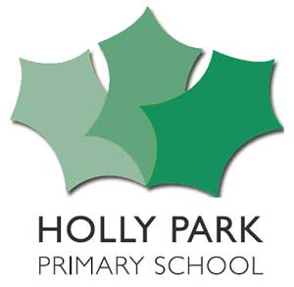

**HOLLY PARK PRIMARY SCHOOL**

**UNIFORM LIST**

**Nursery and Reception Classes**

Grey jogging bottoms

Holly Park School red polo shirt

Holly Park School red sweatshirt

Black shoes with Velcro or secure slip-ons (maximum heel height 3cm) **No trainers**

**Reception to Year 6**

**Winter**

Grey skirt, trousers or pinafore (**not** tracksuit bottoms or jeans)

Holly Park school red sweatshirt

Holly Park school red polo shirt

Red cardigan

Red or grey tights / grey or white socks

Plain black shoes (maximum heel height 3cm) **No trainers**

Plain black boots (maximum heel height 3cm)

White or black sandals with secure fastening

Red, green, white or black hair accessories

School fleece (optional and for outdoor wear only)

**Summer** As winter or -

Green and white checked dress

Grey shorts

Red cardigan

White socks

Plain black shoes **No trainers**

White or black sandals **with secure fastening** (maximum heel height 3cm)

Red, green, white or black hair accessories

School fleece (optional and for outdoor wear only)

A cap to protect from sun

\***No other items of clothing should be visible under the red polo shirt**. If a child is cold they should wear a short sleeved vest and their sweatshirt on top,

**No** zip up tops/jackets should be worn.

**No** hooded tops should be worn

**PE Kit**

PE bag

Red shorts

Plain white T-shirt

Plain white trainers

Outdoor kit of dark green jogging trousers and top

Children also need a red drawstring bag for PE kit (logo optional) **no backpacks**

**Other**

Children also need a red book bag (logo optional)

**Concert Uniform** (for members of school choirs during performances)

Grey skirt, pinafore or trousers

Plain white shirt

School tie

**All clothing and footwear should be clearly labelled with the child’s name**

**Jewellery**

Pupils should not wear jewellery to school, especially as individuals become very upset if a treasured piece of jewellery goes missing or is broken. The only acceptable items of jewellery to be worn are a wristwatch and earring studs or jewellery of a religious significance. Should a pupil have pierced ears, plain studs should only be worn. Please note that the school will be unable to take any responsibility for any jewellery that is lost.

**Make Up**

No make up is to be worn to school as it is not considered appropriate or consistent with our school uniform.

No nail varnish should be worn on nails or toes. Nail extensions, tips, gels or other products should not be worn. Nail extensions could be dangerous and are also not conducive to good handwriting or playing sport.

**Hair**

Hair should be neat and tidy and worn with no extremes of style or colour.

Long hair should be tied back during the school day. Hair accessories should only be Red, green, white or black in colour.

**Hijab**

The hijab may be worn by Muslim girls if this is their parents choice. The hijab must follow the school uniform colours and be red, green, white or black. It must be no longer than shoulder length.

We expect all pupils to follow the dress code as written above.

Branded uniform items are available from Braggs in North Finchley.

Many of the school uniform items above are readily available from supermarkets.

Braggs School Outfitters,

341 Ballards Lane,

North Finchley N12 8LJ

Tel: 020 8445 3945(about 50 metres from the Post Office)

www.braggsschoolwear.co.uk

**Holly Park Pastoral Team**

At Holly Park our aim is to provide a supportive, and friendly atmosphere for all our families and children to help everyone achieve their potential.

If there is a problem, your first point of contact should usually be your child’s class teacher or key worker. They will often be able to reassure you that the problem was dealt with appropriately, or support you with a concern. They are available in the playground most days for a quick word, or if it is a longer or more personal matter please make an appointment to see them after school.

Alternatively, or if you wish to discuss the matter further, you could speak to one of our Pastoral Team. We provide support for families and children who are facing difficulties, and work to promote effective participation in school life.

   

Miss Michael Mrs Puzey Mrs Kelly Mrs Needham

### Miss Maria Michael - Deputy Head

Miss Michael is the Deputy Head. She is also the Designated Safegiarding Lead (DSL) . She teaches children across the school and is the lead staff member for children with behavioural concerns. Miss Michael is the schools Rights Respecting Champion and is leading our use of the Restorative Justice.

### Mrs Kathy Puzey - Learning Mentor

Mrs Puzey is our Learning Mentor. Her role is to support children in overcoming barriers to learning and helps to enhance their emotional wellbeing. She works with children individually, in small groups and with whole classes to build confidence and self-esteem e.g. through Happy to be Me, Pet Therapy, and by using a solution focused approach. She offers support and organizes activities at playtime and lunchtimes with the mini-mentors. Mrs Puzey also co-ordinates our ‘Parent Gym’ sessions. Mrs Puzey is also a DSL

### Mrs Diana Kelly - Children’s Co-ordinator

Mrs Kelly is a member of the Senior Management Team and the school SENCo and Inclusion Manager. Mrs Kelly teaches classes and individuals or small groups who need extra support, and works closely with pupils who have an EHCP and their support staff. She is available to support parents who have concerns about their child’s progress. Mrs Kelly is also a DSL.

### Mrs Andrea Needham - Pupil Welfare Officer

Mrs Needham is our Pupil Welfare Officer. She looks after the medical and first aid needs of all the children in the school as well as providing emotional support to children. She deals with all attendance matters and is responsible for contacting parents when children are absent. Mrs Needham is also a DSL.

C:\Program Files (x86)\Microsoft Office\MEDIA\CAGCAT10\j0199283.wmf

Breakfast Club

[](http://www.google.co.uk/imgres?q=cereal&hl=en&safe=active&biw=1311&bih=625&tbm=isch&tbnid=hwxH35pGb140yM:&imgrefurl=http://moomilkspider.blogspot.com/2011/05/did-you-know-that-cows-love-cereal-just.html&docid=ll5TaNAhn8CL1M&imgurl=http://2.bp.blogspot.com/-cgLqnACDkU4/Tcngwan30xI/AAAAAAAAABs/fHjtwkxOMo4/s1600/cereal.jpg&w=310&h=338&ei=ptw9UfCpHcre7AaR_oEI&zoom=1&ved=1t:3588,r:55,s:0,i:249&iact=rc&dur=1168&page=3&tbnh=192&tbnw=176&start=38&ndsp=24&tx=74&ty=118)

Breakfast Club runs every school day between 7.45am and the start of school at 9am. It is open to all children from Reception to Year 6.

There is no need to book, simply turn up and register your child with a member of staff.

Breakfast is prepared on the premises by the school cook and includes cereal, toast, drinks and regular ‘specials’ such as beans on toast.

We also offer are a range of activities including board games, drawing, large construction toys, books and sports activities.

The cost is currently **£4.00 per child, per day.** (price correct September 2021)

 How To Contact Us

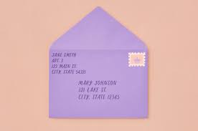 **Address:**

HOLLY PARK PRIMARY SCHOOL

Bellevue Road,

Friern Barnet,

London

N11 3HG

### [phoneme](https://www.hollyparkschool.co.uk/wp-content/uploads/2013/01/phoneme.jpg)Telephone: 020 8368 1434

## **C:\Users\User\AppData\Local\Microsoft\Windows\INetCache\Content.MSO\7AC08FF1.tmpEmail Addresses:**

* School office – [office@hollypark.barnetmail.net](mailto:office@hollypark.barnetmail.net)
* Attendance or sickness – aneedham@hollypark.barnet.sch.uk
* The Headteacher Ann Pelham – head@hollypark.barnetmail.net
* The Deputy Head Maria Michael – mmichael@hollypark.barnet.sch.uk
* You can email the children’s co-ordinator SENDCO Diana Kelly on dkelly@hollypark.barnet.sch.uk
* The Chair Of Governors – [tgraveney@hollypark.barnet.sch.uk](mailto:tgraveney@hollypark.barnet.sch.uk)
* The PTA on ptahollypark@yahoo.co.uk

Good attendance means being in school

at least **96%** of the time.

There are 365 days a year and 190 school days a year. This leaves 175 days to spend on family time, celebrations, holidays, non-urgent appointments, shopping, days out etc,

0 days absence

**100 %**

190 days attendance

10 days absence

**95 %**

180 days attendance

38 days absence

**80 %**

152 days attendance

29 days absence  **90 %**

161 days attendance

19 days absence **90 %**

171 days attendance

Good attendance Poor attendance Very poor attendance

Best chance of educational success Serious impact on education



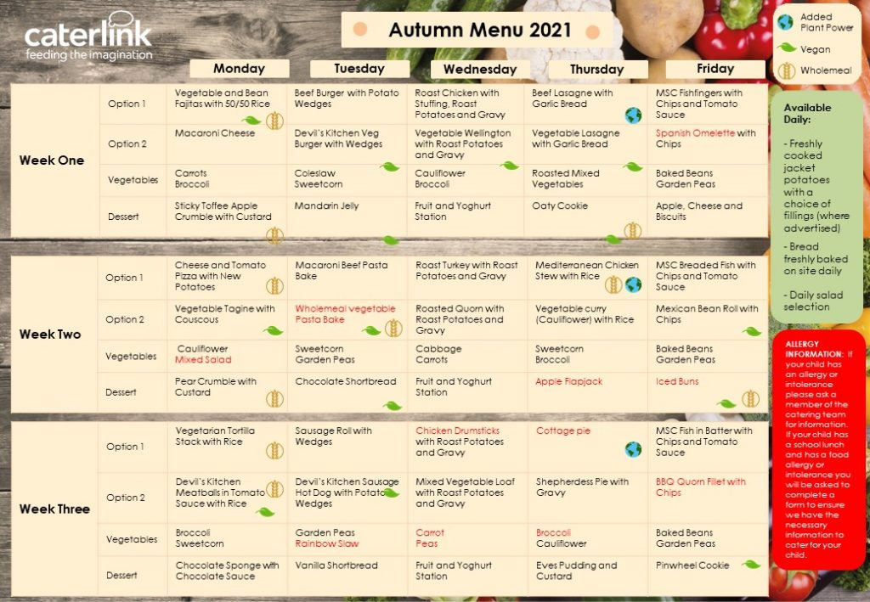

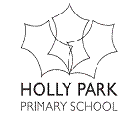

**T E R M D A T E S F O R 2021 – 2022**

**A U T U M N T E R M 2021**

Wednesday 1st September 2021: Staff Training Day, school closed

Thursday 2nd September 2021: Children return to school at 8.55am

Monday 20th September 2021: Staff Training Day, school closed

Friday 22nd October 2021: End of the first half of the Autumn Term

*Monday 25th October – Friday 29th October:* **Half Term Holiday**, school closed

Monday 1st November 2021: Children return to school at 8.55am

Friday 26th November 2021: Staff Training Day, school closed

Friday 17th December 2021: End of the Autumn Term, *school ends at 1.30pm*

*Monday 20tht December – Monday 3rd January:* **Christmas Holidays**, school closed

**S P R I N G T E R M 2022**

Tuesday 4th January 2022: Staff Training Day, school closed

Wednesday 5th January 2022: Children return to school at 8.55am

Friday 11th February 2022: End of the first half of the Spring Term

*Monday 14th February – Friday 18th February:* **Half Term Holiday,** school closed

Monday 21st February 2022: Children return to school at 8.55am

Friday 1st April 2022: End of the Spring Term, *school ends at 1.30pm*

*Monday 4th April – Monday 18th April:* **Easter Holidays**, school closed

**S U M M E R T E R M 2022**

Tuesday 19th April 2022: Children return to school at 8.55am

Monday 2nd May 2022: May Bank Holiday, school closed

Friday 27th May 2022: End of the first half of the Summer Term

*Monday 30th May – Friday 3rd June:* **Half Term Holiday**, school closed

Monday 6th June 2022: Staff Training Day, school closed

Tuesday 7th June 2022: Children return to school at 8.55am

Friday 8th July 2022 School Closed – Extra day for Queen’s Platinum Jubilee

Friday 22nd July 2022: End of the Summer Term, *school ends at 1.30pm*

** Parent Code of Conduct**

**We expect parents, carers and visitors to:**

* Respect the caring ethos of our school
* Understand that both teachers and parents need to work together for the benefit of their children.
* Demonstrate that **all** members of the school community should be treated with respect and therefore set a good example in their own speech and behaviour.
* Seek to clarify a child’s version of events with the school’s view in order to bring about a peaceful solution to any issue.
* Correct their own child’s behaviour especially in public where it could otherwise lead to conflict, aggressive behaviour or unsafe behaviour.
* Approach the school to help resolve any issues of concern.
* Avoid using staff as threats to admonish children’s behaviour.
* Avoid use of mobile phones when on the school site – e.g. when collecting or dropping off children, when talking to staff, at shows & concerts, at meetings or parent consultations.
* Collect children on time at the end of the school day or from clubs and after school care. If parents are unavoidably delayed we would expect a phone call to keep us informed.
* Dress appropriately when on school grounds.
* Take responsibility for the behaviour of other siblings who do not attend Holly Park.
* Show respect for school procedures and follow instructions at concerts, shows, sports days and other events. e.g. not talking during concerts, turning mobiles off, not putting photos/video on social media. These instructions are given in the best interests of the children and for reasons of health and safety.
* Refrain from putting images of Holly Park children (other than their own if they wish) on the internet or social media.
* Think about the health and safety of our pupils and refrain from parking or pulling up onto the zig- zags outside the school during restricted hours. They should also refrain from parking in the staff car park.

**In order to support a peaceful and safe school environment the school cannot tolerate parents, carers and visitors exhibiting the following:**

* Disruptive behaviour which interferes or threatens to interfere with the operation of a classroom, an employee’s office, office area or any other area of the school grounds including team matches.
* Using loud/or offensive language, swearing, cursing, using profane language or displaying temper.
* Threatening to do actual bodily harm to a member of school staff, governor, visitor, fellow parent/carer or pupil regardless of whether or not the behaviour constitutes a criminal offence.
* Damaging or destroying school property.
* Abusive or threatening e-mails or text/voicemail/phone messages or other written communication
* Defamatory, offensive or derogatory comments regarding the school or any of the pupils/parent/staff at the school on Facebook, Twitter, Whatsapp or other social sites. (See Appendix 1). Any concerns you may have about the school must be made through the appropriate channels by speaking to the class teacher, the Head teacher or the Chair of Governors, so they can be dealt with fairly, appropriately and effectively for all concerned.
* The use of physical aggression towards another adult or child. This includes physical punishment against your own child on school premises.
* The use of verbal aggression or abusive language towards another adult or child.
* Approaching someone else’s child in order to discuss or chastise them because of the actions of this child towards their own child.
* Smoking and consumption of alcohol or other drugs whilst on school property.
* Dogs being brought on to school premises.
* Siblings who do not attend Holly Park should not be wandering around the school playgrounds, entering school buildings or showing aggressive behaviour (physical or verbal) to other parents, pupils or staff.



**Anti-Bullying at Holly Park**

Holly Park aims to ensure that all members of the school community feel welcome, safe and happy and so are able to learn and achieve. Bullying of any kind prevents this from happening. Bullying makes people feel unsafe.

As a school, we take bullying seriously. Pupils, parents and staff should understand that reporting bullying is essential, and be assured that the school will support them fully whenever bullying is reported. It is the responsibility of all members of the school community to implement the Anti-bullying policy.

**What is Bullying?**

Bullying is not always easy to define, however most cases include:

* Constant and deliberate hostility and aggression towards a victim
* A victim who is less powerful than the bully
* An outcome which is always painful and distressing to the victim

**Our school definition of bullying is:**

“Bullying is a repetitive series of actions, carried out on purpose, and designed to hurt someone’s feelings and make them feel ashamed of who or what they are. We will not accept it at Holly Park” Holly Park School Council, April 2012

**A recent court case defined bullying as….**

‘The actions of an individual or group, that causes suffering to a less powerful individual or group – whether physical or mental – over a sustained period of time.’

**There are different kinds of bullying :**

* Physical – Pushing, kicking, hitting, pinching, any kind of physical aggression and damage to or appropriation of a person’s property
* Verbal – Name calling, tormenting, threats, threatening gestures, ridicule, humiliation or the use of put-down comments or insults e.g. with regard to another child’s family, their race, their (perceived) sexuality, gender, personal cleanliness etc, deliberately lying about what other people have done or deliberate exclusion from activities and friendship groups
* Racist – Racial taunts, graffiti and gesture
* Sexual – Unwanted physical contact, sexually suggestive comments, or homophobic comments
* On line – On line bullying is an extension of bullying behaviour. It involves technologies and online communication such as mobile phones, facebook, snap chat etc. It often involves quite a wide audience.
* More subtle forms can include nasty looks, emails, texts, anonymous phone calls and pointedly laughing/giggling at or whispering about someone. It can include intimidation and threatening behaviour, including blackmail

**The Holly Park School Council agreed that whatever its form, bullying consists of the following factors:**

* It is ongoing and frequently repetitive, and takes place over a period of time
* It is deliberate
* It is based on a difference in power (age, strength, confidence, number of friends, etc)
* It has a serious effect on the target, including feeling ashamed, feeling like they don’t want to be at school, or feeling that they wish they could disappear completely

**Effective anti- bullying practice gives all children the assurance that they are cared for in a safe and friendly environment.**

## Aims and objectives

* We aim to create a safe and secure environment where all can learn without anxiety.
* We aim to provide a consistent school response to any bullying incidents.
* We aim to make all those connected with the school aware of our opposition to bullying.
* We aim to make clear each person’s role with regard to preventing bullying at our school

## Our Anti- Bullying Charter

* We will work to ensure that everyone believes in themselves and has respect for themselves
* We will promote tolerance and respect including respect for difference and diversity
* We will take bullying seriously
* We will work to ensure that our school community knows what bullying is
* We will make sure that everyone knows that bullying is unacceptable at our school
* We will make sure that children who experience bullying know how to get help
* We will offer children who bully help to understand the consequences of their actions
* We aim to respond to bullying consistently
* We will work together to do all we can to prevent bullying at our school
* We will contribute to local and national anti- bullying events
* We underpin our responses to bullying by having
* Positive leadership from staff about how bullying is dealt with
* Periodic consultation with children to find out what bullying occurs, when, where and by whom
* Mixed age activities throughout the year – e.g Buddy systems and House Challenges
* [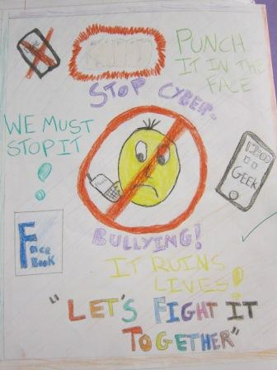](https://www.hollyparkschool.co.uk/wp-content/uploads/2016/09/Anti-bullying-5.jpg)Follow up with victims of bullying and bullies themselves

What we are doing at Holly Park

[​](https://www.hollyparkschool.co.uk/wp-content/uploads/2016/09/Anti-bullying-5.jpg)At Holly Park, we use the Restorative Approach when dealing with problems and when managing unwanted behaviour.  The emphasis of the Restorative Approach is placed on affecting real change, above the need for blame and punishment. By doing this, we are able to create an environment where children have the opportunity to reflect upon and change their behaviour.  Children feel a sense of fairness because they can explain things from their point of view and they feel listened to whilst also understanding how their behaviour has affected others.

## https://www.hollyparkschool.co.uk/wp-content/uploads/2018/10/Winners_Logo_Gold.pngAnti Bullying Award – Highest level of Award

We are an ‘All Together’ school. It is a whole school approach and makes a school reflect on how it tackles bullying. The programme offers online staff training, pupil well being audits, adjusting policies. assemblies, the restorative approach, audits, resilience programmes etc.

I am delighted to tell you that Holly Park was awarded the GOLD award for anti-bullying. The assessors said ‘Thanks for all the work you’ve done on the All Together programme. I’m very happy to let you know that you’ve done a great job of demonstrating your work to reduce bullying and we’re awarding you All Together School GOLD status’

At Holly Park we participate in Anti- Bullying week and there are opportunities for pupils to undertake work on bullying issues from EYFS to Y6. The anti- bullying message is evident.

All staff receive annual training and key staff will receive training in specialised Anti- Bullying strategies – e.g Circle of Friends, Solution focused approaches and Peer Mediation.

**To children who experience bullying:**

* We will assure them that the issue will be taken seriously
* We will intervene (informed by the victim) in a way to avoid escalating the problem
* We will monitor and review

**To those who bully:**

* We will hold them to account for their behaviour
* We will face them with the harm they have caused
* We will give direction to help them behave in ways that do not cause harm
* We will offer steps they can take to address the harm they have caused

**To the bystanders or those affected by the incident:**

* We will aim to give them skills to show them how they could have intervened effectively
* We will involve them in the reparation process
* Restorative Justice is one method of intervention we may use

**Those who have been harmed need:**

* Someone to listen
* Space to think and calm down
* Be informed of progress
* The person who has harmed them to understand and acknowledge the effect of their actions
* A sincere apology
* If possible for things to be put right
* Reassurance that it won’t happen again
* A sense of justice
* A feeling of being in control

* **Those who have caused harm need:**
* Time to think
* Someone to listen to their story
* To be able to explain themselves
* A chance to apologise
* To be able to put things right
* Reassurance that the matter is finished and that they can move on

**For restorative justice to work, all pupils should be treated with respect, there needs to be good communication, a focus on problem solving, all are involved in decisions about a way forward and there is a willingness to listen to others.**

We have an Anti Bullying Goveror.

## What to do if you think your child has been bullied

If an allegation of bullying has been brought forward by a parent, and not witnessed by the school then there will be an initial period of investigation – including observation and speaking to the children involved. The parents will be informed of the outcome. If the allegation is believed to be true then it will be dealt with as above. If it is not believed to be true then we will continue to monitor for an extended time.

In all instances an ‘Allegation of bullying’ form will be completed by the school. This includes details of what has happened, actions so far, who is involved and future actions.

After initial discussion and action (if bullying IS happening) then there will be a review approx two weeks later to see how things are progressing

If staff become aware of any bullying taking place between members of a class, they deal with the issue immediately. The staff member will inform the Deputy Head or Headteacher. There will be support for both the victim of the bullying and the bully, and punishment for the child who has carried out the bullying. We spend time talking to both children: we explain why the action was wrong, and we endeavour to help the bully change their behaviour in future. The  parents of both children are informed.

Parents are on no account to approach another child or parent without first involving the Headteacher or other Senior Staff member. Experience has shown that when the school is involved, issues and concerns are likely to be resolved with acceptable outcomes.

## Preventing Bullying – Being Pro Active

Prevention is better than cure. At Holly Park everyone is vigilant for signs of bullying and always take reports of bullying seriously. We use the following methods for recognising and preventing bullying:

* Staff will be on duty at break and lunch to ensure high level of supervision
* Strong achievement culture rewarding positive behaviour. Positive behaviour policy with clarity of behaviour expectations, sanctions and rewards
* Assemblies about bullying behaviour
* Peer mentoring – to be implemented
* Development of Social, Emotional and Behavioural Skills
* Use of Behaviour Support Plans to modify bullying behaviour
* Regular focus by the School Council focused on anti-bullying issues including organising events for anti-bullying week
* Holly Park is an official  Rights Respecting School sponsored by UNICEF

We want to teach our children the skills which will build their self-esteem and empower them to take responsibility for themselves and give them the power to practise these skills.

We want to promote pro-active strategies to prevent incidents becoming bullying.

**Do the High 5:**

* Ignore
* Talk Friendly
* Walk Away
* Talk Firmly
* Report

**Ignore:**

* Pretend you didn’t hear it.
* Do not make eye contact.
* Maintain positive body posture (calm, confident).
* Think positive self-esteem statements.
* Count to five in your head slowly.
* Take deep breaths.

**Talk Friendly:**

* Use a calm voice.
* Maintain eye contact.
* Confident body language.
* Maintain relatively close body proximity.
* Use “I” statements – I feel ……. when you…….. because……..

**Walk Away:**

* Stand tall, head up high.
* Mouth closed.
* Look confident
* Do not use eye contact.
* Walk somewhere, preferably towards a congested area or to a safety zone (teacher).
* Do not look back. Walk confidently, don’t run.

**Talk Firmly:**

* As per Talk Friendly.
* Use an assertive voice, slightly raised.
* Tell them to stop it.
* Re-state your “I” statement. eg. I said…….
* State the consequences of continued bullying.

**Report:**

* Walk away and tell a staff member.
* Go to a safety zone.
* Bystanders – support and report.
* Report, report, report until somebody listens

## What can children do if they are worried about bullying?

Where children are the targets of bullying behaviour, they have several options:

* To tell a trustworthy friend
* To tell a trusted adult, such as a member of staff or a parent
* To tell a House Captain or School Council representative
* To stand up to the person who is using bullying behaviour and tell them to stop
* To put a note in the Worry Box

When children witness or are aware that bullying behaviour is happening, it is their duty to do something about it. Although this situation can be hard, they need to support the child who is being upset or intimidated. This will mean they need to:

* Tell their teacher
* Tell another member of staff
* Tell their parents or another trusted adult

Children who use bullying behaviour may often need additional support themselves, as it is often a sign of unhappiness, insecurity or loneliness. This does not, however, justify the use of such damaging behaviour against others. If a child is identified as a bully, then it is highly likely that their parents will be invited in to help provide support, and to be told of their child’s behaviour.

**You can read Holly Park’s**[**Anti-Bullying policy**](https://www.hollyparkschool.co.uk/wp-content/uploads/2018/07/Anti-bullying-policy.docx) **in full on the school website**

Other suggested Websites

[www.anti-bullyingalliance.org.uk](http://www.anti-bullyingalliance.org.uk/)

[www.cybermentors.org.uk](http://www.cybermentors.org.uk/)

[www.kidscape.org.uk](http://www.kidscape.org.uk/)

[www.saferinternet.org.uk](http://www.saferinternet.org.uk/)

[www.childline.org.uk](http://www.childline.org.uk)

** GDPR privacy notice for pupils and their families**

**Who processes your information?**

Holly Park is the data controller of the personal information you provide to us. This means the school determines the purposes for which, and the manner in which, any personal data relating to pupils and their families is to be processed. **Ann Pelham** acts as a representative for the school with regard to its data controller responsibilities; she can be contacted on 02083681434 or head@hollypark.barnetmail.net

In some cases, your data will be outsourced to a third party processor; however, this will only be done with your consent, unless the law requires the school to share your data. Where the school outsources data to a third party processor, the same data protection standards that Holly Parkupholds are imposed on the processor.

**Darrell Smith (from TURN IT ON)** is the data protection officer. Their role is to oversee and monitor the school’s data protection procedures, and to ensure they are compliant with the GDPR. The data protection officer can be contacted on 01865 597620 (Option 3) email - dpr@turniton.co.uk

**Why do we collect and use your information?**

Holly Parkholds the legal right to collect and use personal data relating to pupils and their families, and we may also receive information regarding them from their previous school, LA and/or the DfE. We collect and use personal data in order to meet legal requirements and legitimate interests set out in the GDPR and UK law, including those in relation to the following:

* Article 6 and Article 9 of the GDPR
* Education Act 1996
* Section 3 of The Education (Information About Individual Pupils) (England) Regulations 2013

In accordance with the above, the personal data of pupils and their families is collected and used for the following reasons:

* To support pupil learning
* To monitor and report on pupil progress
* To provide appropriate pastoral care
* To assess the quality of our service
* To comply with the law regarding data sharing

**Which data is collected?**

The categories of pupil information that the school collects, holds and shares include the following:

* Personal information – e.g. names, pupil numbers (Unique Pupil Number UPN) and addresses
* Characteristics – e.g. ethnicity, language, nationality, country of birth and free school meal / Pupil Premium eligibility
* Attendance information – e.g. number of absences and absence reasons
* Assessment information – e.g. national curriculum assessment results
* Relevant medical information including allergies
* Information relating to SEND (Special Educational Needs and Disabilities)
* Behavioural information – e.g. number of temporary or fixed term exclusions
* Safeguarding Information (including court orders and professional involvement)
* Permissions information – e.g films, local area walks, trips, use of Internet
* Photographs

**Collecting Pupil Information**

Whilst the majority of the personal data you provide to the school is mandatory, some is provided on a voluntary basis. When collecting data, the school will inform you whether you are required to provide this data or if your consent is needed. Where consent is required, the school will provide you with specific and explicit information with regards to the reasons the data is being collected and how the data will be used.

**How long is your data stored for?**

Personal data relating to pupils at Holly Park Schooland their families is stored in line with the school’s GDPR Data Protection Policy.

In accordance with the GDPR, the school does not store personal data indefinitely; data is only stored for as long as is necessary to complete the task for which it was originally collected.

**Will my information be shared?**

The school is required to share pupils’ data with the DfE on a statutory basis,

We do not share information about our pupils with anyone without consent unless the law and our policies allow us to do so.

We share pupils’ data with the Department for Education (DfE) on a statutory basis. This data sharing underpins school funding and educational attainment policy and monitoring.

We are required to share information about our pupils with our local authority (LA) and the Department for Education (DfE) under section 3 of The Education (Information About Individual Pupils) (England) Regulations 2013.

This includes the following:

* Names, DOB, UPN for assessment registration
* Name, DOB, UPN number, address, ethnicity, religion, language, country of birth, FSM entitlement, proficiency in English, Pupil premium entitlement, gender, nationality, service child information, SEND information, attendance data and exclusion information for the school census.

To find out more about the data collection requirements placed on us by the Department for Education (for example; via the school census) go to <https://www.gov.uk/education/data-collection-and-censuses-for-schools>.

The National Pupil Database (NPD) is managed by the DfE and contains information about pupils in schools in England. Holly Park School is required by law to provide information about our pupils to the DfE as part of statutory data collections, such as the school census; some of this information is then stored in the NPD. The DfE may share information about our pupils from the NDP with third parties who promote the education or wellbeing of children in England by:

* Conducting research or analysis.
* Producing statistics.
* Providing information, advice or guidance.

The DfE has robust processes in place to ensure the confidentiality of any data shared from the NDP is maintained.

We are required by law, to provide information about our pupils to the DfE as part of statutory data collections such as the school census and early years’ census. Some of this information is then stored in the NPD. The law that allows this is the Education (Information About Individual Pupils) (England) Regulations 2013.

To find out more about the NPD, go to <https://www.gov.uk/government/publications/national-pupil-database-user-guide-and-supporting-information>.

The department may share information about our pupils from the NPD with third parties who promote the education or well-being of children in England by:

* conducting research or analysis
* producing statistics
* providing information, advice or guidance

The Department has robust processes in place to ensure the confidentiality of our data is maintained and there are stringent controls in place regarding access and use of the data. Decisions on whether DfE releases data to third parties are subject to a strict approval process and based on a detailed assessment of:

* who is requesting the data
* the purpose for which it is required
* the level and sensitivity of data requested: and
* the arrangements in place to store and handle the data

To be granted access to pupil information, organisations must comply with strict terms and conditions covering the confidentiality and handling of the data, security arrangements and retention and use of the data.

For more information about the department’s data sharing process, please visit: <https://www.gov.uk/data-protection-how-we-collect-and-share-research-data>

For information about which organisations the department has provided pupil information, (and for which project), please visit the following website: <https://www.gov.uk/government/publications/national-pupil-database-requests-received>

To contact DfE: <https://www.gov.uk/contact-dfe>

Holly Park will not share your personal information with any third parties without your consent, unless the law allows us to do so. The school routinely shares pupils’ information with:

* Pupils’ destinations upon leaving the school
* The Local Authority
* The Department for Education (DfE)
* The NHS

The information that we share with these parties includes the following:

* Name, DOB, UPN number, address, ethnicity, religion, language, country of birth, FSM entitlement, proficiency in English, Pupil premium entitlement, gender, nationality, service child information, SEND information, attendance data and exclusion information

For reasons of efficiency and communication, the school will share personal information with your consent with:

* Teachers to parents text service – this will be your mobile number and e-mail address
* School money – this will be your e-mail address

## Requesting access to your personal data

Under data protection legislation, parents and pupils have the right to request access to information about them that we hold. To make a request for your personal information, or be given access to your child’s educational record, contact the school office – 02083681434 or office@hollypark.barnetmail.net

**What are your rights?**

Parents and pupils have the following rights in relation to the processing of their personal data.

You have the right to:

* Be informed about how Holly Parkuses your personal data.
* Request access to the personal data that Holly Parkholds.
* Request that your personal data is amended if it is inaccurate or incomplete.
* Request that your personal data is erased where there is no compelling reason for its continued processing.
* Request that the processing of your data is restricted.
* Object to your personal data being processed.

Where the processing of your data is based on your consent, you have the right to withdraw this consent at any time.

If you have a concern about the way Holly Park and/or the DfE is collecting or using your personal data, you can raise a concern with the Information Commissioner’s Office (ICO). The ICO can be contacted on 0303 123 1113, Monday-Friday 9am-5pm.

**Where can you find out more information?**

If you would like to find out more information about how we and/or the DfE collect, use and store your personal data, please visit our website to download our [GDPR Data Protection Policy](https://www.theschoolbus.net/article/gdpr-data-protection-policy/4575).