Y3 Multiplication Tables Spring Term 2

Dear Y3 parents

As you know, your children are preparing for the national multiplication test in Year 4. There are many times tables to learn so we have chunked it up into smaller groups to learn at one time.

Last term the children revised the 2,5 and 10 times tables as well as the 3 and 4 times tables.

This half term the test before Easter will be on the 11 times tables as well as revising the other times tables (2x, 5x, 10x, 3x, 4x and 8x).

The children will also be revising ALL of the tables that they have learned so far.

So far the children should know: 2, 5, 10, 3, 4 and 8 times tables.

The test will involve quick fire questions in a random order and with the tables muddled up.

Please help your child to practice these regularly at home several times a week.

Remember to use Times Tables Rock Stars to practise times tables as often as you can.

11 x table
0x11=0
1x11=11
2x11=22
3x11=33
4x11=44
5x11=55
6x11=66
7x11=77
8x11=88
9x11=99
10x11=110
11x11=121
12x11=132

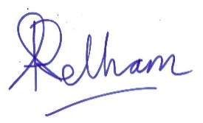
Ann Pelham
Headteacher

