Learning Project - Mountains
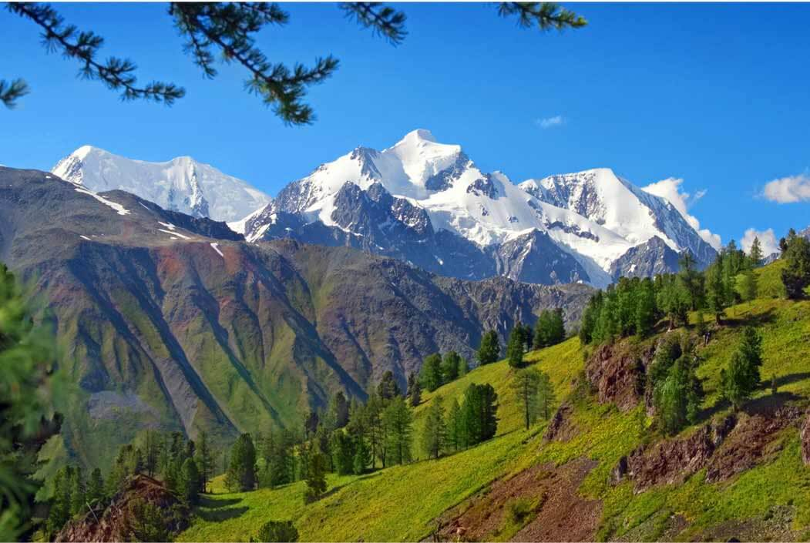
Dear Families,
Welcome to the Spring term in Year 6. This term our topic is mountains and geography will be our key focus. We will be comparing and contrasting various mountain ranges from different continents around the world. Please see below for how this links to different areas of the curriculum.
Best wishes Emily Sampson and Dominic Carini
Science | Maths |  | English - writing
Living things and their habitats  -Classifying living things into groups based on shared characteristics  - Understanding the classification groups of animals (vertebrates and invertebrates), plants and microorganisms. | Decimals  Percentages  Algebra  Converting Units of Measure  Perimeter, Area and Volume  Ratio |  | Shackleton’s Journey by William Grill. Non-fiction:  Writing log-books.  Job Applications.  Fact-files.  Persuasive writing  Newspaper Reports  Poetry – The Dreadful Menace  Performance poetry  List poems  Writing poetry in groups and as individuals.
English - Grammar | English - Spelling | PSHE | RE
Tenses (past and present progressive, past and present progressive)  Active and Passive Voice.  Subordinate and main clauses.  Synonyms and Antonyms | National curriculum Y5/6 words  Topic words  The suffix ‘ough’  The suffix ‘cial’ and ‘tial’  Homophones  The suffix ‘ant’ ‘ance’ ‘ancy’ | Health and Wellbeing:  Immunisation & Vaccination  Keeping Safe in the sun  The risks, laws and effects of drugs | Sacred Texts –  The core sacred texts from various religions. Why are they important and what can we learn from them? We will be making comparisons and seeing how the values they promote may fit into our own lives.
Computing | PE | Geography
Using the internet for research purposes  Creating presentations using different software packages  Coding  Online Safety | Indoor PE  Gymnastics: Synchronisation & Canon  Outdoor PE  Invasion Games:  Tag Rugby | Generally, children will learn about the physical characteristics of mountains and use atlases and maps to identify various ranges from around the world. They will then be carrying out a case study on Mount Everest.  Pupils will also be learning about volcanoes and how they erupt.  In the second half of term we will be comparing different countries and continents – studying the physical characteristics and land around the Grand Canyon and the Alps.
Art & Design | Design & Technology | Spanish | Links with Children’s Rights
Painting:  Famous painter case study  Primary, secondary and tertiary colours  Tints, tones and shades  Brush techniques | Food:  Hygiene  Food from around the world  Healthy Eating  Food preparation  Food production  Sheet Materials | To write a letter in Spanish  To exchange information: name, age, birthday, where you live, pets, family  To learn about a Spanish school / Spanish culture  To recognise different festivals celebrated in Spain  To put together a booklet about different festivals celebrated at Holly Park | 13: Children have the right to share freely with others what they learn, think and feel, by talking, drawing, writing or in any other way.  17: Children have the right to get information from the Internet, radio, television, newspapers, books and other sources.  29: Children’s education should help them fully develop their personalities, talents and abilities.
Trips/Curriculum Days | Key Dates for this year group this term | PE Days & Homework Days | Other information
12th January – rescheduled trip to Science Museum.  31st March – Curriculum Day, Art. | 17th January – Meeting for Parents Regarding Sex Education.  21st January – Pupils Workshop on Social Media | Wednesday – indoor PE  Friday – Outdoor PE.  Homework – Friday to Friday

