Learning Project - Ancient Greece
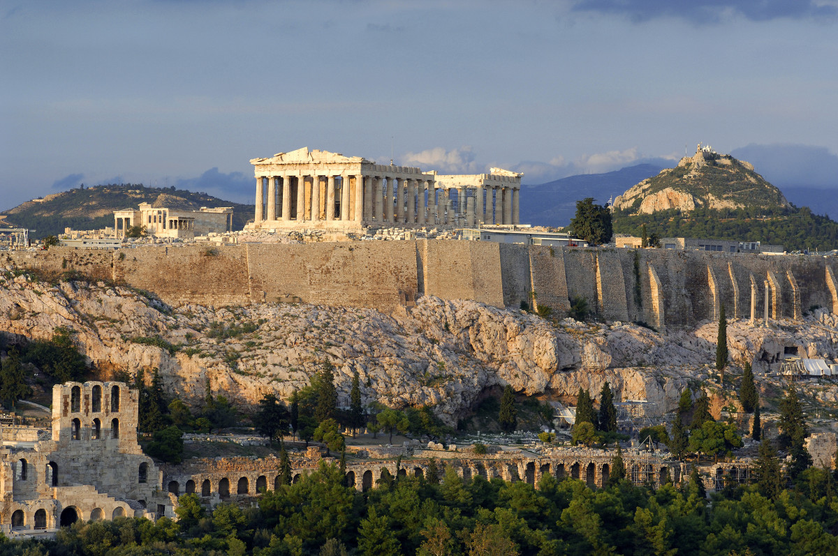
Dear Parents/Carers,
Welcome to the Spring term in Year 5. For our topic this term we will be studying Ancient Greece. This will be linked to history for the first half of term and geography for the second. Please see below for how this will link to different areas of the curriculum. Best wishes Mr French & Miss Boahene
Science | Maths |  | English - writing
Forces: magnetism, air resistance, water resistance gravity.  Materials: Compare and group materials e.g. hardness, softness, solubility, conductivity (electrical and thermal) and response to magnets. | Multiplying 3 digits by 2 digits  Dividing with remainders  Finding equivalent fractions  Converting from mixed numbers to improper fractions  Finding missing numbers and creating and expanding number sequences  Comparing and ordering fractions  Adding and subtracting fractions | Adding and subtracting mixed numbers  Finding fractions of amounts  Decimals up to 2 dp  Decimals as fractions  Comparing and ordering decimals  Rounding decimals  Understanding percentages  Percentages as fractions and decimals  Finding equivalent F.D.P. | Myths:  Studying some Greek myths and then writing our own.  The Adventures of Odysseus (key text):  Writing in role, drama, story predictions, newspaper reports, character studies.  Guided Reading Text:  Who Let the Gods Out by Maz Evans
English - Grammar | English - Spelling | PSHE | RE
Contractions, suffixes, relative clauses, parenthesis, apostrophes for possession and contractions. | Homophones.  Topic and national curriculum words. | Healthy lifestyles: the importance of physical and mental health.  Puberty: Physical and emotional changes.  First Aid training. | Religion, family and worship. What do special places mean to us? The variety of forms and symbols within religion. Places of worship and the variety of acts of worship that happen within them.
Computing | PE | History | Geography
Understanding that programming is a sequence of instructions written to perform a task  Creating and changing a program  Testing a program or set of commands to check how well the code works  Internet safety. | Outdoor:  Tag Rugby (Non-Stop Action)  Athletics  Indoor:  Dance  Gymnastics (Non-Stop Action) | Studying various aspects of life in Ancient Greece including; everyday life, war, religion, theatre, philosophy and the Olympics. The influence of Ancient Greece in the modern world. | Atlas skills: naming and locating countries in Europe; focusing on major cities and including major physical and human characteristics. Studying Athens; comparing and contrasting this with London.
Art & Design | Design & Technology | Spanish | Links with Children’s Rights
The skills of creating artwork (storm at sea) including painting and overlaying different fabrics. | Designing a pop-up book.  Gaining knowledge of different breads from around the world.  Planning and adapting a recipe for a flat bread. | To know about Spanish speaking countries and find them on a map.  To do a presentation about a Spanish speaking country. | Article 17- access to information  Article 24- health, water food and environment  Article- 28- access to education  Article 30- minority, culture, language and religion
Trips/Curriculum Days | Key Dates for this year group this term | PE Days & Homework Days
Wednesday 2nd March – Watch performance at Friern Barnet School.  Wednesday 16th March – Trip to the National Gallery. | 21st March – Rights workshop for parents. | First half term:  Outdoor PE – Monday  Indoor PE – Friday  Second half term:  Indoor PE - Monday  Outdoor PE – Thursday | Homework goes home on Thursday to be returned by the following Wednesday.

