Y3 Multiplication Tables Spring Term 1

Dear Y3 parents

As you know, your children are preparing for the national multiplication test in Year 4. There are many times tables to learn so we have chunked it up into smaller groups to learn at one time.

Last term the children revised the 2,5 and 10 times tables as well as the 3 and 4 times tables.

This half term the test before half term will be on the 8 times tables.

The test will involve quick fire questions in a random order and with the tables muddled up.

Please help your child to practice these regularly at home several times a week.

8 x Table
0x8=0
1x8=8
2x8=16
3x8=24
4x8=32
5x8=40
6x8=48
7x8=56
8x8=64
9x8=72
10x8=80
11x8=88
12x8=96

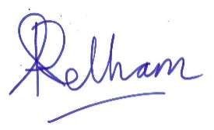
Ann Pelham
Headteacher

