Pupil premium strategy statement

This statement details our school’s use of pupil premium (and recovery premium for the 2021 to 2022 academic year) funding to help improve the attainment of our disadvantaged pupils.

It outlines our pupil premium strategy, how we intend to spend the funding in this academic year and the effect that last year’s spending of pupil premium had within our school.

School overview
Detail | Data
School name | Holly Park School
Number of pupils in school | 439
Proportion (%) of pupil premium eligible pupils | 19%
Academic year/years that our current pupil premium strategy plan covers  (3 year plans are recommended) | 2021/2022
Date this statement was published | December 2021
Date on which it will be reviewed | September 2022
Statement authorised by | Ann Pelham  Headteacher
Pupil premium lead | Sally Thomas
Governor
Funding overview
Detail | Amount
Pupil premium funding allocation this academic year | £116,325
Recovery premium funding allocation this academic year | £12,035
Recovery Reset and Renaissance project funding allocation | £3,475
Pupil premium funding carried forward from previous years | £0
Total budget for this academic year | £131,835

Part A: Pupil premium strategy plan

Statement of intent
- At Holly Park, we have high aspirations for all our children and we believe that all learners, irrespective of their background or the challenges they face, should make good progress and achieve or exceed the Age Related Expectations in all subject areas by the end of KS2. The focus of our Pupil Premium Strategy is to support disadvantaged pupils to achieve the knowledge, skills and values needed to achieve this goal.

- Our pupils in receipt of the Pupil Premium funding face specific challenges to reaching their full potential, and, at Holly Park we are determined to provide the support and guidance they need to help them overcome these challenges.

Common barriers to learning for our disadvantaged children are; weak language and communication skills, lack of confidence and self-esteem, limited enrichment opportunities, less support at home, low levels of education and aspiration amongst families, complex family circumstances, emotional, behavioural and social difficulties which impact on focus to learning, less parental engagement with school and attendance issues.

We acknowledge when making provision for socially disadvantaged children, that not all children who are entitled to free school meals are socially disadvantaged. We also recognise that not all children who are socially disadvantaged are registered or qualify for free school meals. We reserve the right to allocate the Pupil Premium funding to support any child or groups of children the school has legitimately identified as being socially disadvantaged. Pupil premium funding will be allocated following a needs analysis and a provision map of support is updated each term.

- In addition to this, we aim to provide all our pupils with a rich, broad and balanced
- curriculum as well as enrichment opportunities to develop pupils’
- cultural capital. High quality teaching is at the heart of our approach, with a focus on ensuring that teaching and learning builds upon children’s prior knowledge and
- provides progression of knowledge and skills. Our curriculum is designed to build
- fluency and secure long-term memory through opportunities for practice and retrieval. We use Rosenshine’s Principles and the Tom Sherrington WalkThrus to ensure quality first teaching for all children.

After potential barriers to learning have been identified, we use research-based interventions and carefully targeted support to address them. Research conducted by the EEF is used to support decisions around the usefulness of different strategies and their value for money.

- Our strategy is also integral to wider school plans for education recovery, notably in its targeted support through the National Tutoring Programme and School Led Tutoring Programme for pupils whose education has been worst affected by the pandemic.

- Our ultimate objectives are:
- To diminish the attainment gap between disadvantaged and non-disadvantaged children.
- Disadvantaged children to make good or rapid progress from their starting points.
- To support our children’s health and wellbeing to enable them to regulate their emotional state and access learning at an appropriate level.
- To adopt a whole school approach in which all staff take responsibility for disadvantaged pupils’ outcomes and raise expectations of what they can achieve.
- To ensure that teaching and learning opportunities meet the needs of all learners
- All children to leave the school fully prepared for the next stage of their learning.

Using Pupil Premium spending effectively means we can focus on diminishing the gap through; high-quality teaching and targeted support (both academic and social/emotional) Our approach will be responsive to common challenges and individual needs, rooted in robust assessment, not assumptions about the impact of disadvantage

Challenges

This details the key challenges to achievement that we have identified among our disadvantaged pupils.
Challenge number | Detail of challenge
1 | Underdeveloped language and communication skills and vocabulary gaps in EYFS (although this is no worse than non PP children)
2 | Greater difficulties with phonics. (Year 2 2021 final check PP = 81.8% pass and Year 2 not PP = 91.3% pass Year 1 initial practice Aut 2021 PP = 9.09% pass and Year 1 not PP = 23.9% pass)
3 | Attainment gaps in Reading, Writing & Maths.  Children attaining EXS+ (Y1-6) Autumn term data  Reading Non PP 71% PP 53% (18% difference)  Writing NonPP 68% PP 43% (25% difference)  Maths NonPP 75% PP 61% (14% difference)
4 | Multiple barriers to learning e.g. SEND (33% of our PP children are also SEND)
5 | Limited wider cultural and social experiences.
6. | Social, emotional and behaviour issues (slightly more PP children had behaviour alerts in Aut 2021 than non PP)

Intended outcomes
This explains the outcomes we are aiming for by the end of our current strategy plan, and how we will measure whether they have been achieved.
Intended outcome | Success criteria
Improved oral language skills and vocabulary among EYFS disadvantaged children. | - Assessments and observations indicate improved oral language among EYFS children. This is evident when triangulated with other sources of evidence, including engagement in lessons, book scrutiny and ongoing formative assessment.  - Progress in Communication and Language at end of Reception is good or rapid
Improved reading, writing and maths attainment for disadvantaged children in KS1 and KS2. | - Reading, writing and maths outcomes show that 75% of disadvantaged children met the expected standard.
The vast majority of Disadvantaged pupils make at least expected progress | - Reading, writing and maths outcomes show that 80% of disadvantaged children make good progress
The number of disadvantaged children meeting the expected standard in the phonics screening check at the end of Year 1 is in line with the national average. | - End of Year 1 phonics outcomes show that 70% met the expected standard.
Disadvantaged children make expected progress from their starting points in reading, writing and maths. | - Progress in reading, writing and maths is at least expected
Best possible progress and attainment for PP children with additional barriers e.g. SEND through effective EHCP, Support Plans and targeted provision. | - Good individual progress for disadvantaged and SEND learners from their starting points.
Achieve and sustain improved wellbeing for all children in our school, particularly our disadvantaged children. | - Qualitative data from child’s voice, child and parent questionnaires and teacher observations  - Good attendance of PP parents at Meet the Teacher, Parents Evening, online parent workshops etc
Widen cultural and social experiences of our disadvantaged children to support and enhance learning and development. | - Work samples, Pupil Voice, child conferences etc show disadvantaged children have positive attitudes towards school and learning.

Activity in this academic year
This details how we intend to spend our pupil premium (and recovery premium funding) this academic year to address the challenges listed above.

Teaching (for example, CPD, recruitment and retention)
Budgeted cost: £63,699.25
Activity | Evidence that supports this approach | Challenge number(s) addressed
Pupil Premium targeted support by class teachers  PP pupils become a key focus group for teachers and the pupils’ next steps are targeted through one a week guided focus groups. Pre teaching and recap of unmet L.Os are covered.  In these sessions, class teachers to hold weekly pupil conferences with PPG pupils to discuss current learning and next steps.  The rest of the class is covered by an experienced teacher while this happens | Pupil Premium research project within NLC schools found that verbal feedback/ pupil conferencing had highest impact on progress of PP children.  Class teachers are in the best position to know what the next steps are for each child on a week-to-week basis. Prior  assessment ensures that appropriate  targets are set. | 1,2,3,4
Phonics resources  Purchase of Bug Club DfE validated Systematic Synthetic Phonics reading books to support our phonics programme in school and secure stronger phonics teaching for all pupils.  Purchase resources and fund ongoing teacher and TA training and release time | Phonics approaches have a strong evidence base that indicates a positive impact on the accuracy of word reading (though not necessarily comprehension), particularly for disadvantaged pupils:  Phonics | Toolkit Strand | Education Endowment Foundation | EEF | 1,2, 3
NCETM Project EYFS & KS1  Enhancement of our maths teaching and curriculum planning in line with DfE and EEF guidance.  Teacher training in Number sense project in EYFS & KS1  We will fund teacher release time to access Maths Hub resources and CPD | The DfE non-statutory guidance has been produced in conjunction with the National Centre for Excellence in the Teaching of Mathematics, drawing on evidence-based approaches:  Maths_guidance_KS_1_and_2.pdf (publishing.service.gov.uk) | 3
Increased Book Provision  Ensuring that there are a wide variety of books available across the school for all children to read. To develop a love and enjoyment of reading. To increase the diversity of the books on offer so that they reflect our school community. | EEF guidance on improving literacy  The report suggests that schools should support pupils to develop fluent reading capabilities. Most pupils benefit from emphasis on reading fluency.  https://educationendowmentfoundation.org.uk/education-evidence/guidance-reports/literacy-ks2 | 3,4,5,6
Focus On Quality First Teaching  To further develop teacher pedagogy through the Teaching WalkThrus programme of instructional coaching. Focus on embedding opportunities for practice and retrieval across all curriculum areas to ensure knowledge is secured in pupils’ long term memory. | High quality teaching improves pupil  outcomes, and effective professional  development offers a crucial tool to  develop teaching quality and enhance children’s outcomes in the classroom.  https://d2tic4wvo1iusb.cloudfront.net/eef-guidance-reports/effective-professional-development/EEF-Effective-Professional-Development-Guidance-Report.pdf | 1,2,3,4
Improved Subject leader Knowledge  Subject leader files from Helen Youngman to support & prepare for an Ofsted Deep dive – focus on curric development and inclusion.  Subject leader 1:1 sessions with LNI  Subject Leader Inset | EEF Effective professional Development  Supporting high quality teaching is pivotal in improving children’s outcomes. Indeed, research tells us that high quality teaching can narrow the disadvantage gap. PD plays a crucial role in improving classroom practice and pupil outcomes. The report suggests that PD should ensure that professional development effectively builds knowledge, motivates staff, develops teaching techniques, and embeds practice.  It should take into consideration the context and needs of the school.  https://educationendowmentfoundation.org.uk/education-evidence/guidance-reports/effective-professional-development | 3,4,5

Targeted academic support (for example, tutoring, one-to-one support structured interventions)
Budgeted cost: £43,394.75

Activity | Evidence that supports this approach | Challenge number(s) addressed
Barnet Language Enrichment Programme  Programme led by a dedicated qualified speech and language therapist. . The LEP focusses on how to improve pupils' oracy and language through vocabulary, narrative skills and social communication. Provides schools with expertise to support groups of pupils with lower level speech and communication needs who are likely to benefit from some additional structured speech, vocabulary and social communication input. | Oral language interventions can have a positive impact on children’s language skills. Approaches that focus on speaking, listening and a combination of the two show positive impacts on attainment:  Oral language interventions | EEF (educationendowmentfoundation.org.uk) | 1,2,3
Teaching Assistant Support  Additional phonics sessions targeted at disadvantaged pupils who require further phonics support. | Phonics approaches have a strong evidence base indicating a positive impact on children, particularly from disadvantaged backgrounds. Targeted phonics interventions have been shown to be more effective when delivered as regular sessions over a period up to 12 weeks:  Phonics | Toolkit Strand | Education Endowment Foundation | EEF | 2, 3
Teaching Assistant Support  Additional sessions in reading targeted at disadvantaged children who require further support.  - 1:1 reading support  - Small group reading | Research on TAs delivering targeted interventions in one-to-one or small group settings shows a consistent impact on attainment of approximately three to four additional months’ progress  Working in small groups:  Small group tuition | Toolkit Strand | Education Endowment Foundation | EEF | 2, 3,
Third Space Learning Maths Tuition  Engaging with the National Tutoring Programme to provide a blend of tuition, Tutoring for children whose education has been most impacted by the pandemic. | Tuition targeted at specific needs and knowledge gaps can be an effective method to support low attaining children or those falling behind, both one-to-one:  One to one tuition | EEF (educationendowmentfoundation.org.uk)  And in small groups:  Small group tuition | Toolkit Strand | Education Endowment Foundation | EEF | 3
School Led tutoring (School to fund 25% top up funding)  Engaging with the School-Led Tutoring Programme for pupils whose education has been most impacted by the pandemic. | Tuition targeted at specific needs and knowledge gaps can be an effective method to support low attaining pupils or those  falling behind, both one-to-one,  One to one tuition | EEF (educationendowmentfoundation.org.uk)  and in small groups:  Small group tuition | Toolkit Strand | Education Endowment Foundation | EEF | 3

Wider strategies (for example, related to attendance, behaviour, wellbeing)
Budgeted cost: £24,798.88

Activity | Evidence that supports this approach | Challenge number(s) addressed
Learning Mentor Interventions  Improve the quality of social and emotional learning through various smaller groups and wider curriculum opportunities. | There is extensive evidence associating childhood social and emotional skills with improved outcomes at school and in later life (e.g., improved academic performance, attitudes, behaviour and relationships with peers):  and  Collaborative learning approaches.  A collaborative (or cooperative) learning approach involves pupils working together on activities or learning tasks in a group small enough to ensure that everyone participates. Pupils in the group may work on separate tasks contributing to a common overall outcome, or work together on a shared task.  https://educationendowmentfoundation.org.uk/education-evidence/teaching-learning-toolkit/collaborative-learning-approaches | 3, 4,5,6
Wider Curriculum  All disadvantaged children attend school trips, take part in the wider curriculum aspect of school life and are offered the opportunity to attend extra-curricular clubs beyond school hours to support learning and development and enhance social and cultural experiences. | Children need to feel included and have a sense of belonging to their school community. It is important that all children have equal access to enrichment opportunities regardless of economic background. | 4,5,6
HEWS  1:1 Long term and short term HEWS support led by Consellor | - Children are able to plan and prepare for changes and learn ways to  regulate their emotional states.  - Support from the HEWS Counsellor  enables teachers to implement  strategies in class that support pupils’ attachment needs. Transitions  between from home to school have been successfully managed and so children are ready to learn when they enter the classroom.  EEF_Social_and_Emotional_Learning.pdf(educationendowmentfoundation.org.uk) | 1,2,3,4,6
ELSA Project  Emotional Literacy Support Assistants (ELSA)  Programme | ELSA Evaluation Report by Education Psychology Service shows that pupils receiving ELSA support highlighted the importance of being able to share their feelings safely and confidentially with adults who have time to listen to them. Support over time leads to the  development of trust in which the  possibility of behavioural change can be explored in a non-threatening way.  Analysis of post ELSA intervention has shown that teachers observed a decrease in perception of emotional difficulties; behaviour concerns and peer problems, and an increase in  pro-social behaviour was also observed.  EEF_Social_and_Emotional_Learning.pdf(educationendowmentfoundation.org.uk) | 6
To further develop  cultural capital:  A range of enrichment opportunities e.g. Forest School sessions, Y5 and Y6 residential trips  RRR project with partnership of schools:  Y5 Coding Clubs (spring & Autumn)  Y4 Performance Activities  Y5 Coding Clubs (summer) | Research by Sutton Trust shows that the wealthiest families in the UK spend more than 7 times the amount on out of school enrichment than the most disadvantaged families. Sutton Trust recommend that schools use their Pupil Premium budget to develop PPG children’s cultural  capital by ensuring these children have access to museums, galleries, libraries & theatres to enrich their learning.  Increased engagement in lessons as a result of an increase in confidence.  Improved emotional well-being through having the opportunity to have a wider range of experiences | 5,6
Mini First Aid Healthy Minds workshops  As well as teaching children about how to keep themselves physically safe and well, these weekly sessions over 10 weeks also teach that mental wellbeing is a normal and important part of daily life. The aim is to help children be more aware of the importance of a Healthy Mind. | EEF guidance – prioritise social and emotional Learning  Effective social and emotional learning (SEL) can increase positive pupil behaviour, mental health and well-being, and academic performance.  The report stresses this is especially important for children from disadvantaged backgrounds and other vulnerable groups, who, on average, have weaker SEL skills at all ages than their better-off classmates.  https://educationendowmentfoundation.org.uk/news/prioritise-social-and-emotional-learning | 6
Supporting Parents with the curriculum  Times Tables Rockstars annual subscription for learning at home  Workshops/meetings for parents x 12 annually to explain elements of the curriculum  Establish parent champions | EEF WORKING WITH PARENTS TO SUPPORT CHILDREN’S LEARNING  Guidance Report  Provide practical strategies to support learning at home  Supporting early language and literacy  Tailor school communications to encourage positive dialogue about learning  The age of learners affects the nature of the messages  Be positive, personalise, and link to learning  Offer more sustained and intensive support where needed  Target support sensitively  https://educationendowmentfoundation.org.uk/public/files/Publications/ParentalEngagement/EEF_Parental_Engagement_Guidance_Report.pdf | 1,2,3

Total budgeted cost: £131,892.88

Part B: Review of outcomes in the previous academic year

Pupil premium strategy outcomes
This details the impact that our pupil premium activity had on pupils in the 2020 to 2021 academic year.
Due to COVID 19, and the disruption to education, it has been very difficult to assess the impact of the PP funding this academic year.

Reception
- GLD
Due to Lockdown and COVID 19 the Reception profile was cancelled so there is no data for this

Year 1 Phonics
Due to Lockdown and COVID 19 the Y1 Phonics Check was cancelled so there is no data for this

End of KS1
Year 2
Due to Lockdown and COVID 19 the KS1 National assessments were cancelled so there is no data for this

End of KS2
Year 6
Due to Lockdown and COVID 19 the KS2 National assessments were cancelled so there is no data for this

Staff Input £100,000
Learning Mentor - Impact
The learning mentor spent time with PP children on social and emotional problems. The impact was that behaviour incidents decreased, parents became engaged with the school and children were more emotionally stable and able to learn. Our learning Mentor helped with the emotional and social transition back to school in September 2020 after a long period of lockdown and home learning. She also supported PP children new to our school to settle in. During the COVID 19 period of school closure in Spring 2021, the learning mentor provided vital weekly support to PP families (in addition to class teacher phone calls) who were at home and struggling emotionally. This was very much appreciated and needed.
Staff Input – Impact
The Deputy Head and the Key leader for Disadvantaged pupils and LAC worked in class allowing teachers to come out of class and work with PP children from their class in a very specific and targeted way – picking up on misconceptions and also pre teaching. Children worked in 1s, pairs and small groups. This showed impact in the books and also in supporting children to close gaps and have extra pre teaching or reinforcement of concepts to boost their confidence. Teachers felt this was very useful.
During the COVID 19 period in Spring 2021, the Key leader for Disadvantaged pupils and LAC and the Deputy Head made pastoral calls to some PP families (in addition to class teacher phone calls) and provided emotional support. This was very much appreciated.
The Key leader for Disadvantaged pupils and LAC made weekly calls to KS1 PP families to provide extra support with the online home learning (in addition to class teacher phone calls) if there were things they didn’t understand or questions they had. This was well received.

£27,100
Class Teacher conferencing groups – Impact
This money funded a teacher part time to take a class so that the teacher could work with the Pupil Premium children separately on a weekly basis. Staff report really enjoying this extra input that they can have with PP children in pairs, small groups and 1:1. This has enabled regular weekly input in reading, maths and writing as needed. It has enabled staff to pre teach upcoming concepts or to re teach and consolidate objectives that had not been grasped on first teaching in order to diminish the difference.
During the COVID 19 period, the teacher who covered class teachers made weekly calls to KS2 PP families (in addition to class teacher phone calls) to provide extra support with the online home learning. This was well received. Pupils did ask questions about things they didn’t understand.

Internal data Showing Impact
Progress Of PP Children from March 2020 to July 2021
Year 1
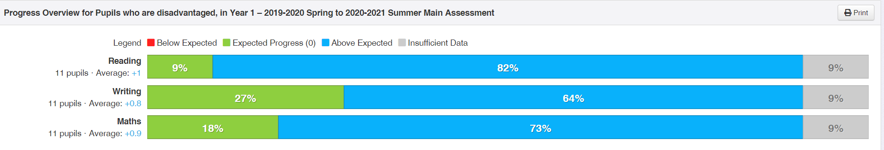

Year 2
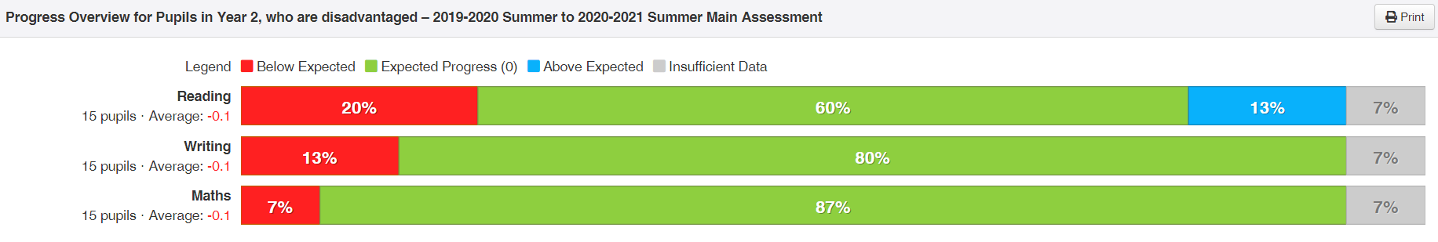

Year 3
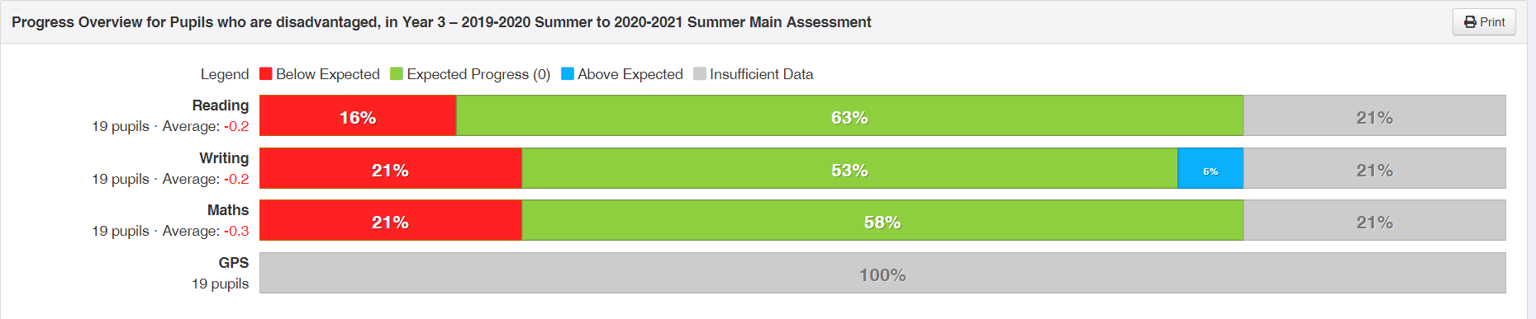
Year 4
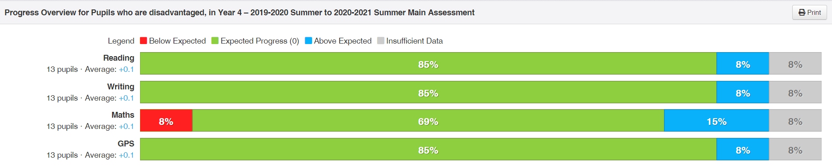

Year 5
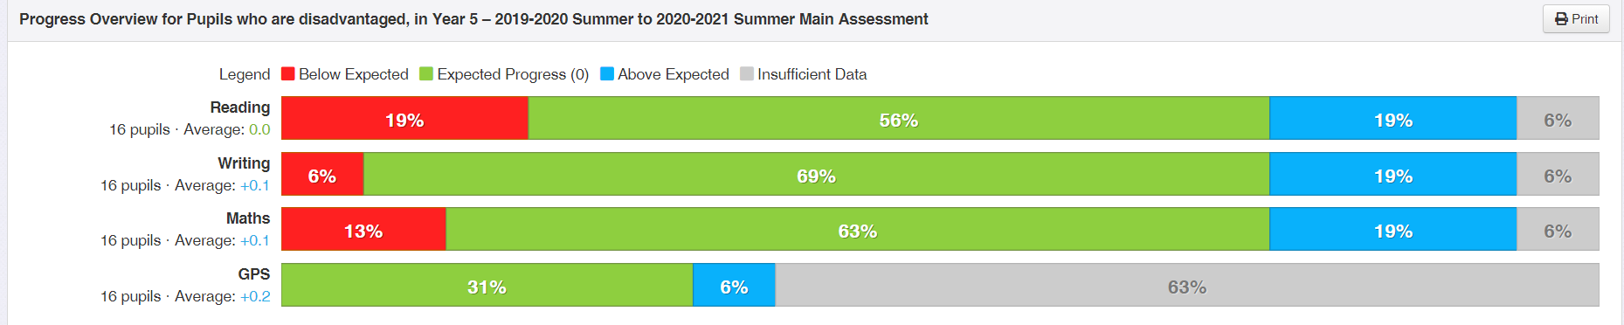

Year 6
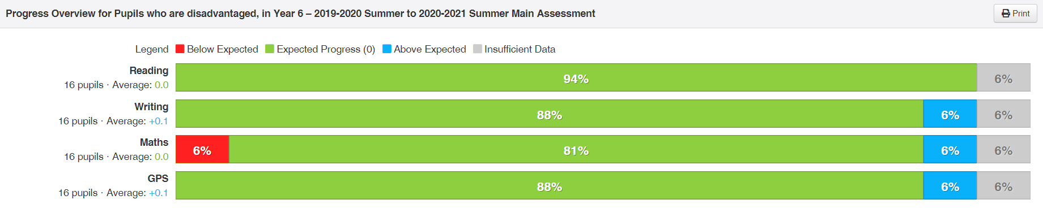

Reception PP Data from entry to school to July 2021
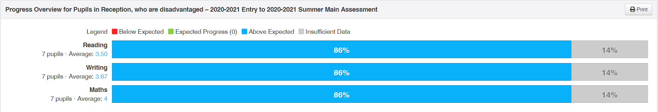

£4,600
Enabling Enterprise – Impact
This project raised aspiration for PP children and non PP alike. The challenge day gave opportunity for working as part of a team and applying learning skills. Children were also offered the opportunity to extend learning skills. The challenge day on November 2020 was ‘Greetings Cards’ – the children had to design greetings cards and make a presentation to the class. The project was about design, advertising, profit and loss. The day was linked to World Children’s day, our national Charity – Corum Children’s Society and also to the Birthday of the UN convention. All of the work linked with our work on Rights Respecting Schools.
Obviously there were no trips due to COVID 19.

£4000
Books – Impact
This enabled us to add to our KS2 reading challenge and increase the reading offer available to all of our children across KS2. It meant that PP children who had reported not many books at home, had a wide range to choose from. This year we added many new books that represented the Global community of Holly Park and the diversity of our families.

£1440
Towards the School Online Tracking system – Impact
We can monitor the progress of PP children more closely with the tracking system and get data about individual pupils, groups and cohorts to see the progress they are making.

£4500
HEWS (Health, Emotional and wellbeing service)
We had noticed a sharp increase in the emotional and behavioural needs of some of our children. HEWs means that more of our PP children can be seen by a health care professional . The impact has been that both children and parents have felt better supported and children are in a better place to learn and to make progress.
HEWS continued through COVID 19 with telephone and online sessions to pupils where possible.

