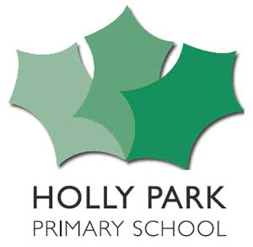

Bellevue Road, Friern Barnet, London N11 3HG
t: 020 8368 1434 e: office@hollypark.barnetmail.net
www.hollyparkschool.co.uk
5th October 2021
Dear Y6 Parents & Carers,

Year 6 School Journey to Norfolk Lakes 16th – 20th May 2022

Following on from the recent meeting, I am writing to remind you that if you are interested in your child participating in this trip, you will need to give permission along with a non-refundable deposit of £50.00. The final date for registering your child for the journey will be Tuesday 19th October. No applications for the school journey will be accepted after this date, unless from pupils who have joined the school subsequently. All money must be paid online using School Money. You also need to sign online on School Money to give permission for your child to attend.

If your child is eligible for free school meals, and you would like to receive 50% support from the Friern Barnet Educational Trust, you must make an appointment with Miss Hounslow before you pay the deposit. If you are eligible for receiving this support, then you will only be required to pay 50% of any charges, e.g. a deposit of only £25.00.

The cost of the trip is made up of two parts. The first part is for Norfolk Lakes itself, which includes accommodation, food and all the activities and specialist equipment. The cost of this is £456. The second part is for the coach. Until we know exact numbers going, we are not able to give an exact costing, as we do not know which size coaches to book.

Once you are registered, and we therefore know what size coaches to book, we will let you know the final cost after half term, and issue a payment plan. All money must be paid by Tuesday 29th March. Failure to pay the agreed amount will mean that your child will not participate in the trip. Once it has been confirmed that your child will be attending, you must pay the full amount. If your child does not attend, you are still liable to pay 75% of the cost to Manor Adventure or 100% if you cancel 13 days or less before the date of the trip.

Nearer the time of the trip, we will issue a kit list of what to pack, and a medical record form, which must be completed and returned to the school. Please remember that we do not allow the children to bring mobile phones with them, and we do not let them phone home during the week, as experience shows us that this only makes them more homesick!

Yours sincerely,
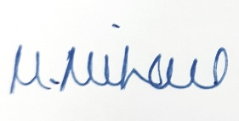
Maria Michael
Deputy Head

