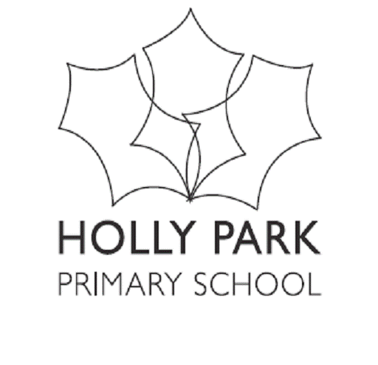
Permission to Administer Medicine

Holly Park School is unable to give your child medicine unless:
- It has been prescribed by a doctor for your child
- You have completed this form

Date ____________________________________________
Child’s name ________________________________
Class ________________________________
Name of medicine __________________________
Expiry Date ________________________________________
How much to give (dose to be given) ______________________________
Time/s to be given __________________________________
Any other instructions _______________________________________

Note: medicines must be in their original container as dispensed by the pharmacy, they must have the prescription sticker on them, clearly showing the name, date and name of medicine.

Consent
I give permission for the school to administer medicine to my child as detailed above. I will inform the school immediately in writing if there is any change in dosage or frequency of the medication or if the medication is stopped.

Parent Signature __________________________
Print parent Name ____________________________

