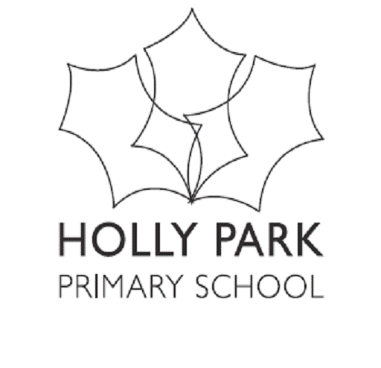

Bellevue Road, Friern Barnet, London N11 3HG
t: 020 8368 1434 f: 020 8361 6329 e: office@hollypark.barnetmail.net
www.hollyparkschool.co.uk
September 2021
Dear Parents and Carers,
Welcome back to the Autumn Term and for your children another new year at Holly Park. Let us hope that we can get through this academic year with minimum disruption. The children all found their new classrooms at the start of the first day and settled well. The school was a very happy place as Miss Michael and I walked around visiting all of the classrooms yesterday. We are all looking forward to an exciting year ahead and what we hope will be a more normal school year.
The start of any new academic year is always important for your children. There is always excitement, anxiety and some apprehension about what their new teacher will be like and about what the expectations of the New Year will be. As well as hard work and effort, we are sure we will have a year that will be full of fun together. Last year despite the virus and the unusual year we had, there was still a great deal to be very proud of:
- Continued good attendance data. Thank you for your support.
- Our PTA team who worked so hard and helped to raise much-needed funds even throughout the lockdowns and the fact that we could not hold events on site. They were very creative. The team were amazing.
- Our special days - our curriculum days and weeks – International Day, British Values day, online safety, sports days etc.
- Our HUB facilities during lockdown for Key Worker children in the Spring term.
- Our online learning offer during spring lockdown enhanced with PHSE activities, assemblies, spanish, music and story corner.
- The ongoing pastoral work the school did throughout the year.
- Our Holly Park staff, who adapted quickly to new ways of working, kept in touch with parents via phone calls and children via Google Classroom and Google Meets during the spring lockdown.
- The way we managed to keep school as normal as we possibly could while still maintaining hygiene, bubbles and playground zones
- Our office staff who worked so hard and kept everything organised and efficient
- Our team of TAs who support children in class and in groups, cover classes when needed, keep the school tidy, put up displays and make fantastic scenery and props
- Our school governors who still managed to meet for scheduled meetings and learning walks in order to help with monitoring the work of the school despite the unusual circumstances.
Thank you for the many lovely comments we received across this school year. Here are just some:
‘We would like to send a huge thank you to yourself and all of the staff at Holly Park. We can only imagine the enormous challenge faced by everyone since the start of the pandemic but the work set and the daily engagement has been amazing; the Holly Park community has really been upheld despite everyone being at home; we are very appreciative. ‘

‘Thank you so much for everything you have done.​ We really appreciate all the effort and hard work you have put in – the home learning activities, the videos, the phone calls (to name but a few things).’

‘Holly Park School has done amazingly well. I have been super impressed and really happy with all the work.’

‘Thought I would let you know that your teachers are doing an amazing job for the children on line. The work they are setting is great and the lesson videos are really helpful. It is really encouraging when they comment on work sent in, it helps us at home to get our daughter to do the work. Please send our thanks to them for all their hard work it is really appreciated.’

‘Overall I am very impressed, so well done to all the staff who have helped get this process working so well’

‘I just wanted to say how impressed I am by how amazingly well you and the rest of the Holly Park team have responded to the huge challenges posed by the current situation….’

‘Thank you – you and your staff have all been completely unbelievable – so calm, caring and supportive’

‘Thank you! This Headteacher award in lockdown put a big smile on his’ face and it definitely helped him carry on today.’

‘‘I have just got home and my daughter is watching the class teachers Google Classroom video from today. Please thank her for making my day! Love it! No wonder my daughter loves school so much.’

‘Thank you for keeping our daughter safe and doing what has to be done. We loved Holly Park before, but since you became head we have loved it even more.’

‘I feel incredibly grateful to have had the opportunity to get involved with the school myself, with PTA and volunteering so thank you for making my experience as a parent a great one’

‘I wanted to take the time to thank you, and all the staff at Holly Park, for my children having a fantastic primary school experience and education.’
‘Both of my children have attended Holly Park since nursery up to Year 6, and I can honestly say they enjoyed going to school every day. They both made meaningful friendships, even though my daughter was quite outgoing and my son is the opposite and far more reserved - the friendships that they both made and enjoyed have been wonderful. Academically, my kids are thriving and that is down to all the staff at Holly Park, class teachers and teaching assistants. All of them have made an impact on my children’s learning. All the enrichment activities that my children experienced - house challenges, sports days, quiz’s, choir, curriculum days out, assemblies and plays, have been invaluable too. They had a lot of fun. Such wonderful primary school memories for them both.’

‘We think Holly Park has done a fab job this year given the chaos this pandemic has thrown upon us all. Such a mammoth and exhausting task to navigate. A big thank you to everyone for keeping the children safe and happy’.

Every new school year, a school will make a whole school improvement plan. This year we will be working on:
- Improving our ICT infrastructure through fundraising
- Continuing to work on quality first teaching and a focus on pedagogy
- Returning to normal trips and visits and develop new calendar of curriculum days and special days/weeks to ensure they are most effective
- Developing parent champions
- Continue to work on diversity throughout the curriculum – to ensure it is reflective of our community of children
- Implementing the new Reception baseline
- Implementing the new EYFS curriculum
- Refreshing and revisit phonics teaching
- Reviewing curriculum maps and progressions of skills for PHSE, RE and Computing
- Reviewing writing coverage across the school
- Being part of NCTEM – Number Sense – mastering number project for Rec and KS1
- Focusing on reading comprehension
- Being part of the ELSA (emotional literacy support assistant) project
- Being part of the Barnet Language enrichment project
- Embedding SEND changes across the school
- Reinforcing pupil voice by re-establishing councils
- Working towards the Rights Respecting Gold award
- Being a Compass For Life School
- Engaging in special enrichment projects with our local partnership of schools
At present, I am afraid that we still cannot have parents fully back on the school site (except for those settling new nursery or new reception children) The Meet the teacher meetings will still go ahead but will be held via Zoom. An invitation link will be sent to you via email. We are delighted to have parents back on the school site at the end of the school day to collect children – however the office area remains closed to parents at this time as we cannot have parents inside the buildings.

The ‘Meet the teacher’ packs will be emailed home to you. You have already been emailed a letter about what to expect for the current year ahead in your child’s year group. If you have misplaced it, you can find it on the year group website page. A letter about our initial two-week whole school learning project will be emailed to you next week. After our Inset day on 20th September, you will receive a letter from the year group teachers about learning and the curriculum for the rest of this term. You will receive a term dates leaflet next week for the Autumn term important dates. We will aim to continue with as many activities as we can. Curriculum days, house challenges, charity events etc. will continue as normal and we will introduce school trips again this year. Some PTA events will begin to be back on the school site. Please continue to read our weekly newsletters over the year to find out about what has happened and what will be happening. Please keep your eye on the school website as this holds an enormous amount of information. Enjoy the Holly Park Highlights at the end of each term.

I look forward to continuing to work closely with governors, staff, parents and children over this next year. I hope that together we will continue to take the school forward and make Holly Park the best it can be.

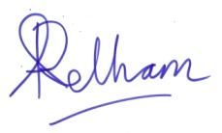
Ann Pelham
Head Teacher

