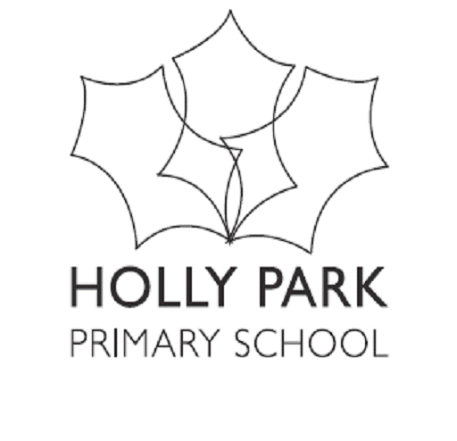
Bellevue Road, Friern Barnet, London N11 3HG
t: 020 8368 1434 e: office@hollypark.barnetmail.net

20th April 2021
Dear Y6 parents
I just wanted to write to you to give you some information about Y6 and the end of year activities at this unusual time. We are still operating under a variety of rules, which means that Bubbles and zones are still in operation and parents are still not permitted on the school site. These are still uncertain times and we are not sure if these rules will still be in place in schools after the 21st June. We cannot wait until 21st June to make our plans – so we wanted to share with you what is likely to happen for your children. We hope this will be useful.

Y6 National Assessments
The Y6 National tests have been cancelled so there will be no formal exam period in school. Barnet are working on a common transfer form so that all secondary schools are given the same information about the children they will be receiving. We wait for more news about this.

National Test Week Breakfast
One of the highlights of the national test week for the children is the special breakfast they are invited to. This is paid for by the PTA and run by the Holly Park staff. So that the children do not miss out completely on this fun experience, we plan to run a couple of Y6 special breakfasts during their activity week.

Y6 Show
We plan to go ahead and have a Y6 end of year show. The children are already very excited by this. Y6 are operating as a bubble – so this is not a problem.
However, at present it is not likely that the rest of the school including siblings will be able to watch it or that parents will be able to come in and watch it.
As with the Y3 Nativity, our main priority is for the children to have the experience of doing a show. The show will be recorded and put onto the school website for a limited period. We will be asking for your permission for your child to be in the video on the website. If you do not give permission for this then your child will be unable to be in the show. If we video the performances then each cast of children will perform just once.
If by the end of term it is possible for parents to come in to school to see the performance – then we will be allocating you one ticket per parent and also allocating which performance you can come to watch so that we can control numbers at each performance. If parents are able to watch then you will receive one ticket for each performance your child is in. This will create an audience of a maximum of 30 parents in the school hall for each performance. Masks will of course need to be worn. The children will be put into either CAST A or CAST B. If the performances are live then each cast will do two performances.
The performances will be:
Monday 5th July Y6 Cast A performance
Tuesday 6th July Y6 Cast A performance
Wednesday 7th July Y6 Cast B performance
Thursday 8th July Y6 Cast B performance

Y6 Activity Week
As the children missed both of their residential trips, we are keen to run a Y6 activity week. At this stage, we hope that we will be able to go ahead with some days out of school. The Y6 activity week will run from Monday 12th July.
The week will consist of some days on site and some days off site. We are hoping to be able to have activities, which may include: an adventurous activity day, cinema, bowling, Alexandra Palace, Forest School, team building etc. Miss Michael, Miss Biggs and Mr Carini are discussing plans and we will let you know as soon as we have a clearer plan.
There will be a cost of course for this week, which could be up to £70, which is in line with what our other local schools are charging. We hope to be able to allow parents to pay in three instalments.

Y6 Party
It is a tradition at Holly Park that we have a Y6 final party. We are going ahead with this as we did last year. The same silent disco that we used last year has been booked for Thursday 22nd July from 7pm to 9pm. It is likely the party will be held outside. Children will be required to bring their own packed picnic and a picnic rug. All children will need to be collected at 9pm by an adult.

Y6 Leavers Ceremony
Last year we were able to hold an outdoor ceremony for our Y6 children. We intend to do this again for our current Y6. This will not be an assembly as in previous years but more of a graduation ceremony.
We hope to be able to invite parents to this but we will not know until nearer the time.
The plan will be that that all of the school will come outside and sit in class groups. Parents will sit on chairs behind the children. A maximum of 2 adults per child will be able to attend.
Various staff will speak about the children and they will be presented with their certificates.
We plan to hold the ceremony on Friday 23rd July at 11.30am. Parents will need to have left the site by 12pm, which is lunchtime.

We hope that this information is useful for you.

Many thanks for your continued support

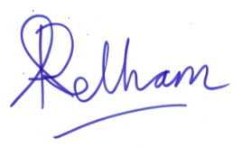
Ann Pelham
Headteacher

