Learning Project – Journey of Life and Death : The Ancient Maya
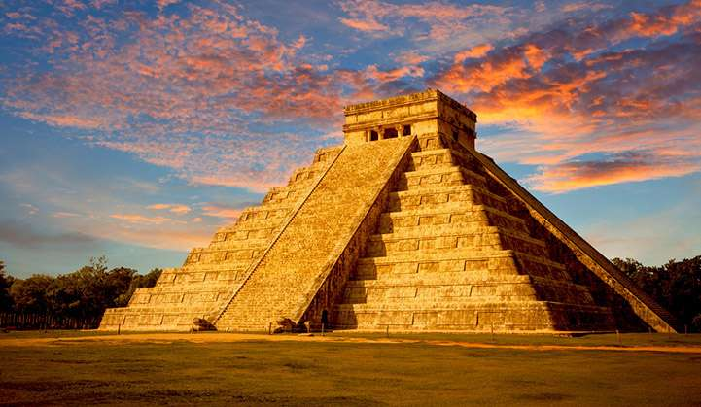

Dear families,
Welcome to the summer term in Year 6! Our Learning Project this term will be Life and Death and the Ancient Maya. We also look forward to beginning preparations for the Year 6 Show - always a highlight of the year (this year especially!) Please see below for further information about each curriculum subject.
Best wishes,
Miss Biggs and Mr Carini

Science | Maths |  | English - Writing
Evolution and Inheritance  Animals including humans | Statistics  Algebra  Ratio | Measurement  Position and Direction  Properties of Shapes | Focus texts:  Skellig  High Rise Mystery  Motivational speeches  Persuasive writing  Letters of complaint  Debates and discussions  Non-Chronological Reports  Narrative Description
English - Grammar | English - Spelling | PSHE | RE
Semicolons  Colons  Active and Passive Voice | Key topic words | Economic well-being: Money and Me  SRE: relationship education  Transition to secondary school | Pilgrimage and Sacred Journeys  Journey of Life and Death  Mayan beliefs
Computing | PE | History | Geography
Digital Literacy  Computer Science  Online Safety | Dance –Preparations for Year 6 Show.  Gymnastics - counterbalance and tension  Games – tennis – developing racket skills, small games, introducing tactics and strategies. | Ancient Maya –  Mayan Death Rituals  Mayan Beliefs  Mayan Gods  Day of the Dead | North and South America  Rivers  Climate Change  Lines of longitude and latitude  Deforestation  Human geography – trade in South America  Fair Trade
Art & Design | Design & Technology | Key Dates for this year group this term
Sketching  Portraits  Painting | Advertising  Stage craft | International day: 21st May  Junior sports day: 2nd July  Reports go home: week of 6th July | Y6 Show week – Monday 5th July  Activity Week – 12th July  Y6 Party – Thursday 22nd July 7pm – 9pm  Y6 Leaving ceremony – Friday 23rd July

