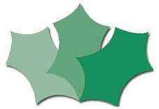
HOLLY PARK PRIMARY SCHOOL

Dear Parents and Carers,

Welcome to the Summer Term!
This term we will be basing lots of our learning around traditional tales such as Little Red Riding Hood. The children will have lots of opportunities to develop their understanding of these stories through drama and art. The children will be encouraged to write their own stories and then read them to their classmates on a special ‘story telling chair’ that we have created together.
In Phonics, we will continue to write words and sentences that contain Phase 3 digraphs and trigraphs. We will also be learning how to read and write two syllable words and we will be introducing some new keywords. We would like to remind you of the importance of reading books on Bug Club every day to help children’s confidence and fluency develop. It is really helpful to spend time looking for any digraphs and trigraphs in words and to spot the key words in sentences. New books will be available each week for you to share with your children.
In Maths, we will be focusing on addition, number bonds to ten and subtraction. We will be exploring subtraction through the story, ‘The Shopping Basket’. We will be spending lots of time talking about how we have found our answers to different number problems as well as recording our answers in different ways.

Thank you for your continued support.

The Reception Team

