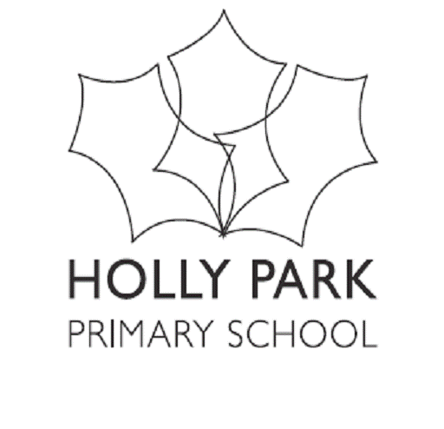
HOLLY PARK NURSERY PRICING
From September 2021

Nursery sessions are based on £8.00 per hour

7.45 – 8.45 | Breakfast | Must be paid for if wanted | £8.00
8.45- 11.45 | Morning Session | Free as part of 15 hours or 30 hours | Can be paid for as an extra if space is available at  £24.00
11.45 – 12.45 | Lunch | Must be paid for if wanted  (30 hours children have priority) | £8.00  + cooked lunch at £2.34  Children can bring packed lunch or go home
12.45- 3.45 | Afternoon Session | Free as part of 15 hours or 30 hours | Can be paid for as an extra if space is available at £24.00
3.45 – 6.00 | Nursery  After School Club | Must be paid for if wanted | £18.00 (nursery)  + meal at £2.20  Children can bring packed tea
3.30-6.00 | Reception  After School Club | Must be paid for if wanted | £20.00 (reception)  + meal at £2.20  Children can bring packed tea

