Learning Project – What is the weather like today?

Dear Parents/Carers,

This term we are learning about What the weather is like today. We will be focusing on weather, water, climate and cold countries.

Best wishes,
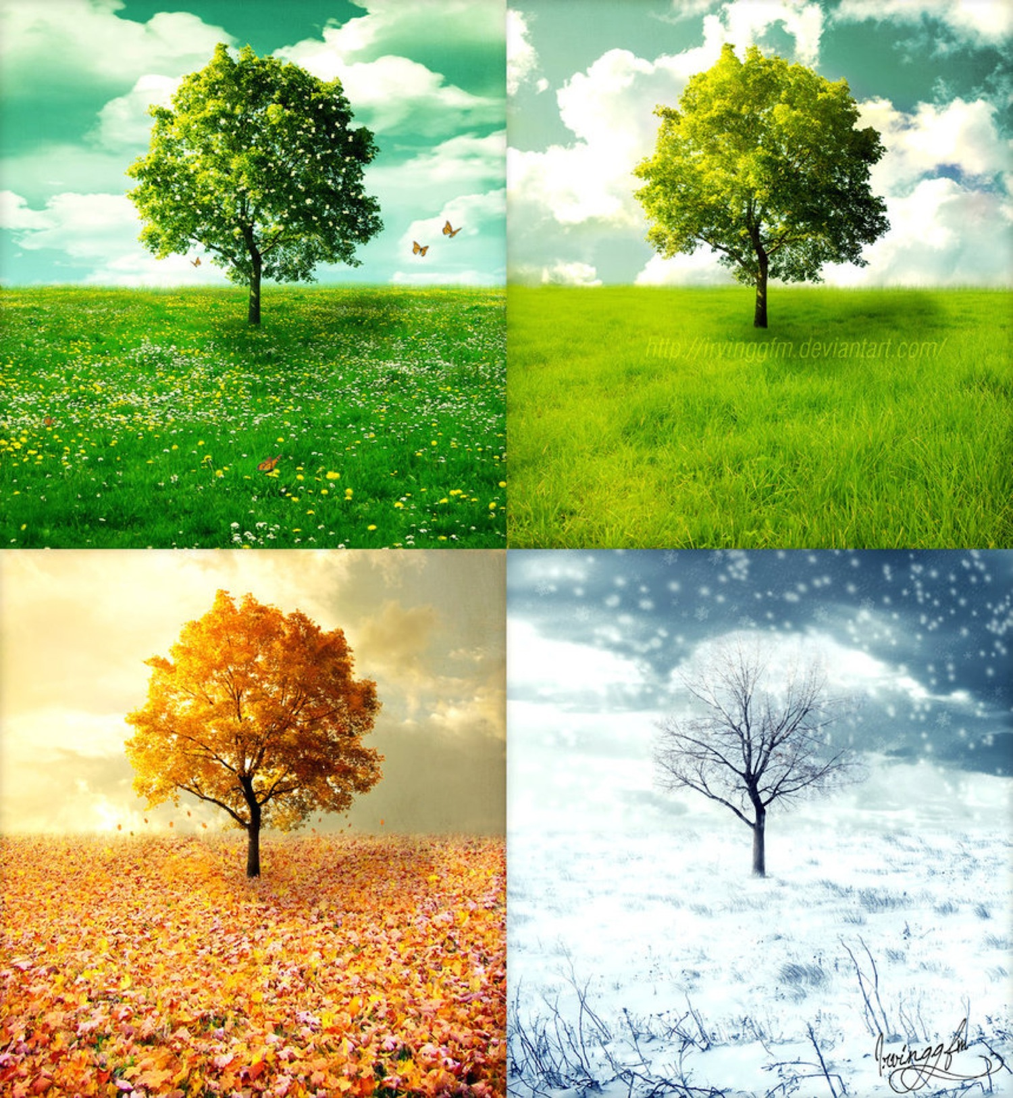
Emma Fitzpatrick, Sharon Casey

Science | Maths |  | English - writing
Water experiments  Animals  Weather  Winter tree | Addition  Numbers to 20  Shape |  | Zog  Lost and Found  Blown Away
English - Grammar | English – Phonics | PSHE | Computing
Finger Spaces  Full Stops  Capital letters | or – aw au  oi – oy  ur – ir  w – wh  f – ph | Losses and changes  Recognising and naming feelings  Helping the environment | Graphs
PE | Geography | Art & Design | Other Information
Dance  Aiming  Agility and Coordination | Weather  Features of the UK  Recognising UK on the map  Cold places | Famous artists | Please make sure your child is reading every day. You will see real progress if your child reads every day!! Thank you

