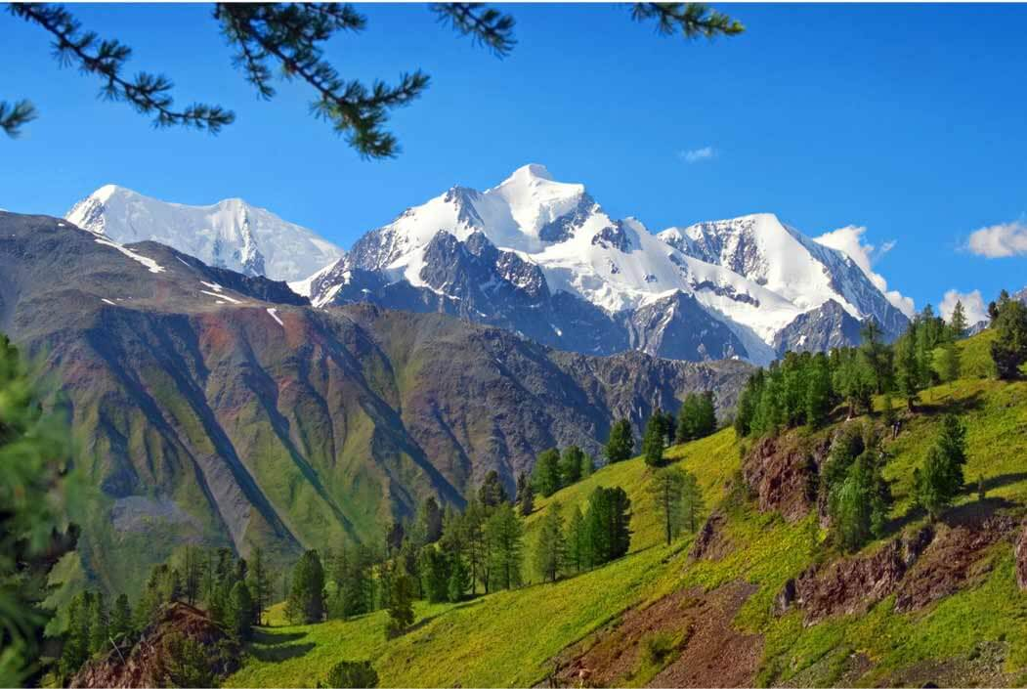
Learning Project - Mountains

Dear Families,
Welcome to the Spring term in Year 6. In the first half of the term our topic focus will be Mountains! In the second half of the term, we move on to look at life and death and the Ancient Maya. Geography will be a key focus this term and we will be focusing on North and South America. Please see below for how this links to different areas of the curriculum.

Best wishes,
Alice Biggs and Dominic Carini

Science | Maths |  | English - Writing
Living things and their habitats  -Classifying living things into groups based on shared characteristics  - Understanding the classification groups of animals (vertebrates and invertebrates), plants and microorganisms | Fractions  Decimals and percentages  Translation, rotation and symmetry  Algebra | Measurement  Shape  Ratio and proportion  Statistics | Text foci:  The Viewer  The Dreadful Menace  The Arrival  Fiction:  Narrative description  Poetry  Non-fiction:  Biography and  Autobiography  Script Writing  Balanced Arguments  Persuasive Letters  Newspaper Reports
English - Grammar | English - Spelling | PSHE | RE
Semicolons  Colons  Active and Passive Voice  Hyphens | Key topic words | Social: Me and my place in the world  Living in the wider world: Media literacy and digital resilience | Pilgrimage and Sacred Journeys  Journey of Life and Death  Mayan beliefs
Computing | PE | History | Geography
Digital Literacy  Computer Science  Online Safety | Spring 1  Fitness and Exercise  Spring 2  Athletics  Dance | Ancient Maya | Mountains (UK and North  and South America)  Study of region within North or South America
Art & Design | Design & Technology
Sketching  Portraits | Food from other cultures  Maya temples

