HOLLY PARK PRIMARY SCHOOL

Dear Parents and Carers, January 2021

We wish you and your families a happy and healthy New Year!
This term is starting off a little differently than expected but welcome to the Spring Term! To help support you with your child’s learning over the coming weeks, we will be providing you with home learning activities. These will be uploaded to the Reception page of the Holly Park website at the beginning of each week. The activities will include reading, writing, maths and physical development tasks. We will keep these as engaging and as practical as possible and we hope that you will enjoy helping your children as they complete them.

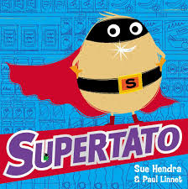
We will be focusing lots of our learning around the ‘Supertato’ series of books. These stories are really exciting and very funny. We know you will love them! The books will give the children a chance to practise a range of skills across the curriculum

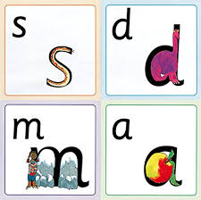
In Phonics, we will be moving into Phase 3. The children will learn the remaining single phonemes and will then learn digraphs (two letters that make one sound e.g ch, ee) and trigraphs (three letters that make one sound e.g air, ure). We will be uploading daily phonics videos introducing the new phonemes. Please remember that there are lots of enjoyable games for your child to practise their phonics skills on Bug Club.

If you have any questions, please email the school office and these will be passed on to us.
Thank you for your continued support.

Best Wishes,
The Reception Team

