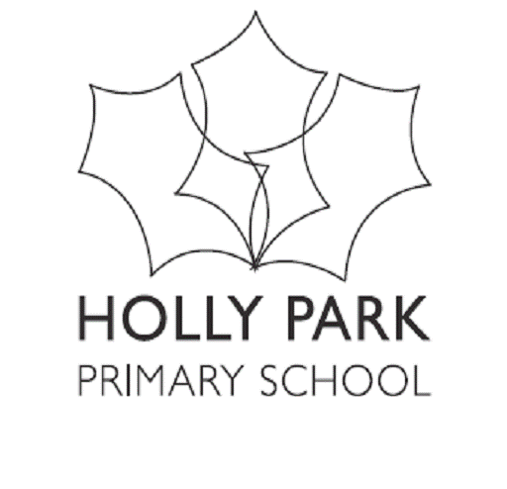 Vocabulary (and concept knowledge) Development
Subject: Art
Vocabulary List
Year Group | Drawing | Painting | Print | Sculpture | Collage | Textile | Digital Media
NURSERY | draw  felt tip pen marker  colour pencil  paper  crayon  chalk | colour  paint  brush  powder paint  easel | press  dab | Playdough  masking tape  cardboard  plastic  straw  junk modelling | glue  stick  cut  scissors  card | cloth | camera  picture  photograph  iPad  app
RECEPTION | shape  dot  circle  line  curly  wavy  zig-zag  squiggly  drawing  big  small  oil pastels | mix  drop  spray  watercolour  painting  artist  swirling | stamp  roll | clay  roll  squash  squish  stick  join  fold | glue spreader  spread  stick  cut  tissue paper | wool  soft  rough  silky  smooth | mouse camera  computer  print
YEAR 1 | thick  thin  soft  fine  pattern  detail mirror image  curve  swirl  drawing- pencil | primary -colours  secondary -colours  light  dark  hot and cold colours  shade e.g. different shades of red,  blue, yellow  bright  broad  narrow  brush head  bristles  stroke | print  rub  smudge image  shapes pressure  printing ink  repeat  pattern decoration | design  model  bend  attach assemble statue  stone  shell  wood  metal | collage pattern  shape  tear  strip | fabric  sew  needle  eye  felt  scraps  yarn  thread  fur  silk  satin  net  weave | digital programme  move  tool  magic wand  stamp
YEAR 2 | shape  detail  nature environment compare  still life  scale  control  observe  horizontal  vertical  diagonal | consistency  tone  shade  colour wash  contrast  colour match  gallery  exhibition  palette | roll  rubbing reverse surface pressure repeat  rotate  mono-print | sculpture structure  sculptor assemble construct carve  form  impress texture | texture  layers combine mixed media | stitch  appliqué  backing  Tie and dye  dip  soak  twist | cut  paste  tool  enlarge  image
YEAR 3 | sketch  sketch book  pencil grade  graphite  hard  soft  charcoal  form  position boundary label  symbol  space  background  change improve  dimension | natural  bold  delicate detailed colour descriptors e.g. scarlet, crimson, emerald, turquoise watery  intense  strong  tint  townscape seascape scenery | imprint impression mould stencil printing block  mono-print background absorb negative image positive image | pottery  carve  viewpoint detail  pliable  kiln  natural form texture  two-dimensional three-dimensional  brick  slate  wood  stone  metal  bronze  iron | arrange  rearrange layering  overlap bunching  matting  effect | natural synthetic threading stitching running stitch  back stitch  hessian | PowerPoint clone  detail
YEAR 4 | foreground middle ground  plan distance direction texture  tone  blend  weight pressure | abstract  colour wheel  structure  element  representational imaginary idealised  stippled spectrum | collograph  impress  continuous cylinder  tessellation  polystyrene tile | malleable  form  shape  craft  texture profile stylised proportion ornate symbolic perspective  surface architecture | twisting  curling  folding  coiling | cross stitch embroidery  embroidered weft  quilting | special effects  filters  brush tools  palette cloning translucence  textures  layer  style
YEAR 5 | hatching  cross-hatching  stippling  shading  shadow  angle  bird’s eye view  weight  alter  modify interior exterior  natural form subject caricature  atmosphere  illusion | complementary contrasting  viewfinders  traditional representational imaginary modern abstract stippled splattered dabbed  scraped  stroked textured  flat  layered | resist  relief printing  monotype plate  inking up water-based  oil-based intaglio  etch  etching engraving indentation pressure Victorian | realistic  scale relationship transform movement rhythm construct flexible pliable  papier –mache  hollow  solid  slip  slab  slabbing scoring | depict  alter  adapt  segment | Batik  fray  embellished manipulated  replicate quilting  taffeta organdie poplin  tweed | still image  video  edit  scale  merge  text box  opacity
YEAR 6 | perspective  viewpoints  focal point  horizon movement reflection  vista  distorted -image  blurred image stylised  action  balance direction dynamic imbalance poised transition panorama | acrylic  traditional inanimate composition arrangement complimentary  tonal  shading  mural  translucent  opaque | repetition, rotation symmetry  symmetrical aesthetic motif  Islamic  relief | ceramic mosaic  frieze  coil  pose position gesture sequence flowing motion rhythm proportion balance  plane  angle  attachment | proportion balance  relationship transform movement rhythm composition  plane  angle | smocking ruching  embellish accentuate enhance detract practicality aesthetics | graphics  animation  manipulate  manipulation

