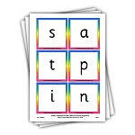 Articulation of Phonemes/letter sounds 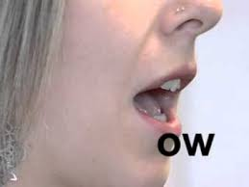

Please use the link below to watch a video that demonstrates very clearly how each letter/grapheme should be pronounced. It also includes how to pronounce digraphs (two letter sounds) and trigraphs (three letter sounds).

https://www.youtube.com/watch?v=BqhXUW_v-1s

