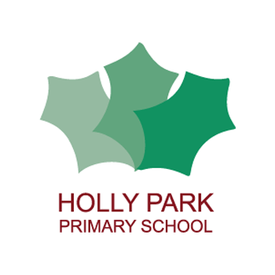Holly Park Nursery
Dear parents/carers,
Please find some more home learning activities below. These include phase one phonics, handwriting and maths ideas. There are also more links to myself reading stories online.
Please send any photographs of your children learning through play to the school email with your child’s name and class attached.
Enjoy!
Phase One Phonics
In nursery we do phase one phonics. Children need to be confident in all aspects of phase one before learning to read and write. You can find more information on the Letters and Sounds website which is on last weeks newsletters. Here are three activities that you can do at home.
- Listening walks This is a listening activity that can take place indoors or outdoors. Remind the children about the things that good listeners do (e.g. keep quiet, have ears and eyes ready). Invite the children to show you how good they are at listening and talk about why listening carefully is important. Encourage the children to listen attentively to the sounds around them. Talk about the different sounds they can hear. The children could use ‘cupped ears’ or make big ears on headbands to wear as they go on the listening walk. After the children have enjoyed a listening walk indoors or outdoors, make a list of all the sounds they can remember. The list can be in words or pictures and prompted by replaying sounds recorded on the walk.
- New words to old songs Take a song or rhyme the children know well and invent new words to suit the purpose and the children’s interests. Use percussion instruments to accompany the new lyrics.
- Action songs Singing songs and action rhymes is a vital part of Phase One activities and should be an everyday event. Children need to develop a wide repertoire of songs and rhymes. Be sure to include multi-sensory experiences such as action songs in which the children have to add claps, knee pats and foot stamps or move in a particular way. Add body percussion sounds to nursery rhymes, performing the sounds in time to the beat. Change the body sound with each musical phrase or sentence. Encourage the children to be attentive and to know when to add sounds, when to move, and when to be still.

Activity ideas in photographs

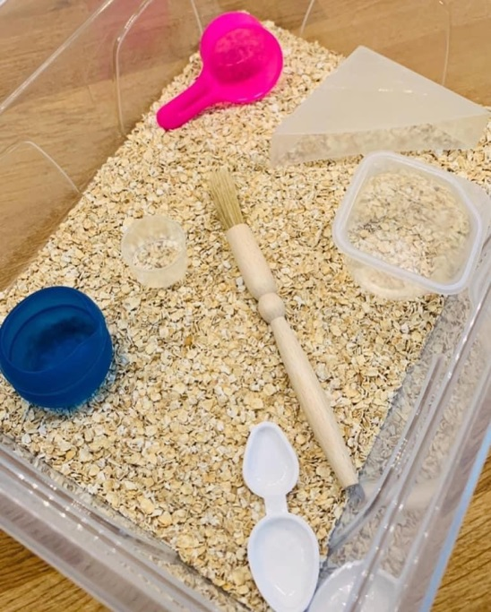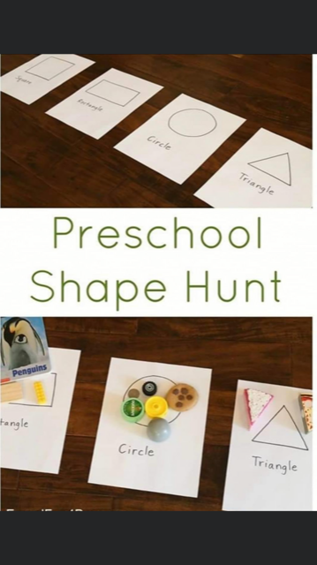

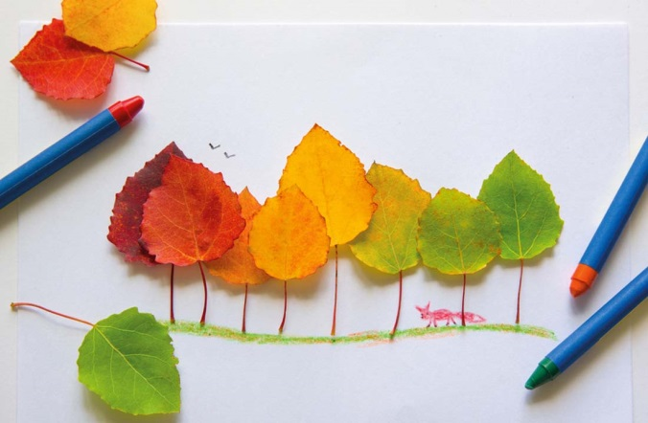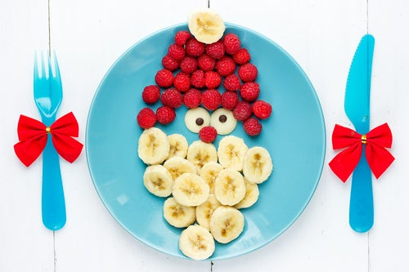

PENPALS for Handwriting

Every week the children do exercises that help to develop the strength in their arms, wrists, hands and fingers. This helps with pen grip which leads them to become good writers. Here are this weeks exercises:

https://youtu.be/S0nQBHtTa1I

https://youtu.be/_AWaf-td88k

https://youtu.be/rEzs2_jt5YY

https://youtu.be/tUGT2r4WK4Y

Kitchen Maths at home

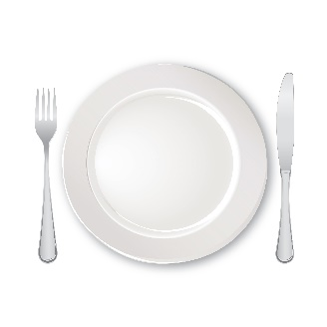 | Setting the table – Counting how many people, how many plates/cups/bowls needed, laying the items needed on the table for dinner, are all ways to develop Maths skills. Counting, Shape and Space, and organisation skills are all in play as children undertake this task. Not to mentioned social development as they show that they can contribute to the family by helping.
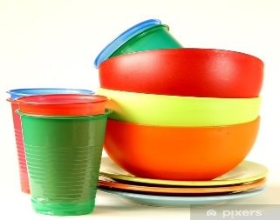 | Putting dishes away – Children can practise sorting skills as they stack plates, bowls, cups and cuttlery after washing. This helps build early language skills of categorisation, sorting and organising.
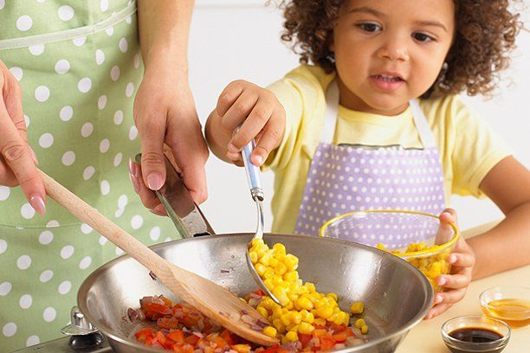 | Preparing food – Children explore measuring, weight, sorting as they help prepare food. Not to mention the fine motor skill development that takes place when chopping, peeling and grating. Also there is the opportunity to make connections with health and wellbeing as they choose healthy foods.
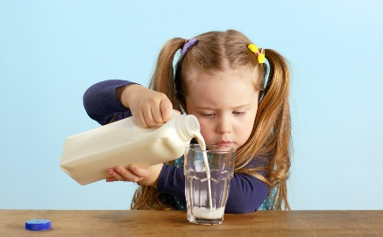 | Pouring drinks – Capacity is being explored as children pour – finding out how much liquid can be held in different shaped cups, jugs and bottles. Fine motor skills, hand-eye coordination and confidence are all being developed as children try this tricky task. Be prepared for spills – that’s part of the process as children make judgements.

Reading stories

Please continue to read stories to your child every day. There are lots of stories being read by different teachers on the Holly Park website. Here are some of the stories that I have read:

https://youtu.be/GWVAVyh4T0E
Shark in the Park

https://youtu.be/P8iSGHBC8bc
Shark in the Dark

Useful links
Home schooling videos for primary aged children
http://senresourcesblog.com/2020/04/01/home-schooling-videos-for-primary-aged-children/

