Nursery Home Learning
- Make playdough together with your child

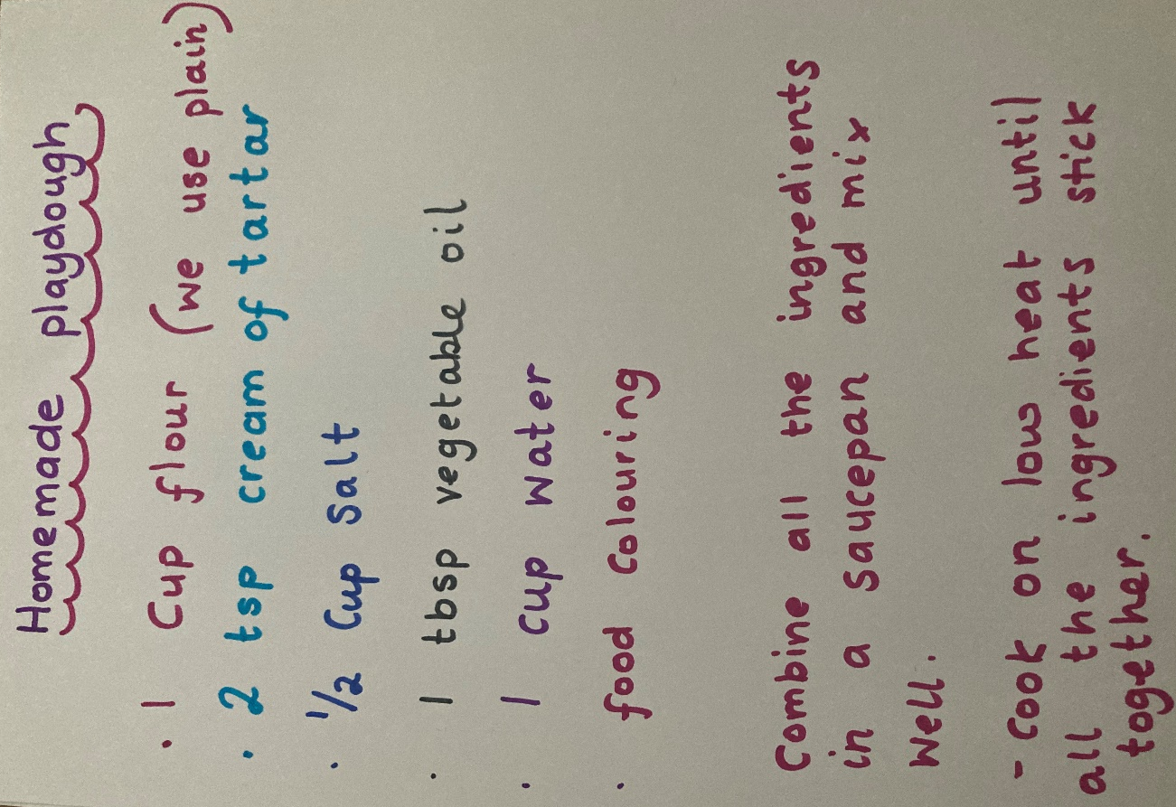

- Do some mark making (drawing / writing) together. Here are some ideas:
- Use a piece of tin foil to make marks on with pens or paints
- Draw pictures, roads, maps etc on large sheets of wallpaper
- Everybody has old pots of spices in their cupboards. Pour the spice into a tray then use your finger, twig or feather to make marks.
- Make ice cubes or ice bricks (in a Tupperware container). Empty the ice onto a tray and decorate with paints.

- Some number activities
- Number hunt around their home. Parents write the numbers from 1-10 on pieces of paper and stick them around the house. Give the child a pen and a number check list and tell the child to go and find the numbers and cross them off their list. They have done this in the nursery so are familiar with what to do.
- Use a cake tin, put the cake cases inside the tin making sure a number from 1- 12 is written on the bottom of the case. Give the child a small bowl of beads, buttons etc. put the correct number of objects in each case.
- Roll a dice, count the dots on the dice, clap that many times, jump that many times.
- Go for a walk and look at the numbers on the front doors of the houses you pass.
- Go for a walk, count how many steps you walk.

Here are some lovely counting activities:
https://www.topmarks.co.uk/maths-games/3-5-years/counting

There are many lovely things to do on The Imagination Tree. Click on this link:
https://theimaginationtree.com/category/age/ageprescooler/

And most importantly, talk with your child, read lots of stories together and sing some songs.
https://www.youtube.com/watch?v=lzc_Rd4TuYg

