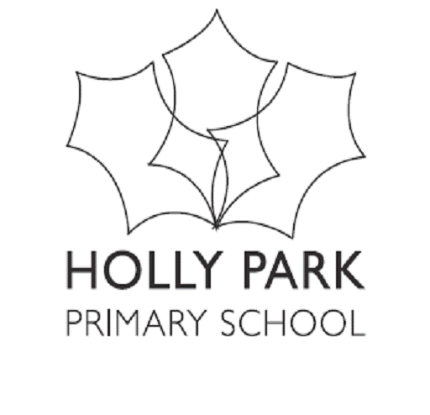 Vocabulary (and concept knowledge) Development

Subject ________MUSIC_____________
Year Group | Vocabulary List
NURSERY | Pulse, steady beat. Rhythm, rhythm pattern.  Loud, quiet.  Fast, faster, quick, quickly. Slow, slowly.  Names of percussion instruments. Wood, metal.  Beater, hard/soft.
RECEPTION | Pitch. High, low (up, down). Voice, musical instrument.  Beat, rhythm, marching, skipping. Louder/quieter.  ‘Forte’ = loud. ‘Piano’ = quiet. Symbols: ‘f’ and ‘p’.  Soh – lah - me. (Kodaly pitch/hand signals.)  Pictures and symbols.
YEAR 1 | Rhythm, rhythm pattern, rhythmic phrase.  Beater. Tap, shake, scrape.  Create, compose. Symbols, composition.  Me – ray – doh (Kodaly pitch/hand signals.)  Pulse, beat. Melody, tune. Posture.
YEAR 2 | Sequences of sounds. Musical score.  Rhythm pattern/phrase.  Symbols, Fly = crochet. Rest. Spider = quaver.  Pitch/pitches. Posture. ‘Patschen’ = body percussion.  Control of voice: ‘intonation’ = singing in tune.  Lah – ti- doh (high ‘doh and low ‘doh’).
YEAR 3 | Pitch, pitch contours. Stepwise motion.  Musical swoops. ‘Sirening’.  Rhythm, tempo. Duration.  Crotchets, crotchet rests.  Pentatonic scale. ‘Scala’ = ladder. ‘Penta’ = five.  ‘Tonic’ = sound. C-D-E-F-G-A-B = note names.
YEAR 4 | Quavers. Traditional notation.  Pentatonic scales and drones.  Melodic shapes. Copy and contrast.  Musical ‘mood’. Descriptive music.  Dissonance and consonance. Octave.
YEAR 5 | Semi-quavers. Musical form.  Part-singing. Vocal blend. Vocal expression.  Conductor’s signals and dynamics. Diphthongs.  Lyre, lyrics. Programmatic music. Pitch clusters. Antiphonal effects. Sequencing and overlapping.
YEAR 6 | Syncopation, syncopated rhythm.  Complementary rhythms and cross-rhythms.  Musical sample. Sequencer programme. Arrangements.  Timbre. Texture. Sound modification. Attack and decay.  Cyclic patterns. Djembé, djembi.  Inter-related dimensions of music.

