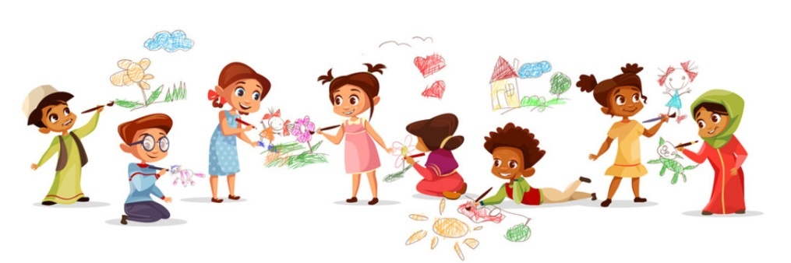
Dear parents/carers,
As you have heard the nursery will be closed this week and possibly the week after at least. We will be reviewing the situation weekly and will let you know when it is safe to open the nursery. We completely understand that you are juggling a lot at home. Many of you are trying to home school and work at the same time so I do not want to give you more work to do! Below are some simple ideas that you can do with your nursery child at home which should not cause too much stress.
Please look on the nursery page of the school website regularly as I will be putting up daily videos where I will read stories and talk to the children. Every week that the nursery is closed, I will put a home-learning letter on the nursery page with activity ideas that you can do at home to support your child’s learning.
If you have any questions at all or if you want specific ideas, then please email the school office and your emails will be forwarded to me.
Miss Wood
Reading
- Read stories. Children can never have too many stories! Talk about the pictures. Ask your child to predict what might happen next. Ask your child who is their favourite character and why. Get children to draw pictures of their favourite stories and write their re-telling of the story.
- Play games like ‘I spy’ where children have to find an object that begins with a particular sound e.g. I spy something beginning with ppppppp (say the sound, not the letter name).
- Blending. Segment words when you say them e.g. can you sit on the ch-air, can you pass me the c-u-p, time to go to b-e-d. This will help with their reading later on.
- Feely sound socks – put objects into socks (pasta in one sock, rice in another, coins in another). Shake the sock and get your child to describe the sound and guess what they think is inside the sock. Then get your child to feel the sock and describe what they feel like. Once they have given a final guess, open the sock and show them what was inside
- Sing songs. Encourage them to join in action songs. YouTube have lots of nursery rhyme videos. They also have JustDance and GoNoodle which the children love. The Dinosaur Stomp song seems to be a favourite this year!
There are many more activities in the Phase 1 section of the Letters and Sounds website.
Writing
- Simply giving your child different types of pens, pencils and crayons with paper and letting them make a variety of marks is enough. Encourage your child to talk about the marks they have made.
- If you have an outdoor area you could get your child to paint on the floor with water colours or just water using paint brushes. They could also draw on the floor with chalk.
- Children should now be drawing simple pictures that look like object they are drawing e.g. a person has a head with a face, a body underneath, arms and legs. Encourage your child to add details such as hair and ears.
Maths
- Get your child to count! We have been spending a lot of time counting objects carefully. This means we want them to touch each object as they count them so that they always get the correct amount.
- Point out numbers and shapes all around you and name them.
- Ask your child to give you a particular number of objects e.g. can you give me 3 cups, 5 marshmallows, 6 cars etc…
- Go on a number or a shape hunt around the house. Can they find any circles? Can they find a number 2 anywhere?
Health and self-care
Please encourage your child to be independent by allowing them to dress themselves, feed themselves and go to the toilet themselves.
Other activities you can do at home include:
- Cooking/baking – there are lots of simple recipes online
- Make play dough with your child
2 cups flour
2 cups water
1 cup salt
3 teaspoons of Cream of tartar
5 tablespoons of oil
Food colouring
Mix in a saucepan on the hob until it is not sticky
- Puzzles
- Turn taking games – Orchard games are great
- Painting – encourage your child to mix colours and talk about what they can see
- Arts and crafts – encourage your child to use scissors, sellotape and glue to create models
- Construction – building models. Ask your child to talk about the models they create
The busythings website has a lot of lovely games and activities for nursery children that cover the early years curriculum.
https://www.busythings.co.uk/play/
Pinterest have many activity ideas that you can do at home. They particularly have good early year’s science experiments that are simple and do not need too much resourcing.
I hope these ideas are useful. Most of them require very little planning or setting up.
We hope that the children will be back with us again soon!
Louise Wood
Nursery Teacher

