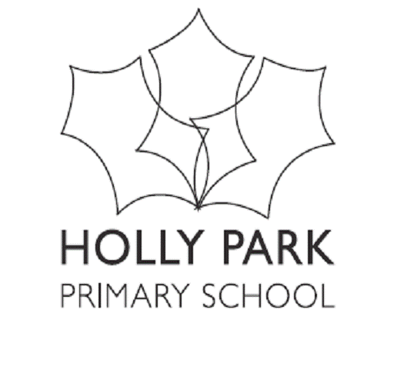 Holly Park Reading Challenge

Roald Dahl Boy
Going Solo
Malorie Blackman Noughts and Crosses
Knife Edge
Berlie Doherty Street Child
Anthony Horowitz Stormbreaker
Point Blanc
Michael Morpurgo King of the Cloud Forests
Private Peaceful
E Nesbit The Railway Children
Five Children and It
Mary Norton The Borrowers
Philip Pullman The Ruby in the Smoke
The Tiger in the Well
Northern Lights
The Subtle Knife
The Amber Spyglass
Arthur Ransome Swallows and Amazons
RL Stevenson Treasure Island
Kidnapped
Paul Stewart Storm Chaser
David Almond Skellig
Eoin Colfer Artemis Fowl
Helen Cresswell Moondial
Alan Garner The Owl Service
Penelope Lively The Ghost of Thomas Kempe
Geraldine McCaughrean The Kite Rider
Roger Mortimer Eagle Warrior
Jenny Nimmo The Snow Spider
Philip Reeve Mortal Engines
JRR Tolkein The Fellowship of the Ring
PL Travers Mary Poppins
Jacqueline Wilson Vicky Angel
Dustbin Baby
The Illustrated Mum
Phillipa Pearce Tom’s Midnight Garden
Richard Adams Watership Down
Colin Dunn The Animals of Farthing Wood
Gerald Durrell My Family and Other Animals
Jack London White Fang
The Call of the Wild
Richmal Compton Just William
Morris Gleitzman Adults Only
Toad Rage
Dodie Smith One Hundred and One Dalmations
Henry Williamson Tarka the Otter
Terry Pratchett Johnny and the Bomb
Diggers
Louis Sacher Holes
There’s a Boy in the Girl’s Bathroom
Nina Bawden Carrie’s War
The Peppermint Pig
Frances H Burnett The Secret Garden
Betsy Byars The Midnight Fox
Susan Coolidge What Katy Did
Anne Fine Madame Doubtfire
The Stone Menagerie
Anne Frank The Diary of a Young Girl
Judith Kerr When Hitler Stole Pink Rabbit
Beverley Naidoo Journey to Jo’burg
Katherine Paterson Bridge to Terabithia
Mildred Taylor Roll of Thinder Hear My Cry
Robert Westall A Time of Fire
The Machine Gunners
Jamila Gavin The Wheel of Surya
The Eye of the Horse
Stewart Foster Bubble Boy
Mitch Johnson Kick
Neil Gaimen Coraline

NON FICTION

Earth Heroes- Lily Dyu
The Speed of Starlight- Colin Stuart
The Language of the Universe- Colin Stuart
Rescue- David Long

