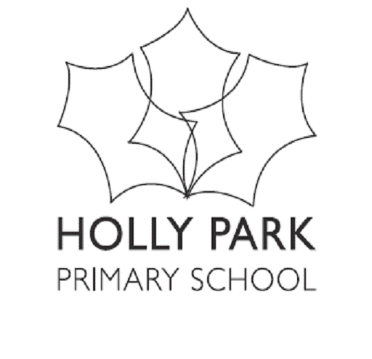 Holly Park Reading Challenge
BLUE
Fight the Flames | Comics for Phonics series
The Crossing of Doom | Comics for Phonics series
Get in the Game | Comics for Phonics series
Flash Dash | Comics for Phonics series
Cool New Costumes | Comics for Phonics series
Spinderella | Julia Donaldson
Big Red Balloon | Anne Fine
Monster Eyeballs | Jacqueline Wilson
Frogs Do Not Like Dragons | Patricia Forde
Dilly and the Goody Goody | Tony Bradman
Jungle School | Elizabeth Laird and Roz Davison
Space Saver | Kate Agnew and Frances Castle
My Secret Alien | Elizabeth Dale
Flat Stanley - Goes Camping | Lori Haskins Houran
The Talent Contest | Tony Bradman
Flat Stanley – The Haunted House | Jeff Brown
Show and Tell, Flat Stanley | Lori Haskins Houran
It’s a Dog’s Life | Michael Morpurgo
Witches Do Not Like Bicycles | Patricia Forde
Ordinary George | Joanna Nadin
Insect Detective | Steve Voake
From Egg to Bee | Camilla de la Bedoyere
It’s a No-Money Day | Kate Milner
See What a Seal Can Do | Chris Butterworth
A Sunflower’s Life Cycle | Mary R Dunn
My Name is not a Refugee | Kate Milner
Hedgehogs Do Not Like Heights | Patricia Forde
The Little Marzipan Man | Laurence Anholt
Sleep | Kate Prendergast
Miranda and the Castaway | James Mayhew
A Squash and a Squeeze (Let’s Read series) | Julia Donaldson
Friday Surprise | Anne Fine
Alfie’s Great Escape | Kate Irwin
I am a Woolly Hat | Salma Koraytem retold by Vivian French
Snakes and Ladders | Michael Morpurgo
Under the Bed | Anne Fine
The Posh Party | Scoular Anderson
Mucky Micky | Laurence Anholt
Magic Ball | Anne Fine
Under the Sea | Sue Mayfield
The Gruffalo (Let’s Read series) | Julia Donaldson
Monster Rhymes | Sheryl Webster
Mairi’s Mermaid | Michael Morpurgo
Spooky Soccer | Malachy Doyle
Flora the Fairies Magic Spells | Tony Bradman
Polly and the Pirates | Tony Bradman
Flora the Fairy | Tony Bradman
Flat Stanley Plays Ball | Lori Haskins Houran
Shout, Show and Tell | Kate Agnew
Cake Test | Pippa Goodhart
Max’s Amazing Models | Linda Chapman
Norman the Naughty Knight and the Flying Horse | Smriti Prasadam-Halls
Dinosaur Disasters | Kate Agnew
Monty Wins the Cup | Jake Sparks
The Stepmonster | Joanna Nadin
Flat Stanley and the Very Big Cookie | Lori Haskins Houran
The Shark in the Dark (Let’s Read series) | Peter Bently
Big Bad Troll | Sally Prue
Space Knights and the Ice Dragons | Sheryl Webster
Who Loves Mr. Tubs? | Bel Mooney
Jam Jar Genie | Sam Hay
Flat Stanley on Ice | Lori Haskins Houran
Dilly and the birthday Treat | Tony Bradman

