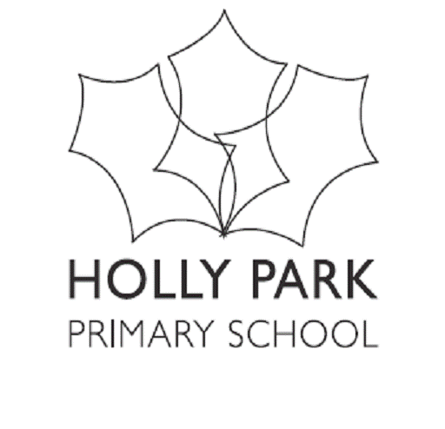 Vocabulary (and concept knowledge) Development

Subject _____History________________
Year Group | Vocabulary List
NURSERY | long ago, before, after, past
RECEPTION | past, present, history, young, before, change
YEAR 1 | past, present, change, before, timeline, decade
YEAR 2 | artefact, contribution, century, ancestor, timeline, society
YEAR 3 | artefact, evidence, era, nomad, agriculture, invasion, revolt, empire
YEAR 4 | Significance, chronology, empire, republic, monarchy, execution, invasion
YEAR 5 | Chronological, empire, industrial, civilisation, legacy, democracy, significance
YEAR 6 | Causation, civilisation, secondary/primary evidence, continuity, allies, archive, perspective.

