Chronological understanding | Range and depth of historical knowledge  An overview of world history | Investigation and Interpretations of history | Historical enquiry | Organisation and communication
I can talk about significant events in my own experience | I can talk about significant events in my own experience | I can talk about the photos in my Special Book | I can ask questions about why things happen and give explanations | I can build up vocabulary that reflects the breadth of their experience
I can talk about past and present events in my own life | I can talk about past and present events in my own life | I can ask questions about why things happen and give explanations | I can talk about differences between old black and white photos and colour photos of the present day | I can use past, present and future forms accurately when talking about events that have happened
I can talk about a past event in the correct order | I can talk about a past event in the correct order
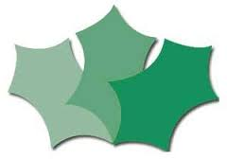Progression in History

