Holly Park School
Teacher Pay Policy
Contents Page
- Policy
- Leadership Group
- Teaching Staff
- Unqualified Teacher Pay
- Teaching & Learning Responsibility (TLR)
- SEN Allowances
- Recruitment & retention Incentives
- Additional Discretionary Payments
- Salary Safeguarding
- Part time Teachers
- Short Notice/Supply Teachers
- Leave of Absence
- Honoraria
- General
- Appeals process
- Document Control
Appendix A School Teachers’ Pay 2018-19
Appendix B Pay Committee Terms of Reference
Appendix C Pay Progression
Appendix D Application to be paid on the Upper Threshold
Appendix E Guidance in Relation to Inspection
Appendix F Holly Park Staffing Structure
SECTION 1 POLICY

1.1 INTRODUCTION
This document is a statement of the aims, principles and policy for determining the pay of teaching staff at Holly Park School.
This policy meets the schools statutory duty to set out how it will determine teachers’ pay and the procedure for appeals.
The statutory requirements for teachers’ pay and conditions in maintained schools are set out in the most up to date School Teachers’ Pay & Conditions Document (STPCD). This policy has been developed to comply with current legislation and the requirements of the STPCD and has been consulted on with the recognised trade unions.
At Holly Park we believe that a distinction should be made between pay increases connected to performance and pay increases relating to the cost of living.
The values of the pay scales adopted by the governing body are shown in Appendix A.
This pay policy will be revised in line with any changes to the staffing structure. The staffing structure sets out the number and pay ranges for teaching posts within the school and is located at Appendix B.
Pay is linked to the Appraisal process, Appraisal will be fair and transparent and sufficiently robust/effective to inform pay decisions. The Pay policy works in conjunction with the Schools Appraisal Policy.
This policy will be reviewed annually at a meeting of the Finance Committee in the autumn term of each new academic year.
This policy has been updated to reflect the recommendations of the School Teachers’ Pay and Conditions Document . It will be kept under review in the light of future reports.
Teachers and representatives of recognised unions will always be consulted on formulating the policy and on any changes to it.
The school’s staffing structure is attached to the pay policy and appropriate consultation with staff and trade unions must take place when any changes are proposed to the staffing structure.

1.2 AIMS
The governors will manage pay policy and decisions in a fair, transparent and responsible way, recognising the principle of equal pay for like work and for work of equal value and having regard to relevant legislation.
Governors wish to utilise pay and rewards effectively to:
- Assure and maximise the quality of teaching and learning at the school
- Determine the annual pay budget
- Link pay decisions to the school’s Appraisal Policy
- Support recruitment and retain, reward, motivate and develop a skilled and flexible workforce.

1.3 PRINCIPLES
All teachers employed at Holly Park school are paid in accordance with the statutory provisions of the School Teachers’ Pay and Conditions Document (STPCD). The school supports the intention laid out in the STPCD that the majority of teachers will progress within the pay range. Teachers will not progress where their overall performance fails to reach expected, clear and measurable criteria.
All pay-related decisions take full account of the school improvement plan.
The Pay Committee of the governing body will ensure that the policy is implemented to required time-scales.
The governing body will publish its pay policy on the school website and on the staff shared drive. This policy will be made available to staff upon request.
Governors will consult with staff and trades unions within the school in the event of any change to this policy

Governors will keep its policy in line with that of other local schools and in accordance with the government’s initiatives around workforce reform.

Governors will avoid direct or indirect discrimination on grounds of age, disability, gender, marital status, sexual orientation, race, colour, religion, nationality, ethnic or racial origins;

1.4 RESPONSIBILITIES
The governing Body has established the following committees which have fully delegated powers to make decisions on pay and (except in relation to the headteacher’s pay) will be advised by the headteacher as appropriate:
- Pay Committee
- Pay Appeals Committee
The Chair of the pay committee is not employed at the school. All members of the Committee will treat as confidential any information, discussions or recommendations of the committee. All pay-related decisions taken by the committee will take full account of the school improvement plan.
The Pay Committee will be attended by the Head in an advisory capacity. Where the Pay Committee has invited either a representative of the LA or the External Adviser to attend and offer advice that person will withdraw while the committee reaches its decision.
Please see Appendix C for terms of reference.

1.5 TIMING OF SALARY DETERMINATIONS AND NOTIFICATION
- A decision on whether to award a headteacher’s pay increment(s) will be made no later than 31 December each year.
- A decision on whether to award pay increments for the Deputy headteacher, Assistant headteacher, Leading Practitioners, and Teachers will be made no later than 31 October each year.
- All teachers are given a written statement setting out their salary and any other financial benefits to which they are entitled by November 30th each year.
- A decision on applications to access the Upper Pay Range will be made within 10 working days of the closing date for applications (subject to governing body approval)
- Reviews can take place at other times of the year to reflect changes in circumstance or job description that change the basis for calculating an individual’s pay.
- A written statement will be given after any review outlining the basis on which the decision was made.
- Where a pay determination leads to the start of a period of salary safeguarding, the governing body will give the required notification no later than one month after the date of the determination.
All teachers (including Leadership members) should be issued with an annual salary statement.
The annual pay statement for staff will state the following:
- The relevant point/amount in the salary range the employee will be paid (from 1 September)
- The full-time salary.
- The pro rata annual salary to be paid if the employee is part-time.
- Any increments and salary discretions that have been exercised to determine the salary i.e.: TLR, SEN or Recruitment or Retention allowances.
- Any safeguarded sum and duration.

1.6 BASIC PAY DETERMINATION ON APPOINTMENT
Governors will determine the pay range(s) for any vacancy prior to advertising it. Leadership posts will be advertised with an Individual Salary Range (ISR) pay range based on the relevant pay band linked to group size. Where there are any circumstances in which a salary range may be increased for an exceptional candidate this will be clearly stated in the advertisement.
The starting salary will be decided on appointment. In making pay determinations, the governing body may take into account a range of factors:
- The nature of the post
- The level of qualifications, skills and experience required
- The wider school context e.g. challenges and circumstances of the school
The governing body may decide to pay a higher starting salary within the range advertised where it is necessary to recruit a teacher of the necessary quality and is merited by evidence of the skills and experience of the successful candidate.
Teachers will not be paid on the Upper Pay Range unless the school is required or entitled to do so, and will not be paid on the pay range for leading practitioners or leadership unless they are employed as teachers whose primary purpose is the modelling and leading improvement of teaching skills and have met the criteria relevant to a specific post within the schools staffing structure.
NQTs in their first year will normally be paid on the minimum of the Main Pay range.
Where the post is on a temporary basis, the advertisement will specify the reason for and duration of the post.

SECTION 2 LEADERSHIP GROUP

The school will adopt the Local Authority recommendation of retaining the 43 Point Pay Range for Leadership Group pay.

2.1 SCHOOL GROUP SIZE
The headteacher Group size of Holly Park School is Group 3. This has been determined by reference to the criteria laid down in the current STPCD.
The governing body will review the headteacher Group Size:
a) Whenever it is proposed to appoint a new headteacher;
b) Where there is a significant change in responsibilities;
c) Where there is an expected or known change in pupil numbers and
d) In any event, not more than 3 years after the school was last assigned to a headteacher group.

2.2 Determination of the School’s Individual Schools Range (ISR)
The governing body have determined that there will be a 7 point Individual Salary Range (ISR) pay range within the Leadership headteacher Group Pay Spine.
- The ISR is not an incremental scale carrying expectation of automatic pay progression.
- The ISR will be determined by the broad pay range based on group size plus other factors that may influence pay related to the particular challenges, context and circumstances of the school.
- The ISR will take into account any permanent duties and responsibilities of the post and any additional factors that need to be considered e.g.: additional accountabilities, long term provision of services to other schools, significant recruitment and retention difficulties.
- The bottom point of the ISR will be at least one spine point above the maximum of the pay scale of any Deputy or Assistant headteacher at the school unless exceptional circumstances apply in which case they will be clearly stipulated.
- Where there is any flexibility to increase the salary range for an exceptional candidate by negotiation this will be reflected in the advertisement.
- Governors will not take account of the salary of the serving HT if they re-determine the ISR when recruiting a new Headteacher.
- Governors will ensure sufficient flexibility and scope to allow and reward for performance related progress over time.
- Governors will revise the ISR which has been assigned based on expected pupil numbers, if the expected numbers change.
- Governors may choose to review the pay of all the leadership team if this is necessary to maintain consistency with new appointments made on or after 1 September 2014 in line with revised arrangements for determining leadership pay.

The ISR of Holly Park is point 18-24

2.3 HEADTEACHER’S PAY
At the beginning of each academic year the Governing Body will delegate two governors (Chair and Vice Chair) who will agree performance objectives with the Headteacher. The governors will appoint an external adviser to provide independent advice .The performance objectives will reflect priorities identified in the school's development plan.
The appraisal review will be conducted in accordance with the school's appraisal procedure.
Following the annual Appraisal of the Headteacher, the Pay Committee will receive recommendations from the delegated governors about the salary of the Headteacher. The recommendation shall reflect the delegated governors' views based on the outcomes of the annual performance review and the Chair of Governors view of the Headteacher's overall performance during the year.
The recommendation for the Headteacher will be made to the Pay Committee of the Governors, giving reasons for the recommendation and the level of salary that it is recommended should be paid from the 1st September i.e. back dated to the start of that school year.
The headteacher's salary will be reviewed by 31 December each year with reference to performance objectives agreed between the headteacher and the Appraisal Governors.
- Taking into account the achievement against previously agreed or set objectives and the criteria for leadership group progression, governors may award up to two performance points in an academic year, effective 1 September.
If the Headteacher wishes to appeal against the proposal of the Pay Committee of the Governors regarding his/her pay, s/he may appeal to the Appeals Panel as referred to in this procedure.

Governors will aim to ensure that the maximum of the ISR does not exceed the maximum of the headteacher Group range however there is discretion to set pay up to a maximum of 25% above the top of the relevant pay band where this is justified by school/candidate specific factors.
The total sum of discretionary payments to the headteacher in any school year will not exceed 25% of the headteacher’s current pay point (except in wholly exceptional circumstances). It should be noted that the 25% is the upper limit, it is not the expectation that discretionary payments will automatically be set at 25%.
The governing body will take a wide view on which overall contextual factors, circumstances and complexities will justify raising the ISR beyond that of the Headteacher group range. The following areas are examples of what may be considered to inform such decisions, please note these are for illustrative purposes only and the presence of any factor offers no automatic entitlement to an increase. Governors will also consider the affordability and sustainability of such an increase.
School context – e.g. single phase, size of school, significant recruitment and retention problems, level of challenge/required performance of the school
Candidate specific – e.g. differentials between members of the leadership team, opportunity for pay progression, incentive to relocate, avoiding detriment in relation to existing pay, additional skills/experience required
Level of disadvantage – e.g. Challenge this presents to individual school, number of free school meals
Governors will only make discretionary payments to their headteacher which exceed 25% of the Headteacher’s current pay point in wholly exceptional circumstances. Only in exceptional circumstances, where independent advice has been sought and where supported by a business case, can Governors exceed the 25% limit. If it is considered that there are exceptional circumstances that warrant a payment in excess of the limit governors will make a business case for the payment to the full governing body. Governors will then seek external independent advice from an appropriate person or body who can consider the provisions of the STPCD and whether they have been properly applied to the headteacher’s pay, before making a decision on whether it is justifiable to exceed the limit in each particular case.
There will be a clear audit trail for any advice given to the governing body and a full and accurate record of all decisions made by the governing body and the reasoning behind them.
If a Headteacher in post is already on an ISR that exceeds the maximum of the headteacher Group range, that ISR will continue to apply unless/until governors decide to recalculate the ISR, after which the new ISR will need to be within the range available for the group size unless discretion is exercised.
Headteachers may not be awarded recruitment or retention payments other than as reimbursement of reasonably incurred housing or relocation costs.
Headteachers may not be awarded Additional Payments for: -
- Continuing professional development undertaken outside the school day
- Activities relating to the provision of initial teacher training as part of the ordinary conduct of the school
- Participation in out of school hours learning activity
- Additional responsibilities and activities due to, or in respect of the provision of services relating to the raising of education standard to one or more additional schools.

2.4 HEADTEACHERS ACCOUNTABLE FOR MORE THAN ONE SCHOOL
2.4.1 Permanent arrangement
Where the school enters into a permanent arrangement where the headteacher is appointed as headteacher (or Executive Headteacher) of more than one school a new headteacher group size will be determined by adding together the total pupil unit score of all of the schools.
2.4.2 Temporary Arrangement
Where the school enters into a temporary arrangement where a headteacher (or Executive Headteacher) is temporarily responsible for one or more additional schools, as well as their continuing role as headteacher of their own school, the additional responsibility will be rewarded via a discretionary payment, not via an increase in the ISR.
Temporary arrangements will be limited to a maximum of two years while a permanent solution is being sought. Governors of both/more schools will clarify how (a) these arrangements will work in practice and (b) how the arrangements will be brought to an end.
A fixed term variation of contract for the temporary arrangement will specify that the headteacher is for a fixed period employed additionally as headteacher of the additional school(s).
Where the arrangement for the head teacher is temporary, any adjustment to their pay and that of other teachers is also temporary, and safeguarding provisions will not apply when the arrangements cease.

2.4.3 Temporary Payments to Headteachers
In addition to the pay set via the ISR governors have the flexibility to award payments for clearly defined temporary responsibilities.
Governors will consider
- The appropriateness of the payment in the context of the school.
- the affordability aspect, both at the time of the request and over the next 2-3 years
- any other pertinent issues including risks, such as equal pay challenges

The total sum of discretionary payments to the headteacher in any school year will not exceed 25% of the headteacher’s current pay point (except in the wholly exceptional circumstances. It should be noted that the 25% is the upper limit, it is not the expectation that discretionary payments will automatically be set at 25%.

2.5 DEPUTY AND ASSISTANT HEADTEACHER’S PAY
Deputy Head
The governing body will determine the pay range for deputy when it proposes to make a new appointment; or revise the actual pay range where there is a significant change in their responsibilities.
The pay range may be determined as of 1 September or at any time of the year to reflect any changes in the circumstances or job description.
The pay spine of any deputy will start at a higher point than the lowest point on any Assistant Headteacher’s range in the school, and in the absence of an assistant headteacher, at a point above the salary of the highest paid teacher unless exceptional circumstances apply
At Holly Park the highest point on a deputy headteacher’s scale will be at least one point lower than the bottom point of the headteacher’s ISR (7-point scale) The pay range for a Deputy or Assistant Headteacher should only overlap the Headteacher pay range in exceptional circumstances.
The pay range will take into account any permanent duties and responsibilities of the post and any factors that need to be considered e.g. additional accountabilities, long term provision of services to other schools, significant recruitment and retention difficulties
The governing body have determined that a 5 point range on the Leadership Group Pay Spine for the deputy headteacher (s) shall be point 10 to point 14. If there is more than one deputy or assistant headteacher the pay spines may be different, to take account of the responsibilities of each post.
The Pay Committee delegates to the Headteacher the agreement of performance objectives for pay purposes for the Deputy Head. Objectives will be agreed and reported to the Pay Committee as early as possible in the Autumn term. The Deputy Head may agree objectives directly with the Pay Committee where agreement between the head and Deputy is not achieved.
The Pay Committee is aware of the headteacher’s duty to set performance objectives in default of agreement. This power will only be exercised as a last resort after the appeal procedure has been exhausted. The general appeals procedure will apply. The Deputy Head is entitled to submit a written statement, commenting on any objectives set, which will be taken into account at the time of the review.
Where performance objectives are deemed by the Headteacher, or reviewer, to have been satisfactorily met, he/she may recommend to the Pay Committee that the Deputy or assistant headteacher’s pay will increase by 1 or 2 points on the pay range.
Deputy Headteachers and Assistant Headteachers may not be awarded recruitment or retention payments other than as reimbursement of reasonably incurred housing or relocation costs. The 25% discretion applicable to Headteachers does not apply to other members of the Leadership team.

Assistant Head (Not a role at HPS at the current time)
If a decision is made to appoint an Assistant Head, the Governing Body will determine the pay range to be advertised and agree pay on appointment as follows:
The Pay Committee will determine an Assistant Head pay range
The Pay Committee will have regard to appropriate differentials being created and maintained between posts of differing responsibility and accountability.
The Pay Committee delegates the Head the agreement of performance objectives for the Assistant Head. Objectives will be agreed and reported to the Pay Committee as early as possible in the autumn term. The Assistant Head may agree objectives directly with the Pay Committee where agreement between the Head and Assistant Head is not achieved.
The headteacher is aware of the duty to set performance objectives in default of agreement. This power will only be exercised as a last resort after the appeal procedure has been exhausted. The general appeals procedure will apply. The Assistant Head is entitled to submit a written statement, commenting on any objectives set, which will be taken into account at the time of the review.
The headteacher will review the performance of the Assistant Head against the performance objectives and award up to two points where objectives are met.

2.5.1 Additional responsibilities due to changes to the role of the Headteacher
If the headteacher at the school becomes responsible for more than one school (permanent or temporary arrangement) consideration will be given to the pay of deputy and assistant heads. An increase in pay will only be agreed where the post accrues additional extra responsibilities as a result of the Headteacher’s enlarged role. It should not be assumed that an increase to the deputy and assistant heads pay is a requirement in all cases.
The governors will consider:
- increasing the pay range of the deputy/assistant head
- appointing a teacher to a post in the staffing structure which attracts a TLR payment
- using additional payments where the other options are not appropriate.

Where the arrangement for the headteacher is temporary, any adjustment to their pay and that of other teachers is also temporary and safeguarding provisions will not apply when the arrangements cease.
2.5.2 Acting Deputy/Assistant Headteachers
The governing body will consider whether teachers who have been appointed as acting headteacher, deputy headteacher or assistant headteacher but who have been assigned to and have been carrying out the duties of head, deputy or assistant headteachers should receive an acting allowance as a separate addition to their normal pay. The consideration will be made within four weeks of the commencement of the teacher carrying out such temporary duties.
The allowance will be paid from or backdated to the time when the teacher performed tasks that required the full authority of the post to be exercised.
Any pay agreed by the governing body will be equivalent to at least the minimum leadership spine point payable in the school for the post in which the teacher is acting.
Teachers in receipt of an acting allowance will be subject to all the conditions of employment appropriate to the post in which they are acting up.
(Salary Safeguarding provisions will not apply when the Acting arrangements cease).

2.6 LEADERSHIP GROUP STEPPING DOWN FROM POST INTO UPPER PAY RANGE
Where a teacher is a post-threshold teacher governors may determine which point on the upper pay range to place them.

SECTION 3 TEACHING STAFF

3.1 Pay of Upper Pay RANGE and Main Pay Range Teachers
The school will adopt the Local Authority recommendation of retaining the 6 point Main Pay Range and the 3 point Upper Pay Range.
- Upper Pay Range teachers (UPR)
UPR teachers will have a three point scale containing UPR1, UPR2 and UPR3. Only teachers who have met the relevant criteria can progress into the Upper Pay Range.
Progression on the UPR is performance based, rather than incremental.
b) Main Pay Range teachers
Progression in the Main Pay Range is performance based, rather than incremental, the Appraisal Policy should be used as the basis of decisions relating to Main Pay Range progression.

3.2 ASSESSMENT AND MOVEMENT ONTO THE UPPER PAY RANGE
Any qualified teacher on the main pay range is eligible to apply to access to the upper pay range. It is the responsibility of the teacher to decide whether or not they wish to apply to be paid on the upper pay range.
The school will consider applications once a year. Applications should be made in writing to the Headteacher by 31st October notifying the school that the teacher wants to be considered for the threshold at the end of that academic year. The pay committee meet in July to consider pay recommendations.
The application must be passed to the Appraisal team manager and must be assessed by the Appraisal team manager.
If a teacher is simultaneously employed at another school(s) this school will not be bound by any pay decision made by another school.
Upper pay scale teachers will generally start on the lowest point of the UPR upon access to the Upper Pay Range; however the governors may consider other factors when determining their salary such as
- The nature of the post
- The level of skills, qualification or experience required
- Market conditions
- The wider school context

3.2.1 The Assessment
An application from a teacher holding QTS will be successful as evidenced by 2 successful appraisal reviews and where the governing body is satisfied that:
a) The teacher is highly competent in all elements of the relevant standards;
- ‘highly competent’ means performance which is not only good but also good enough to provide coaching and mentoring to other teachers, give advice to them and demonstrate to them effective teaching practice and how to make a wider contribution to the work of the school, in order to help them meet the relevant standards and develop their teaching practice.
And
b) The teacher’s achievements and contribution to the school are substantial and sustained.
- ‘substantial’ means of real importance, validity or value to the school; play a critical role in the life of the school; provide a role model for teaching and learning; make a distinctive contribution to the raising of pupil standards; take advantage of appropriate opportunities for professional development and use the outcomes effectively to improve pupils’ learning; and

- ‘sustained’ means maintained continuously over the previous 2 academic years. A lesser period of time can be considered in situations such as maternity or long term sickness. If a teacher is working on a part time basis, the period of time remains 2 years and is not lengthened on a pro rata basis.

It is NOT enough to go through to each level of UPS just having done 2 years since the last application. Teachers wishing to go through to each new level MUST meet the requirements and performance criteria. Teachers who are on the UPS pay scale will need to meet the Post Threshold standards over a sustained period of time.
The application will be finally assessed by the headteacher who will make a recommendation to the pay committee of the governing body so that they can make the final determination
3.2.2 Notification
The assessment will be made within 10 working days of the closing date for applications at which point the employee will receive a written response informing them of the outcome of the headteacher’s recommendation (at this stage this would be still subject to governing body agreement)
If successful, applicants will move to the upper pay range and have their pay start at the beginning of the next academic year following on from which they have been assessed as meeting the criteria.
If unsuccessful, feedback will be provided by the headteacher in writing within 10 working days of the decision, clearly setting out the reasons for the decision.
An appeal against a decision not to move the teacher to the Upper Pay Range will be heard under the schools pay appeal arrangements.

3.3 LEADING PRACTITIONERS
The governors have chosen to refer to the Local Authority determined points within the leading practitioner pay range and the 5 point pay range will be L2 to L6.
Existing Advanced Skills Teachers (ASTs) and Excellent Teachers (ETs) will be considered for assimilation to the Leading Practitioner range at a pay range which would maintain as a minimum their existing pay entitlements if it can be shown that their posts already have the primary purpose of modelling and/or leading improvement of teaching skills, where those duties fall outside the criteria for the TLR payment structure.
Leading practitioners are a specific post identified in the school staffing structure, application to become a leading practitioner will only be considered where such a vacancy exists within the structure. Leading practitioners must demonstrate sustained high quality of performance in the light of their agreed performance objectives which should be linked to modelling and leading the improvement of teaching skills, and will be subject to an appraisal before any pay recommendation is made. Where applicable work undertaken at other schools as part of their role, higher education facilities, the local authority and elsewhere will be taken into account.
Leading practitioners are expected to take a lead role in developing, implementing and evaluating policies and practice that contribute to school improvement.
Progression on the Lead Practitioner Pay Range is performance based, rather than incremental.

SECTION 4 UNQUALIFIED TEACHERS PAY
The school will adopt the Local Authority recommendation of retaining the 6 point Unqualified Teacher pay scale.
There are three types of ‘unqualified teacher’ (UQ) employed in schools:
- Trainees working towards qualified teacher status (QTS).
- Overseas trained teachers who have not exceeded four years in post without attaining QTS status.
- Unqualified teachers or instructors with a particular skill.
Unqualified Teachers will only be appointed where:
No qualified teacher is available following attempts at recruitment (except in the case of unqualified teachers or instructors with a particular skill)
The School is supporting an individual through employment based route to obtain qualified teacher status, e.g. Graduate Training Programme
Progression on the Unqualified Pay Range is performance based, rather than incremental.

4.1 UNQUALIFIED TEACHER’S ALLOWANCE
Governing bodies may pay an additional allowance to an unqualified teacher, in the context of their staffing structure and pay policy, if they consider that the unqualified teacher has:
- A sustained additional responsibility which is focused on teaching and learning, and requires the exercise of a teacher’s professional skills and judgement; or

- Qualifications or experience which bring added value to the role they are undertaking for example -
- A recognised overseas teaching qualification
- A recognised post-16 teaching qualification
- A recognised qualification relevant to their subject area
- Experience other than employment as an unqualified teacher which the relevant body consider to be of value to the performance of the unqualified teachers duties.
- Excellent performance over the previous school year having regard to all aspects of the teachers professional duties, in particular, classroom teaching.
- Experience as an overseas-trained teacher
- Experience of teaching in further education, including sixth form colleges.
- Experience teaching in higher education.
- Experience working in a relevant area for example industrial or commercial training, time spent working in an occupation relevant to the teacher’s work at the school, and experience with children/young people.

4.2 Unqualified teacher who becomes qualified
Where an unqualified teacher becomes qualified the relevant body will transfer the teacher to the main pay range either at the same salary or higher that it was on the unqualified teacher range.

SECTION 5 TEACHING AND LEARNING RESPONSIBILITY (TLR) PAYMENTS

TLR payments are only payable to classroom teachers for undertaking sustained and substantial additional responsibilities for the purpose of ensuring the continued delivery of high quality teaching and learning that are not required of all classroom teachers. This responsibility and level of accountability will be clearly defined in the job description of the TLR. Teachers will not be expected to undertake permanent additional responsibilities without payment of a permanent TLR1 or TLR2. TLR’s are not payable to Unqualified Teachers, Leading Practitioners, Assistant/Deputy or Headteachers.
The governing body pays TLR payments either at TLR Level 1 or TLR Level 2, or a fixed term payment at TLR Level 3 in accordance with the pay ranged specified in the STPCD as updated from time to time and the following levels and values will apply :-
Before awarding any TLR 1 or 2 payments, the governing body must be satisfied that the teacher’s duties include a significant responsibility that is not required of all classroom teachers and that:
- is focused on teaching and learning;

- requires the exercise of a teacher’s professional skills and judgment;

- requires the teacher to lead, manage and develop a subject or curriculum area; or to lead and manage pupil development across the curriculum;

- has an impact on the educational progress of pupils other than the teacher’s assigned classes or groups of pupils; and

- involves leading, developing and enhancing the teaching practice of other staff.

In addition, before awarding a TLR1 payment, the governing body must be satisfied that the significant responsibility referred to above includes line management responsibility for a significant number of people.
During the course of the school year additional projects/priorities arise that may lead to the award of additional TLR3s (e.g. in response to Ofsted inspection) in such cases the number and level of these will be determined by the headteacher.
Where a TLR3 is awarded for a fixed term school improvement project, or one off externally driven responsibilities, the duration of the fixed term will be established at the outset.
A teacher cannot hold a TLR 1 and a TLR2 concurrently.
But a teacher can hold a TLR 3 concurrently with either a TLR1 or TLR2.
Unqualified teachers may not be awarded TLRs but they can be awarded an allowance as the Governing Body consider appropriate where it considers that the teacher has: -
- Taken on a sustained additional responsibility which:
- is focused on teaching and learning; and
- requires the exercise of a teacher’s professional skills and judgement; or
- qualifications or experience which brings added value to the role being undertaken.

SECTION 6 SPECIAL EDUCATIONAL NEEDS ALLOWANCE (SEN)

SEN allowances are not payable to Unqualified Teachers, Leading Practitioners, Assistant/Deputy Headteachers or Headteachers.
A spot rate SEN allowance between £2064- £4075 is payable to a classroom teacher who meets the following criteria for such an allowance.
Governors will award an SEN allowance to a classroom teacher-
  - In any SEN post that requires a mandatory SEN qualification
  - In a special school;
  - Who teaches pupils in a designated special class(es) or units in a school or in the case of an unattached teacher, in a local authority unit or service;
  - In any non-designated setting (including any PRU) that is analogous to a designated special class or unit, where the post -
(i) involves a substantial element of working directly with children with SEN;
(ii) requires the exercise of a teacher’s professional skills and judgement in the teaching of children with SEN; and
(iii) has a greater level of involvement in the teaching of children with SEN than is the normal requirement of teachers throughout the school or unit within the school
Where an SEN allowance is to be paid, governors will determine the spot value of the allowance, taking into account the structure of the school’s SEN provision and the following factors-
  - whether any mandatory qualifications are required for the post;
  - the qualifications or expertise of the teacher relevant to the post; and
  - the relative demands of the post.

SECTION 7 RECRUITMENT AND RETENTION INCENTIVES AND BENEFITS

The governing body may make payments or provide other financial assistance, support or benefits to a teacher as it considers necessary as an incentive for the recruitment of new teachers or retention of existing teachers.
The expected duration of the arrangement will be clearly communicated in each case but may be subject to review for example if the teacher changes role within the school year. Salary Safeguarding provisions will not apply when the arrangement ceases.
The Headteachers and others on the Leadership range may not be awarded payments other than as reimbursement of reasonably incurred housing or relocation costs on appointment.

Recruitment Incentives
The governing body will pay recruitment incentives to: -
- Teachers in shortage subjects
- Poor response to adverts as evidenced by the need to readvertise

Retention Incentives
The governing Body will pay retention incentives to
- Teachers in specific shortage subjects

The above will be kept under review and subject to change.

SECTION 8 ADDITIONAL DISCRETIONARY PAYMENTS FOR TEACHERS

The governing body may make discretionary payments to a teacher other than a Headteacher in respect of :
- Continuing professional development undertaken outside the school day
- Activities relating to the provision of initial teacher training as part of the ordinary conduct of the school
- Participation in out of school hours learning activity
- Additional responsibilities and activities due to, or in respect of the provision of services relating to the raising of education standard to one or more additional schools.

The basis on which such payments are made should be reviewed regularly.

8.1 PAYMENTS FOR CONTINUING PROFESSIONAL DEVELOPMENT (CPD) ACTIVITIES
Additional discretionary payments may be awarded to teachers who agree to undertake CPD outside normal school times as requested by the school – these would be longer term courses stretching over several weeks.

8.2 INITIAL TEACHER TRAINING (ITT) ACTIVITIES
Additional discretionary payments may be awarded to teachers who agree to undertake activities related to providing ITT as part of the ordinary conduct of the school.
Activities may include - supervising and observing teaching practice; giving feedback to students on their performance and acting as professional mentors; and formally assessing students’ competences; planning an initial teacher training course; preparing course materials; and taking responsibility for the well-being and tuition of initial teacher training students.
Teachers who undertake initial teacher training activities which are not seen as part of the ordinary running of the school will be given separate contracts of employment to cover areas of work that are not part of their substantive teaching job or contract of employment.

8.3 PAYMENTS FOR SERVICES FROM ONE SCHOOL TO ANOTHER
Additional discretionary payments may be awarded for teachers undertaking additional responsibilities and activities connected with the provision of services relating to the raising of educational standards to one or more additional schools if they have been asked to do this by the school over an extended period of time.

SECTION 9 SALARY SAFEGUARDING

9.1 GENERAL SALARY SAFEGUARDING - TEACHERS
Salary Safeguarding will be managed in accordance with the criteria laid down in the STPCD.
The governing body will notify a teacher in writing within one month of any determination, which results in salary safeguarding, of:
- The reason for the determination
- The date on which the decision will take effect;
- The teacher’s original salary
- The safeguarded sum
- The date on which safeguarding will cease if his/her employment at the school ends or his/her salary increases owing to movement up the scale/spine and the increase equals or exceeds the safeguarded sum

Teachers in receipt of a safeguarded sum of more than a total of £500 are required to undertake additional duties commensurate with the safeguarded sum. The headteacher and teacher will agree what these additional duties should be.

SECTION 10 PART TIME TEACHERS

Teachers employed on an ongoing basis at the school but who work less than a full working week are deemed to be part-time
The salary/allowances of a part-time teacher must be determined in accordance with the pro-rata principle.
“pro rata principle” means that proportion of total pay (what the teacher would be paid if employed in the same post on a full time basis) which corresponds to the number of hours that the teacher is employed during the course of the school’s timetabled teaching week as a proportion of the total number of hours in the school’s timetabled teaching week; …
“the school’s timetabled teaching week” means the aggregate period of time in the school timetable during which pupils are normally taught).
When determining a part time teacher’s salary in accordance with the pro rata principle the governing body will consider not only the hours normally worked under the contract of employment but also any additional hours the teacher may agree to work from time to time at the request of the head teacher or in the case where the part-time teacher is a head teacher, the governing body.
The same percentage must be applied to any allowances awarded to a part-time teacher.

SECTION 11 SHORT NOTICE/SUPPLY TEACHERS

Teachers employed on a day-to-day or other short notice basis must be paid on a daily basis calculated on the assumption that a full working year consists of 195 days, periods of employment for less than a day being calculated pro rata. Such teachers who are employed throughout a period of 12 months beginning in August or September must not be paid more in respect of that period than would have been paid had the teacher been in regular employment throughout the period.

SECTION 12 LEAVE OF ABSENCE

Teachers employed full-time must be available for work for 195 days in any year, of which 190 days shall be days when they may be required to teach children.
Requests for leave of absence for reasons other than personal sickness will be considered by the Headteacher in consultation with the governing body as appropriate, and within the framework of the appropriate special leave policy.

SECTION 13 HONORARIA
- There is no provision within the STPCD for the payment of bonuses or honoraria of any kind.

SECTION 14 GENERAL

14.1 EQUALITY ISSUES, CONSULTATION AND RECORDING
The governing body will, through its pay policy and other means seek to ensure that staff are afforded equal opportunities, in all matters relating to gender, race, disability, religion, sexual orientation, age and trade union activities.
The governing body will monitor the outcomes and impact of this policy on a regular basis (annually) including trends in progression across specific groups of teachers to assess its effective and the school’s continued compliance with equalities legislation.

14.2 CONSULTATION
Governors note that the model policy from the Local Authority upon which this school policy has been based has been the subject of consultation with local Trade Union representatives.
The governors will ensure that all members of staff have access to a copy of the School’s Pay Policy.
The governors will make the Pay Policy subject to annual consultation and review.

14.3 SALARY RECORDS
All staff will have the right to access their own salary records. Any member of staff requesting their salary record should contact the Headteacher. The school will ensure confidentiality of staff salaries information. It will be stored in a secure place and access will be controlled in line with the requirements of the Data Protection Act.

14.4 JOB DESCRIPTIONS AND CONTRACTS OF EMPLOYMENT
The Staffing and Pupil Welfare Committee of the governing body is responsible for ensuring that: -
  - Each post has a job description that accurately sets out the duties of that post.
  - All new appointees receive a letter of appointment and statement of particulars which may be via the school’s HR provider.

SECTION 15 APPEALS PROCESS
Process/Conduct of meeting:-
15.1 APPEALS COMMITTEE
The teacher can make a formal appeal to the Pay Appeals Committee against a decision on pay. The Appeal must be lodged within 10 working days of receipt of the Pay Committee’s decision.
The Pay Appeals Committee must consist of 3 governors who are not employees of the school and should have had no prior involvement in the process.
To make an appeal the teacher must write to the chair of the Appeals committee and state their grounds for appeal.

15.2 GROUNDS FOR APPEAL
The available grounds for appeal are,
That the person or committee by whom the decision was made –
- Incorrectly applied the schools’ pay policy
- Incorrectly applied any provision of the STPCD;
- Failed to have proper regard for statutory guidance;
- Failed to take proper account of relevant evidence;
e) Took account of irrelevant or inaccurate evidence;
f) Was biased; or
g) Unlawfully discriminated against the teacher.

Please note that an appeal will not deal with:
  - Issues relating to a teacher’s competence
  - The performance of other teachers

The committee or person who made the determination should provide a hearing, within ten working days of receipt of the written appeal, to consider the appeal. Papers intended for consideration must be exchanged no later than 5 working days on advance of the appeal.
The teacher should attend and had the right to be accompanied by a workplace colleague or trade union representative.

15.3 PROCESS / CONDUCT OF MEETING
The meeting should be attended by:-
- Employee (and their representative)
- Representatives of the Pay Committee
- Headteacher should attend to provide information and advice
- Pay Appeals Committee
- Witnesses (if required)
- Clerk
- LA/HR Advisors (if required)

15.4 Pay Panel Hearing Procedure
A suggested procedure for the conduct of formal hearings:
Introductions
• Chair introduces everyone, what their role is, and then outlines the order of the hearing.
• Clerk takes notes of the hearing.
The employee case
• Employee or their representative presents employee case providing any evidence to support their case including from witnesses (if any).
• Management representative has the opportunity to question the employee.
• Chair asks questions and subsequently opens the discussion to the panel.
The management case
• Management representative presents management case, providing any evidence to support their case and any witnesses.
• Employee or their representative has the opportunity to question the management representative.
• Chair asks questions and subsequently opens the discussion to the panel.
Summarising and end of hearing
• Employee or their representative sums up the employee case.
• Management representative sums up the management case.
• If appropriate, the Chair can sum up the key points on both sides. Chair will then end the hearing, advising the employee that they will receive the panel’s decision in writing within a given timescale.
Decision-making
• Panel meet to reach their decision.
• Clerk notes main points of panel discussion and their decision.
• Panel obtains HR advice if required to inform their decision-making.
Communication of decision
• Employee is notified of decision. Decision and reason for the decision confirmed in writing.
Outcomes
- Original decision is upheld and pay progression is denied
- Original decision is overturned and pay progression is granted

Document Control

Revision History
Version | Revision Date | Revised By | Revision
1.0 | Autumn 2013 | Ann Pelham | Updated in light of current advice regulations about teacher pay & Appraisal
1.1 | Autumn 2013 | Govs Finance | Reviewed
1.2 | Autumn 2014 | Govs Finance | Reviewed
1.3 | Autumn 2015 | Ann Pelham | Re-written based on LA advise and model pay policy
1.4 | December 2015 | Full governors | Ratification of policy
1.5 | September 2016 | Ann Pelham | Updated in line with STRB review 2016-17  Consultation with staff Sept & Oct 2016
1.6 | October 2016 | Govs Finance | Review & updated
1.7 | Autumn 2017 | Govs Finance | Reviewed & updated in line with government direction and Barnet & union advice
1.8 | Autumn 2018 | Govs Finance | Reviewed & updated in line with government direction and Barnet & union advice
1.9 | Autumn 2019 | Govs Finance | Reviewed & updated in line with government direction and Barnet & union advice
2.0 | Autumn 2020 | Govs Finance | Reviewed & updated in line with government direction pay Committee and Barnet & union advice

Signed by
 | Name | Signature | Date
Headteacher | Ann Pelham
Chair of Governors | Tim Graveney

Distribution
Shared with
- Staff via school server
- Prospective candidates via Website
- Governors via finance committee meetings
- Governors via full governing body meeting

Date for next review
Autumn 2021

APPENDIX A TEACHER PAY
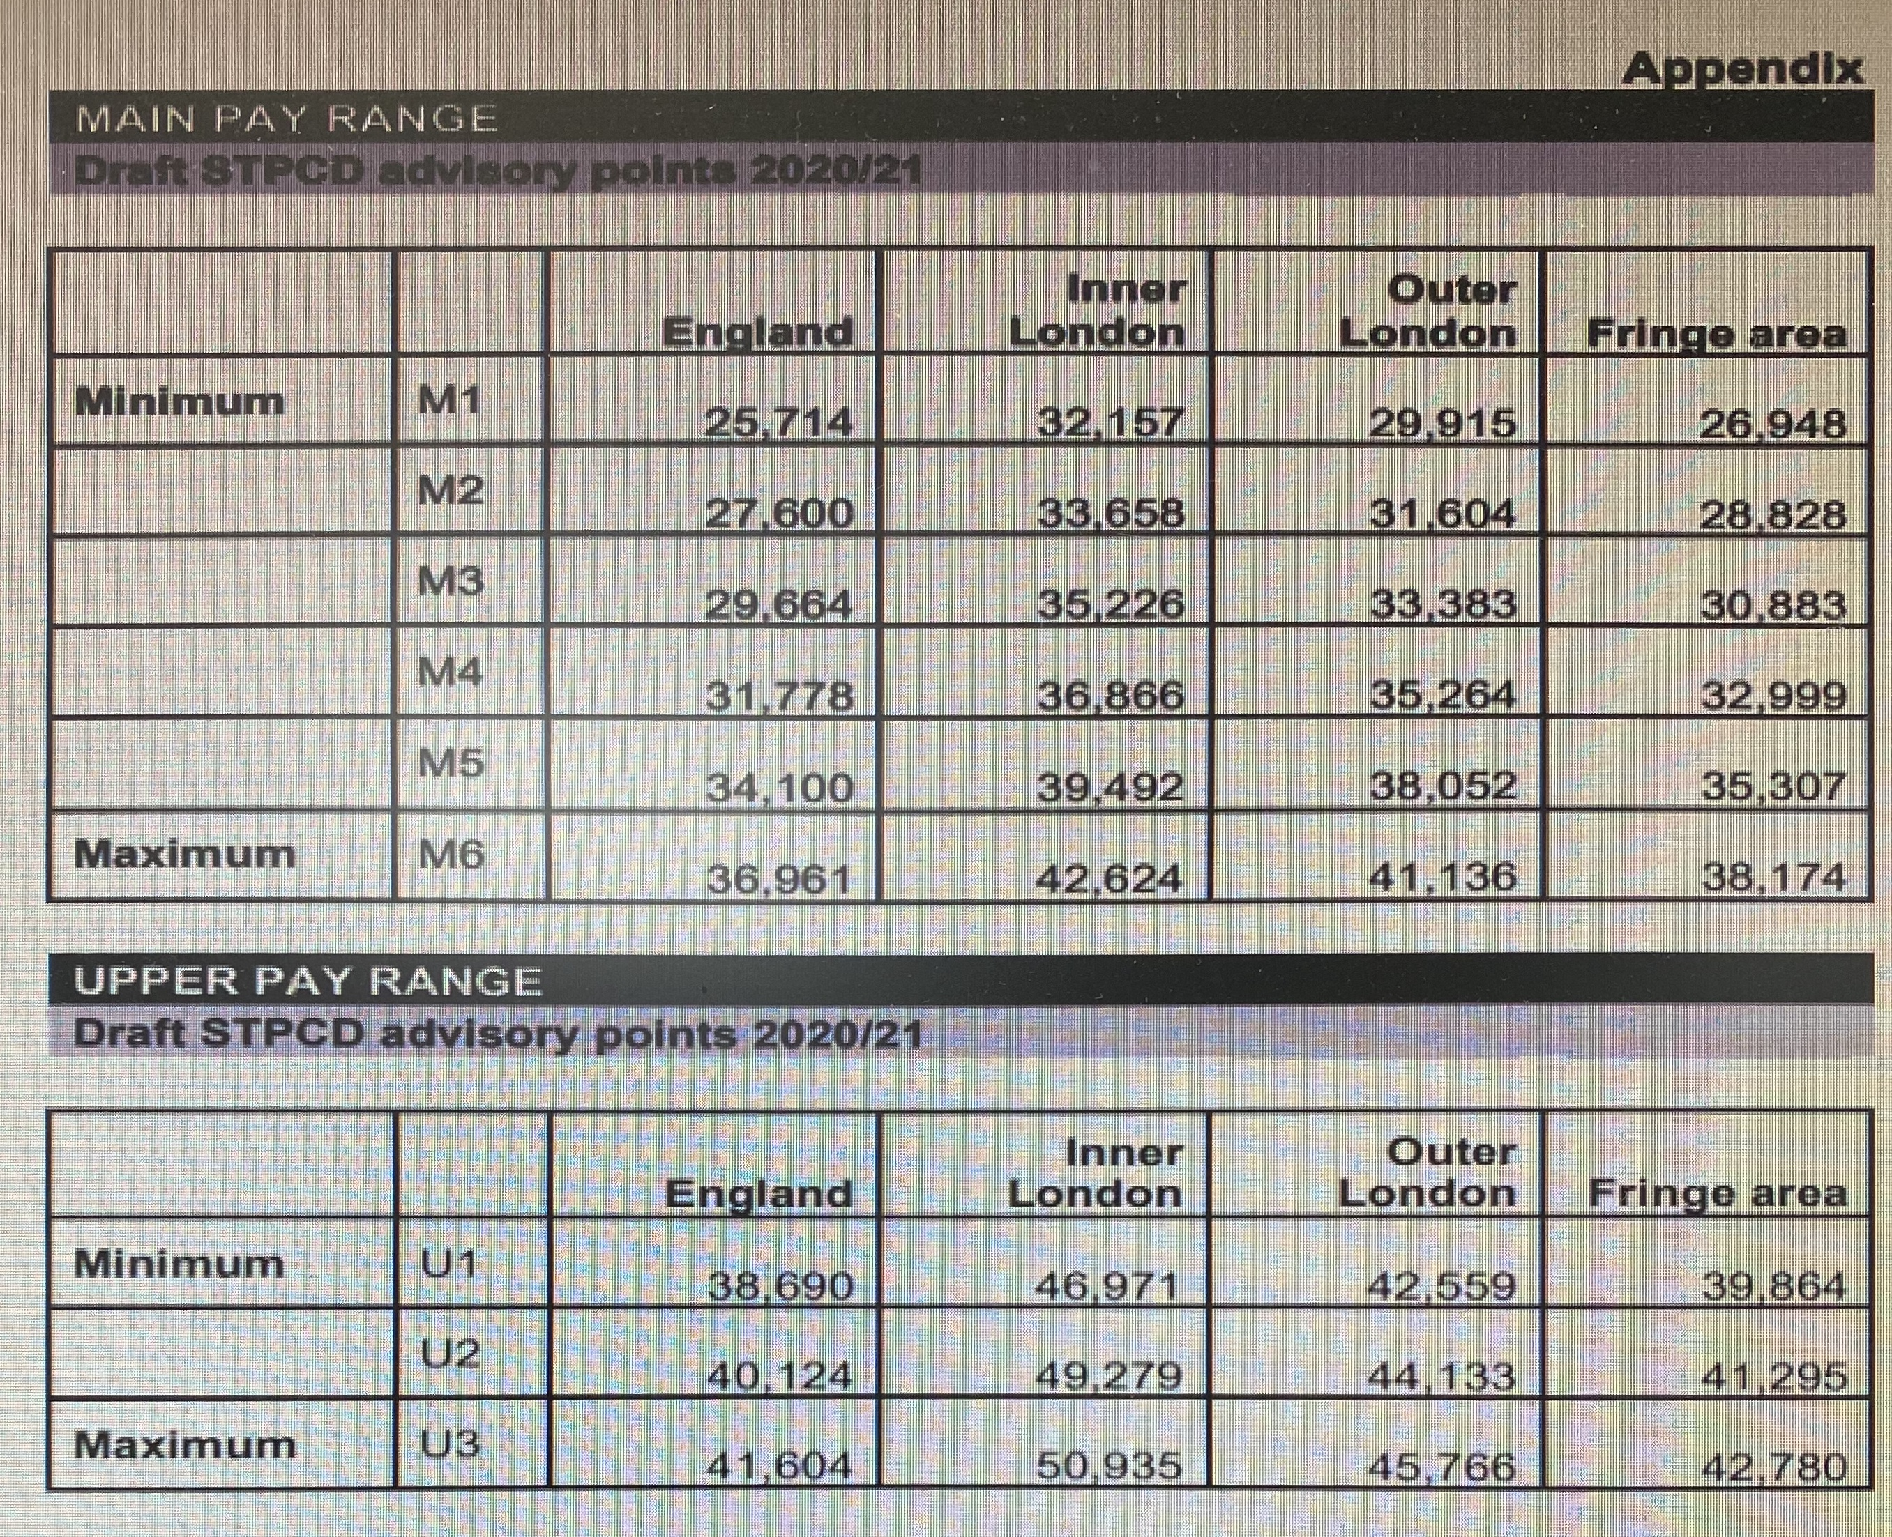

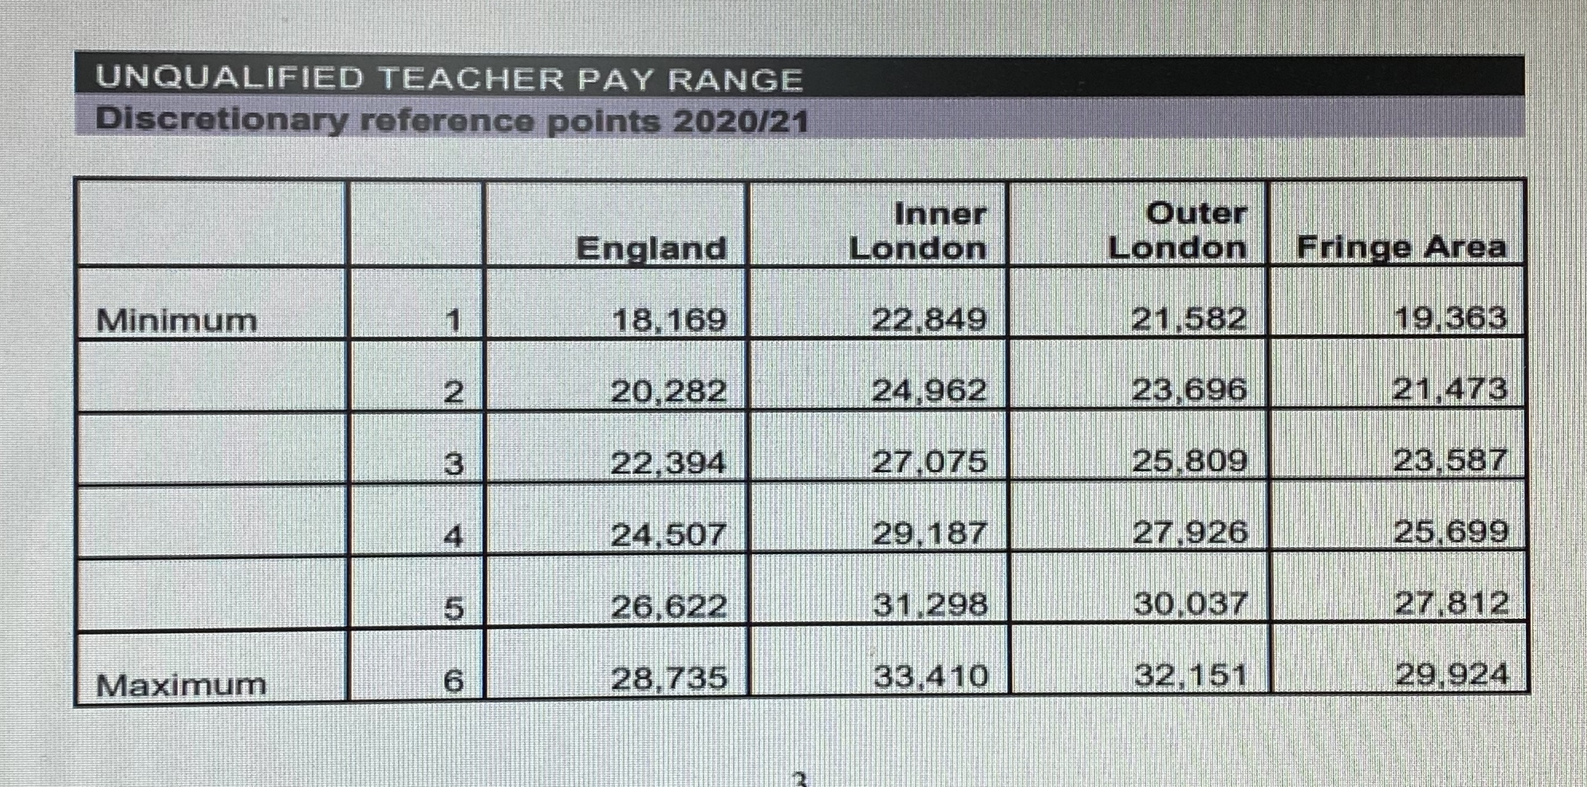
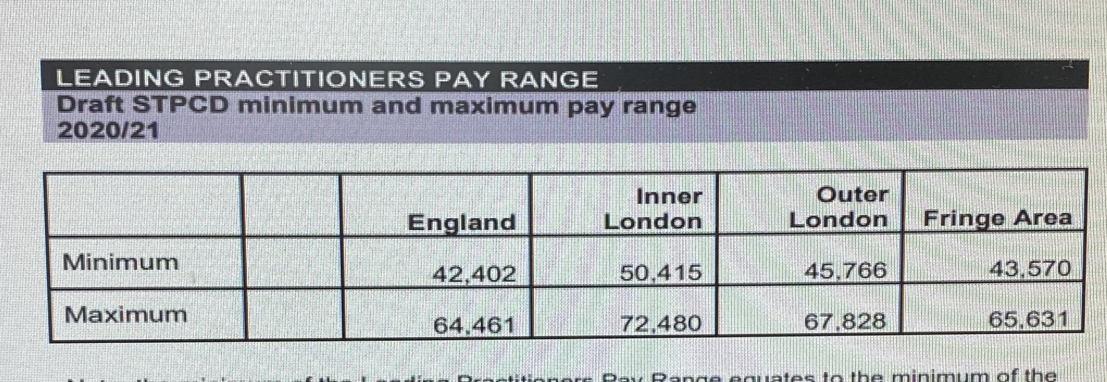
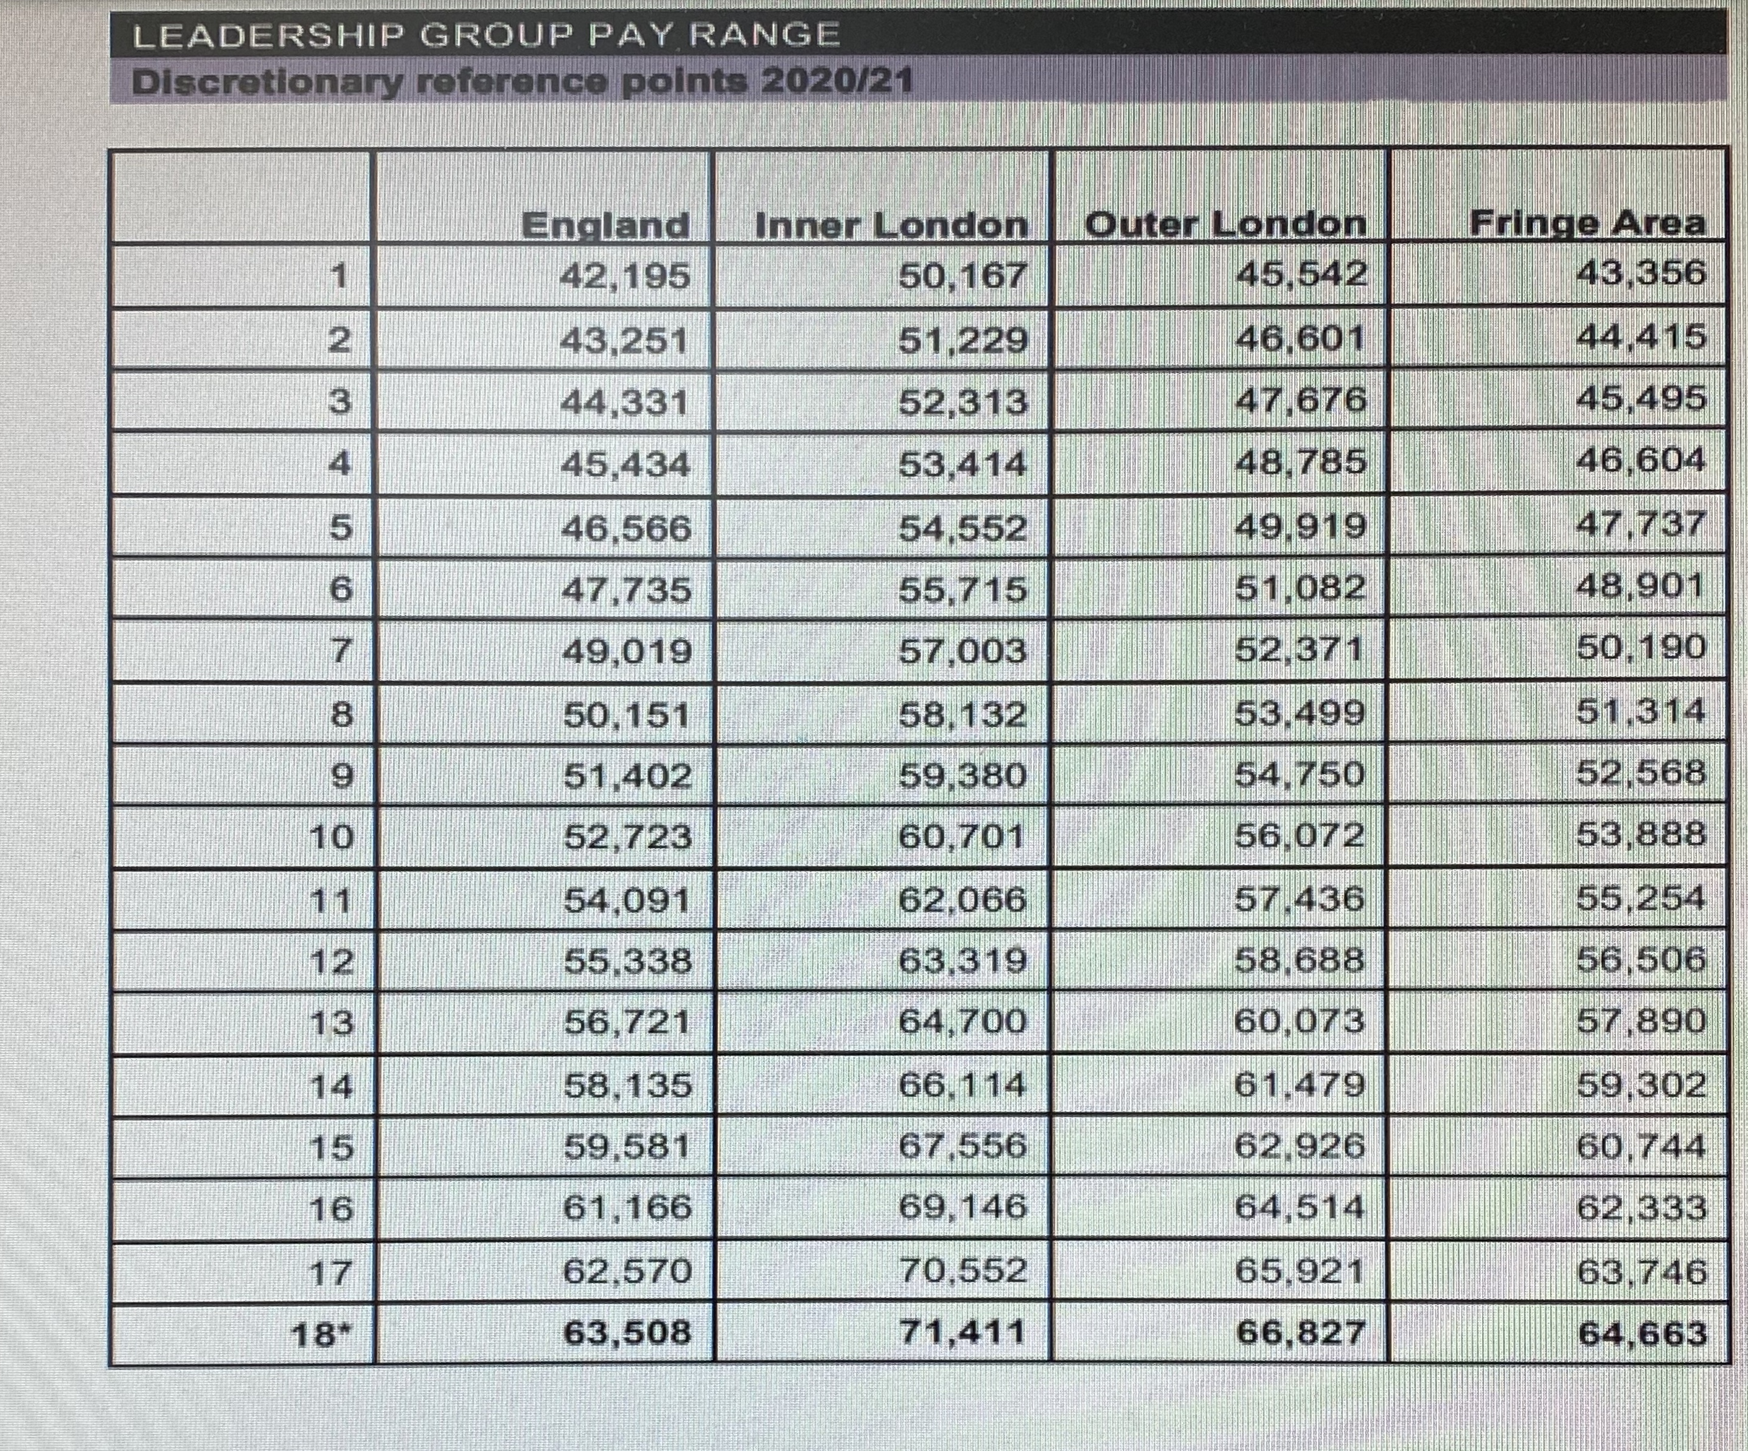
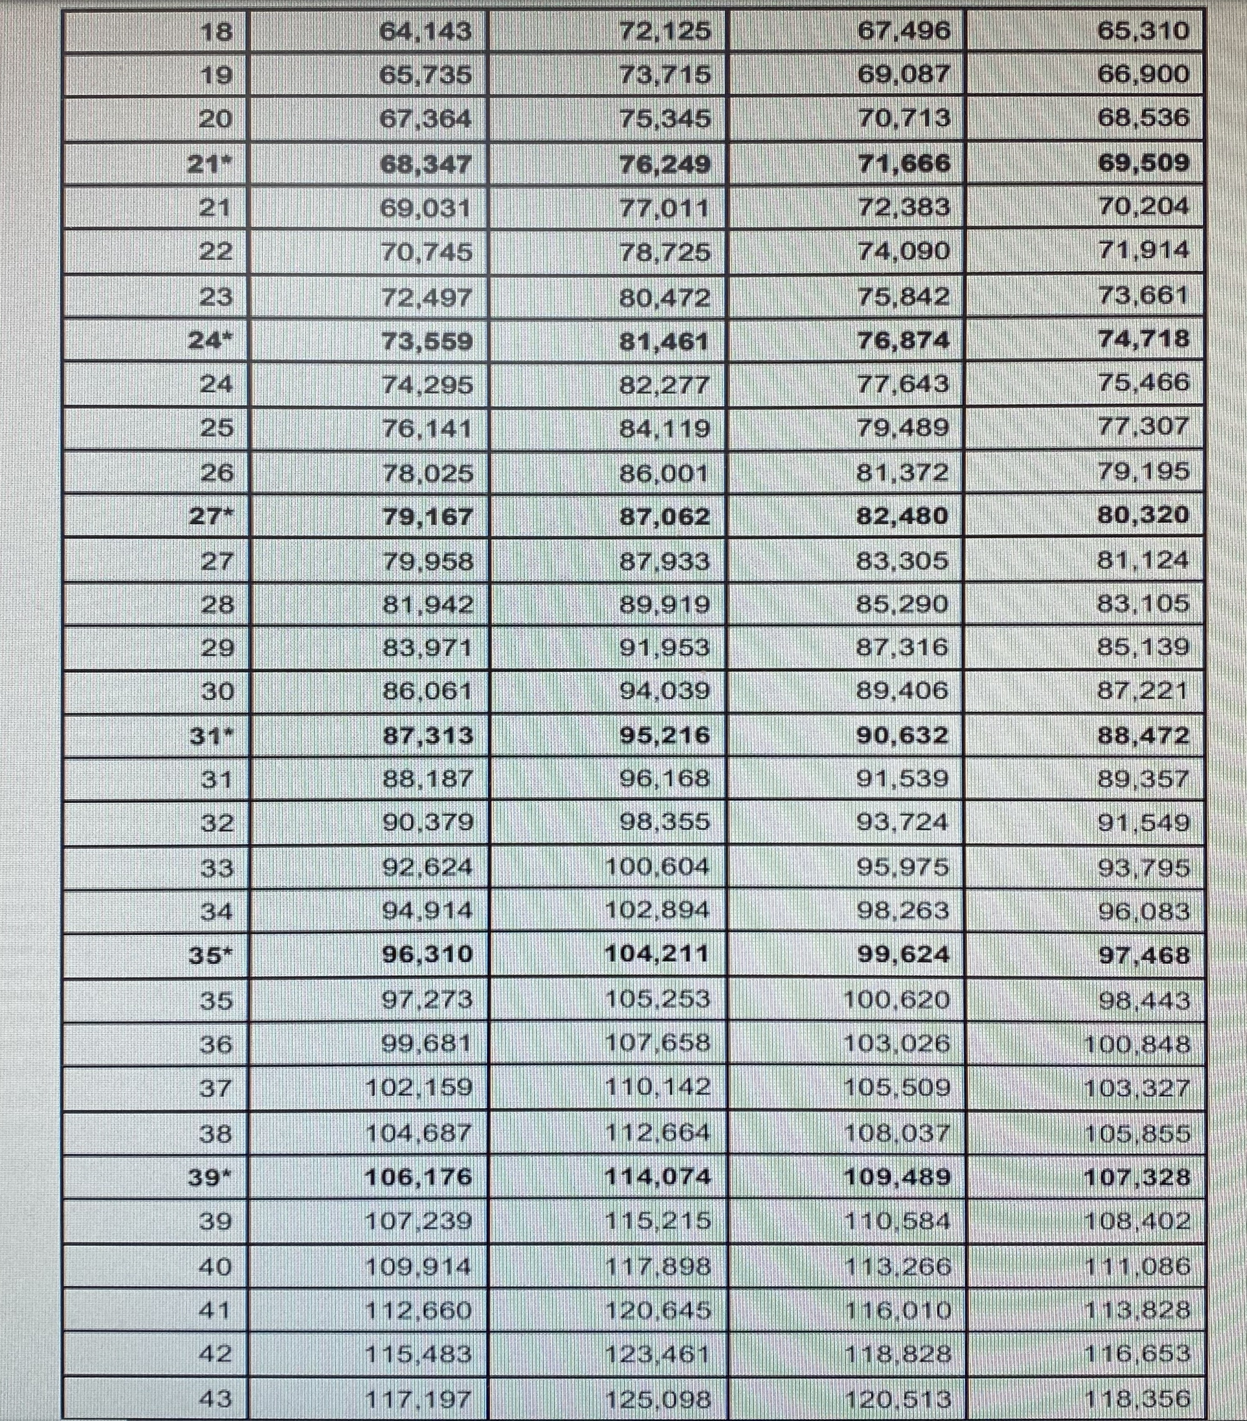
 | TLR 1 | TLR 2 TLR 3
minimum | £8,291 | £2,873 | £571
maximum | £14,030 | £7,017 | £2,833

APPENDIX B
PAY COMMITTEE TERMS OF REFERENCE
The governing body shall establish a Pay Committee to set the pay policy for the school and to implement the approved pay policy in respect of pay for teaching staff.
The Pay Committee shall consist of:
- At least two members of the governing body (Generally the Chair & Vice Chair).
- The Headteacher
. The committee will have full powers to make recommendations/decisions within the pay policy adopted by the governing body. The terms of reference are as follows:
. To achieve the aims and objectives of the school pay policy
. To apply the criteria set by the policy, including linkages with the school Appraisal Policy, in determining the pay of each member of staff
. To observe all statutory and contractual obligations
. To update and ensure that the policy complies with the most recent School Teachers’ Pay & Conditions Document
. To minute clearly the reasons for all recommendations / decisions and to report these to the full governing body
. To ensure that staff know the procedure for making an appeal against pay decisions
. To ensure that clear job descriptions for each post at the school, so that additional allowances can be awarded in a fair, equitable and consistent manner
. To keep abreast of developments influencing pay considerations and to advise the governing body when the pay policy needs to be reviewed

PECUNIARY INTEREST
No governor may participate in discussions leading to recommendations / decisions in which he / she has a pecuniary interest.

APPENDIX C

PAY PROGRESSION

Decisions regarding pay progression will be made with reference to the teacher’s appraisal reports and the pay recommendations they contain.
To be fair and transparent, assessments will be properly rooted in evidence. In this school we will ensure fairness by annual monitoring of the application of the pay policy and pay decisions.
The evidence we will use to inform appraisals and measure performance will include appraisal evidence, pupil tracking, work scrutiny and lesson observations.
Teachers may be awarded pay progression within their own pay range following a successful performance review/appraisal that measures progress against objectives and overall performance against the teacher standards.
In the case of UPR teachers a successful performance review requires the teacher to be highly competent in all elements of the relevant standards, and their achievements and contribution to the school to be substantial and sustained. Pay progression may follow after two successful performance management/appraisal reviews

ESSENTIAL AND GENERAL UPPER PAY RANGE PROGRESSION CRITERIA

Professional Attributes
Contributes significantly, where appropriate, to implementing workplace policies and practice and to promoting collective responsibility for their implementation.

Professional Knowledge and Understanding
Have an extensive knowledge and understanding of how to use and adapt a range of teaching, learning and behaviour management strategies, including how to personalise learning to provide opportunities for all learners to achieve their potential.
Have an extensive knowledge and well-informed understanding of the assessment requirements and arrangements for the subjects/curriculum areas they teach, including those related to public examinations and qualifications.
Have up-to-date knowledge and understanding of the different types of qualifications and specifications and their suitability for meeting learners’ needs.
Have a more developed knowledge and understanding of their subjects/curriculum areas and related pedagogy including how learning progresses within them.
Have sufficient depth of knowledge and experience to be able to give advice on the development and wellbeing of children and young people.

Professional Skills
Be flexible, creative and adept at designing learning sequences within lessons and across lessons that are effective and consistently well-matched to learning objectives and the needs of learners and which integrate recent developments, including those relating to subject/curriculum knowledge.
Have teaching skills which lead to learners achieving well relative to their attainment, making progress as good as, or better than, similar learners nationally.
Promote collaboration and work effectively as a team member.
Contribute to the professional development of colleagues through coaching and mentoring, demonstrating effective practice, and providing advice and feedback.

There is an expectation that where there are any concerns about performance these will be raised during the annual performance cycle. Reviews will be deemed to be successful unless significant concerns about standards of performance have been raised with the teacher during the annual performance management/appraisal cycle and have not been sufficiently addressed through support provided by the school by the conclusion of that process.
The policy at this school is that a pay progression recommendation will not be made for any teacher subject to formal capability procedures. Where a teacher has successfully engaged with and is no longer in formal capability procedures the governors will review their overall performance in line with the general performance pay progression criteria in determining whether a pay progression recommendation will be made.

REVIEWING THE HEADTEACHER’S PERFORMANCE
The headteacher must demonstrate sustained high quality of performance, with particular regard to leadership, management and pupil progress at the school, and all aspects of the relevant standards Performance reviews will be supported by an External Adviser. Progression will be subject to a review of performance against performance objectives before any points are awarded. Annual pay progression within the range for this post is not automatic. The governing body will consider whether to make an award, and if so, whether this will be one or two pay progression points, or more in exceptional circumstances. Headteachers will be eligible for progression if they meet all of their objectives and are assessed as fully meeting the relevant standards. The following levels provide an indication of what level of progression will be awarded
0 points – Objectives not met and/or Headteacher subject to formal disciplinary/capability procedure
1point – Objectives met, good level of performance in relation to relevant standards
2 points – Objectives exceeded, outstanding level of performance in relation to relevant standards
3 points – Objectives exceeded, performance above and beyond normal expectations in dealing with unusual/unprecedented events. Substantial contribution to the school in delivering transformational/innovative projects to a high level.
As part of their decision making, the Pay Matters Committee will also consider if the Headteacher has been:
    - Subject to any disciplinary action
    - Subject to any action under the capability procedure

If any of the above circumstances apply, the Pay Matters Committee will not award performance points.
The Governing Body shall advise the Headteacher in writing annually of their salary determination and the basis for this determination including details of performance increase.

REVIEWING THE DEPUTY HEADTEACHER AND ASSISTANT HEADTEACHERS PERFORMANCE
Deputy Headteachers and Assistant Headteachers must demonstrate sustained high quality of performance in respect of school leadership and management and pupil progress and will be subject to a review of performance against their performance objectives before any performance points are awarded. This review as outlined in the appraisal regulations and performance management policy will involve
- Performance objectives
- Classroom observation (where relevant)
- Other evidence
The review will assess whether the teacher has grown professionally by developing their leadership and (where relevant) teaching expertise.
The governing body has discretion to award a deputy or assistant head 0, 1, or 2 points in an academic year from 1 September only.
Annual pay progression within the range for these posts is not automatic. The governing body will consider whether to make a pay award, and if so whether to award one or two pay progression points.
Deputy/Assistant Headteachers will be eligible for progression if they meet all of their objectives and are assessed as fully meeting the relevant standards unless any of the circumstances specified in 4.2.1 apply.
The following levels provide an indication of what level of progression will be awarded
0 points Objectives not met or Deputy subject to formal disciplinary/capability procedure
1point – Objectives met, good level of performance in relation to relevant standards
2 points Objectives exceeded, outstanding level of performance in relation to relevant standards
3 points Objectives exceeded, performance above and beyond normal expectations in dealing with unusual/unprecedented events. Substantial contribution to the school in delivering transformational/innovative projects to a high level.

Performance pay increases for a Deputy or Assistant Headteacher will be contained within their 5-point scale.
As part of their decision making, the Pay Committee will also consider whether or not the Deputy Headteacher (or Assistant Headteacher) in paragraph 10) has been:
- Subject to any disciplinary action
- Subject to any action under the capability procedure

If any of the above circumstances apply, the Pay Committee will not award performance points.
CLASSROOM TEACHERS (MAIN PAY RANGE)
In this school judgements of performance will be made against:
- Objectives
- Teacher Standards
- Classroom observations
- Pupil Progress (which will include an element of work scrutiny)

The rate of progression will be differentiated according to an individual teacher’s performance. Teachers on the main pay range with an overall assessment of Level 1 will receive two increments and teachers on the main pay range with an overall assessment of Level 2 will receive one increment. Teachers on the upper pay range will receive one increment if the overall assessment in the preceding two years is Level 1.
For exceptional overall performance the Headteacher may consider awarding more than two increments.
The decision about whether a teacher progresses will be based solely on whether the stated criterion are met; there will be no ‘quota’ imposed for financial or other reasons.
Objectives will be graded on the basis of exceeded, met, partially met and not met.
When assessing objectives, the reviewer will use their professional judgement taking account of circumstances and the aspirational nature of the objectives.
Teacher Standards will be graded on the basis of exceeded, met, partially met and not met. All eight teacher standards will be individually graded and score allocated to the grades with 3 points for exceeded, 2 points for met, 1 point for partially met and 0 points for not met. A total score for the teacher standards will be reached, with the maximum score being 24.

Quality of Teaching will be based on a range of evidence including:
- Classroom observation
- Quality of planning and assessment
- Quality of marking
- Pupil Progress and attainment will be assessed on the basis of whether pupil progress has been in line with national standards.
- Book Scrutiny
Main pay range classroom teachers will receive an increase within the range for satisfactory performance over the year.
The policy at this school is that a pay progression recommendation will not be made for any teacher whose performance is unsatisfactory because they are or have been managed within the formal stages of the capability procedures. Where a teacher has successfully engaged with and is no longer in formal capability procedures the governors will review their overall performance in line with the general performance pay progression criteria in determining whether a pay progression recommendation will be made. Where a decision has been made not to recommend pay progression the teacher must be notified in writing of this decision and the reasons.
Newly qualified teachers that complete their induction period satisfactorily will receive performance progression.
Final decisions about whether or not to accept a pay recommendation will be made by the full governing body/Pay committee, taking into account advice from the (pay committee/headteacher).

APPENDIX D

APPLICATION TO BE PAID ON THE UPPER PAY RANGE

Personal Information
Name: | Job Title:
School: | Date of application:

Details of Performance Management/Appraisal:

Years covered by planning/review statements

Schools covered by planning/review statements

Summary of application.

(Continue on additional sheets if needed)

Declaration
I confirm that at the date of this request for assessment I meet the eligibility criteria and I submit the appraisal and brief supporting evidence as appropriate.

Signed (applicant): Date:

APPENDIX E

Guidance in Relation to Inspection
Extract from: Subsidiary guidance supporting the inspection of maintained schools and academies, 2012
Page 20: Inspectors should consider whether governors:
- carry out their statutory duties;
- understand the strengths and weaknesses of the school, including the quality of teaching;
- ensure clarity of vision, ethos and strategic direction;
- understand and take sufficient account of pupil data, or whether they are misled by ‘headlines’;
- are aware of the impact of teaching on learning and progress in different subjects and year groups;
- are challenging and supporting leadership in equal measure;
- are providing support for an effective Headteacher, or whether they are hindering school improvement by not successfully tackling key concerns;
- understand how the school makes decisions about teachers’ salary progression
- performance manage the Headteacher rigorously;
- are failing to perform well and contributing to weaknesses in leadership and management.

Pages 22 and 23: Performance management
In reaching their judgement on leadership and management, inspectors evaluate how well the Headteacher/principal, and where relevant, other senior staff are managing staff performance and using the staff budget to differentiate appropriately between high and low performers. However, inspectors do not consider or report on any individual’s performance or whether the quality of teaching of an individual is accurately reflected in that individual’s progression on the salary spine.
Inspectors consider the extent to which the Headteacher/principal ensures that all staff undergo performance management procedures which enable them to benefit from appropriate professional development. Where teachers’ performance is less than good, inspectors will seek evidence that this is rigorously managed, and that appropriate training and support are provided. Where teachers’ performance is good, inspectors will expect to see evidence that this is recognised through the performance management process.

Inspectors should ask the Headteacher for anonymised information from the last three years, which shows the proportions of teachers who have:
- progressed along the main pay scale
- progressed to, and through, the upper pay scale
- progressed along the leadership scale
- received additional responsibility payments, such as teaching and learning responsibility payments and special needs allowances.
The information provided should include information about patterns of progression through the different salary scale points, and comparisons between subject departments and/or teachers deployed in different key stages.
Inspectors should compare this with the overall quality of teaching, and determine whether there is a correlation between the two, and if there is none, find out why, taking into account the length of time the Headteacher has been in post.

Examples of the information Headteachers could provide include:
- the proportion of staff that progressed through thresholds over the last three years;
- the proportion that did not progress through thresholds over the last three years;
- a table showing for each salary point, the number of staff, points they have moved from, and the number that met their performance management objectives;
- performance management information the school provides to governors;
- any other relevant information with regard to the performance management process.

The performance management information must be provided in an anonymised format which takes all reasonable steps to avoid identifying individuals in any school. Inspectors should take account of the particular concerns of those working in small schools. In all cases, the information provided:
- must be recorded in such a way that individual members of staff are not identified on inspectors’ evidence forms or in inspection reports;
- must not leave the school site;
- must not be sent to inspectors electronically.

APPENDIX F

HOLLY PARK PRIMARY SCHOOL

Staffing Structure: 2018

HEADTEACHER
Leadership and Management, Standards, Achievement and Attainment, School Improvement
School Financial Management, Premises Controller, Excellence and Enjoyment, Every Child Matters
(Non-class based)

DEPUTY HEADTEACHER
Continuing Professional Development,, School Improvement Planning
Assessment for Learning, Pupil Progress and Interventions, Achievement and Standards
(Non-class based)

 | FAMILIES’ CO-ORDINATOR  Extended Services Provision, Safeguarding, Lifelong Learning, Family Support, Every Child Matters Agenda  (Non-class based)  TLR 1 |  | CHILDREN’S CO-ORDINATOR  Inclusion Manager, Nurture Group Manager,  SEN / EMA / G&T Line Manager, Every Child Matters Agenda  (Non-class based)  TLR 1 |  |  | SCHOOL BUSINESS MANAGER  Admin Manager,  Finance Manager, SMT  Admissions
 | LEADING PRACTITIONER  Music (Non-class based) |  |  |  | LEADING PRACTITIONER  Early Years Foundation Stage (Class based)
 | KEY LEADER  The Juniors  TLR 2C | KEY LEADER  The Infants  TLR 2C | KEY LEADER  Innovations and New  Technologies  TLR 2A |  | KEY LEADER  Diversity  and Equality  TLR 2A | KEY LEADER  Curriculum Development  TLR 2A |  |  | KEY LEADER  English  TLR 2A |  | KEY LEADER  Maths  TLR 2A
 |  | CLASSTEACHER | CLASSTEACHER |  | CLASSTEACHER | CLASSTEACHER |  |  | CLASSTEACHER | CLASSTEACHER
 | CLASSTEACHER | CLASSTEACHER | CLASSTEACHER |  | CLASSTEACHER | CLASSTEACHER |  |  | CLASSTEACHER
 | CLASSTEACHER | CLASSTEACHER | CLASSTEACHER |  | CLASSTEACHER | CLASSTEACHER
PUPIL SUPPORT OFFICER  Medical Needs and Pupil Welfare, Attendance Officer  First Aid |  |  |  | SCHOOL ADMINISTRATOR  Admin Support  Welfare Support  Finance Support |  |  |  | SITE MANAGER  Premises Manager  Maintenance and Repairs  Caretaking

MFL TEACHER
SPANISH (Non-class based)

LEVEL FOUR TEACHING ASSISTANT
HIGHER LEVEL TEACHING ASSISTANT
Senior Teaching Assistant , PPA Cover – EYFS
EMA Interventions and curriculum support

LEARNING MENTOR
LEARNING AND BEHAVIOUR SUPPORT
Targeted Interventions

LEVEL THREE TEACHING ASSISTANT  CURRICULUM SUPPORT YEAR 6  Targeted Interventions  Curriculum Support and Display | LEVEL THREE TEACHING ASSISTANT  CURRICULUM SUPPORT YEAR 5  Targeted Interventions  Curriculum Support and Display | LEVEL THREE TEACHING ASSISTANT  CURRICULUM SUPPORT YEAR 4  Targeted Interventions  Curriculum Support and Display
LEVEL THREE TEACHING ASSISTANT  CURRICULUM SUPPORT YEAR 3  Targeted Interventions  Curriculum Support and Display | LEVEL THREE TEACHING ASSISTANT  CURRICULUM SUPPORT YEAR 2  Targeted Interventions  Curriculum Support and Display | LEVEL THREE TEACHING ASSISTANT  CURRICULUM SUPPORT YEAR 1  Targeted Interventions  Curriculum Support and Display
INCLUSION ASSISTANT – LEVEL THREE
SEN Admin Support
Orchard Club Assistant
Specialist Interventions
LEVEL TWO TEACHING ASSISTANTS
Learning Support – Statemented Pupils

NURSERY NURSE  Foundation Stage Practitioner  Curriculum Support, Pastoral Support  Working with Families | NURSERY NURSE  Foundation Stage Practitioner  Curriculum Support, Pastoral Support  Outdoor Curriculum | NURSERY NURSE  Foundation Stage Practitioner  Curriculum Support, Pastoral Support  Transition and Settling | NURSERY NURSE  Foundation Stage Practitioner  Curriculum Support, Pastoral Support  Role Play Opportunities
EYFS ASSISTANT (LEVEL THREE)  Foundation Stage Practitioner  Pastoral Support  Early Years Breakfast Club |  | EYFS ASSISTANT (LEVEL TWO)  Foundation Stage Practitioner  Pastoral Support  Early Years After-School Club
SENIOR MTS | MTS/Play leader | MTS/Play leader | MTS/Play leader
MTS/Play leader | MTS/Play leader | MTS/Play leader | MTS/Play leader
MTS/Play leader | MTS/Play leader | MTS/Play leader | MTS/Play leader

