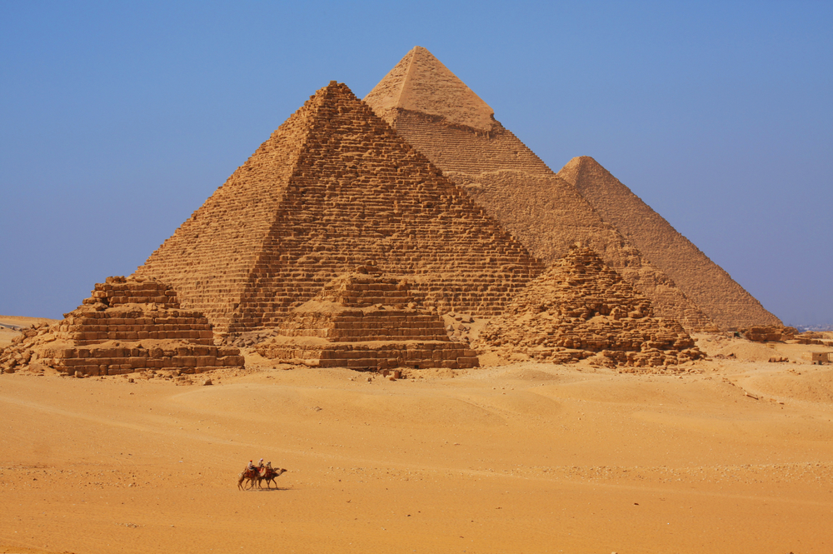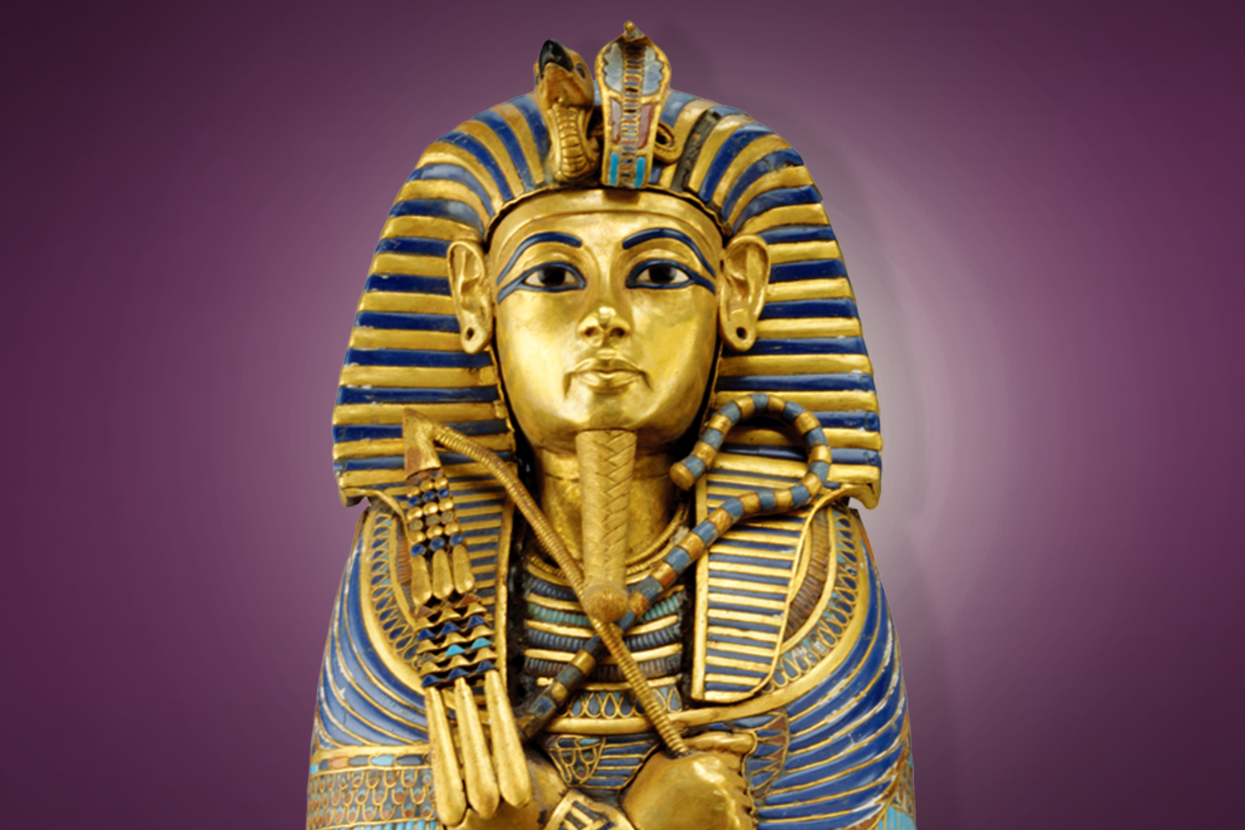
Ancient Egypt
Dear Parents/Carers,
We hope you had a lovely half term break. The children have come back ready for new challenges ahead. This half term we will be learning about the Ancient Egyptians. We will learn about the pharaohs, gods and goddesses, the pyramids and about Ancient Egyptian writing and mathematics. We will also learn how ordinary people lived in those times, as well as the slave population. We will enjoy a virtual trip of the British Museum in our classrooms, using the internet. WE will also be having an Ancient Egypt curriculum day, when we will make arts and crafts linked to those times. In addition, the children will be using printing ink and rollers to create block prints of Ancient Egyptian hieroglyphs. So, lots to do! We will do all we can to keep the children safe at school, while enjoying a wide range of lessons and learning experiences.
Best wishes,
Ms Owen, Mrs Thrasyvoulou and Mrs Tsenti
Science | Maths |  | English - writing
Humans - nutrition and digestion  Animal diets – omnivores, herbivores, carnivores  Prey/ predators  Food chains – producers and consumers | Measure – length in km, m, cm and mm. Conversion of measures.  Multiplication – times tables, factors, written methods.  Division – using times tables facts to divide, informal jottings and formal written methods. | Fractions – equivalent fractions, counting in fractions, adding and subtracting fractions, calculating fractions of quantities. | ‘Fly eagle fly’ by Christopher Gregorowski.  ‘There’s a pharaoh in our bath’ by Jeremy Strong.  Playscripts  Creative writing; news articles  Non-fiction research work  Explanation writing (science)
English - Grammar | English - Spelling | PSHE | RE
Noun phrases  Clauses  Conjunctions  Revise speech punctuation  Adverbial phrases  Fronted adverbials | Ancient Egypt pyramid  Hieroglyph pharaoh  digestion nutrition  nutrition  oesophagus  stomach  intestine  Homophones | Social life – exploring different relationships we have in our lives.  What are social stereotypes? How are they used?  Healthy lifestyles – link to science and nutrition.  Link to PE and the importance of exercise. | Inspirational people.  What does it mean to inspire others?  Including Chris Ofili (artist), Dina Asher-Smith (athlete)  Dr Maggie Aderin-Pocock (scientist and astronomer)  Other notable people.
Computing | PE | History | Geography
Problem solving through programming (coding)  Communications  Using the internet to research a topic  Keeping ourselves safe online | All Year 4 - Hockey skills  Mulberry - Swimming – improving our skills.  Sycamore - Gymnastics | Who were the Ancient Egyptians?  How did they live?  Learn about their writing, clothing, mathematics, pharaohs, citizens and slaves.  Art works and statues. | Investigate the geography of Ancient Egypt.  Focus on the importance of the River Nile.  Locations of main buildings and religious centres.
Art & Design | Design & Technology | Spanish | Music
Wood block printing – use printing ink and rollers. Designs linked to Ancient Egyptian hieroglyphs and other symbols. |  | Weather  Family  Numbers 1-30  Describing people  Chocolate & Easter  Links to a Spanish school | Rhythm patterns and traditional notation  Composing using expressive sounds
Trips & Special Days | Key Dates for this year group | Other Information | Requests
23.11.20 Year 4 curriculum day – Ancient Egypt. | 1th November Year 4 parent zoom meeting - Maths | Outdoor PE on Friday  Mulberry class - Swimming on Wednesday this half term  Sycamore - indoor PE on Thursday  Homework given out Wednesday, hand in Tuesday

