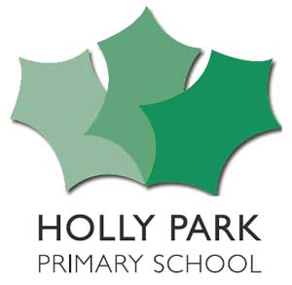 Learning Project – Holly Park Forever 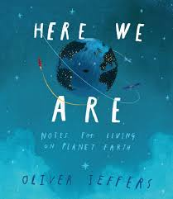
Here We Are
Dear Parents/Carers,
Welcome to the Autumn term. For the first four weeks back at school, we will be operating a curriculum recovery project. The purpose of this is to settle the children back at school happily into their new classes after such a long period away and also to assess where the children are, make sure that the curriculum from the summer term is consolidated and to establish which areas will need more work as we move forward into the new academic year. Music, PE and Spanish will continue as normal. After our Inset day on 5th October, you will receive the usual curriculum letter for what each year group will be learning for the rest of the term.
Maths | English
Mornings will be maths and English – going over the curriculum from previous year summer term to consolidate and assess where the gaps are |  |  | Mornings will be maths and English – going over the curriculum from previous year summer term to consolidate and assess where the gaps are
HOLLY PARK FOREVER
The main idea is to reunite the children and welcome them back to our school –to the school community they are part of. They will look at areas such as:
- New beginnings after the lockdown and the fact that we are all Holly Parkers together. – The HPS family
- The people who help us at Holly Park.
- A day in the life of the children and adults at Holly Park – interview a selection of staff maybe
- The global village of Holly Park – who we are – diversity of HPS
- What Holly Park in the future might be like.
- The history of Holly Park – we have original log books and the website has a history section on it
- What it means to be a Holly Parker.
- Maps of the school
There will be cross-curricular links to art and other foundation subjects. During the project the children will do charts, diagrams, maps, questionnaires, history research, debate etc – they will celebrate all that is Holly Park.
HERE WE ARE: Notes for Living on Planet Earth By Oliver Jeffers
The main idea is to acknowledge that this has been a year of significant world events, disrupting and changing the ways of life of people across the globe. This unit of work is to support the children to re-connect with each other and re-engage with school life. -– so thinking beyond themselves & the school to the wider world beyond.
This is a very literacy based topic. Each series of sessions will explore the key themes of:
- Earth’s place in the wider universe The Earth’s environment
- Our place on the planet as humans How we, as humans, relate to each other
- Other species and our responsibility towards them Belonging and community
- Our responsibility as world citizens
The project will involve:
Using Poetry as a Vehicle for Expression Writing a Letter to a Special Person
Writing Guidance and Recommendations for conserving the environment Writing Song Lyrics
Using Poetry to Tune into our World Writing a Health Campaign Leaflet Devising a Social Contract
Formulating Notes of Advice Using Poetry to Make Sense of the World Around Us Creating a Gallery of Greatness
Key Dates |  |  |  | Other Information
8th September Year 6 Meet The Teacher  9th September Year 3 Meet The Teacher  11th September Year 4 Meet The Teacher  14th September Year 5 Meet The Teacher  5th October Inset Day  21st October HARVEST FESTIVAL  9th November Y5 School Journey Meeting  11th November Y3 Workshop  12th November Y5 Workshop | 17th November Y4 Workshop  27th November Inset Day  11th December Y5 and Y6 parties  16th December Y3 and Y4 parties |  |  | PE Kit needs to be in school all week  Book bags need to come to school every day  It is more important than ever to ensure all clothing is named

