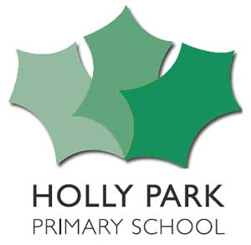 Learning Project – Holly Park Forever 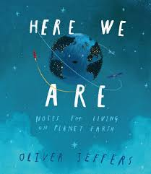
Here We Are
Dear Parents/Carers,
Welcome to the Autumn term. For the first four weeks back at school, we will be operating a curriculum recovery project. The purpose of this is to settle the children into life at school and happily into their new classes. Music, PE and Spanish will continue as normal. After our Inset day on 5th October, you will receive the usual curriculum letter for what each year group will be learning for the rest of the term.
Settling
The children are still settling into school life and we are really enjoying getting to know them. They will need time to become increasingly more familiar with many of their new routines.
HOLLY PARK FOREVER
The main idea is to help establish the children at Holly Park and to welcome them to our school –to the school community they are now part of. They will look at areas such as:
- New beginnings - the fact that we are all Holly Parkers together. – The HPS family
- The people who help us at Holly Park.
- A day in the life of the children and adults at Holly Park – interview a selection of staff maybe
- The global village of Holly Park – who we are – diversity of HPS
- What it means to be a Holly Parker.
There will be cross-curricular links to art and other foundation subjects. They will celebrate all that is Holly Park.
HERE WE ARE: Notes for Living on Planet Earth By Oliver Jeffers
The main idea is to acknowledge that this has been a year of significant world events, disrupting and changing the ways of life of people across the globe. This unit of work is to support the children to re-connect with each other and re-engage with school life. -– so thinking beyond themselves & the school to the wider world beyond.
This is a very literacy based topic. Each series of sessions will explore the key themes of:
- Earth’s place in the wider universe The Earth’s environment
- Our place on the planet as humans How we, as humans, relate to each other
- Other species and our responsibility towards them Belonging and community
- Our responsibility as world citizens
The project will involve:
A focus on personal narratives Communicating about own lives and experiences writing a song Outdoor Learning Learning how to care for ourselves and for others: Labels, Captions and Instructions Exploring new vocabulary and concepts Looking after other living things – Reading and writing for information Asking and answering questions recounting events Writing notes
Key Dates | Other Information
23rd September Meeting for nursery & Reception parents about the curriculum 9am and repeated again at 1pm  5th October Inset Day  2nd October Phonics meeting for Reception parents  21st October HARVEST FESTIVAL  27th November Inset Day  15th December EYFS parties | PE Kit needs to be in school all week  Book bags need to come to school every day  It is more important than ever to ensure all clothing is named

