Measuring the impact of the Sport Grant 2019/20
PE and school sport play an important part in the life of Holly Park. We believe that PE plays an important part in the holistic development of our children and through this they learn more about values such as respect, co-operation, team spirit, friendship, courage, determination etc

COVID 19 meant that there were no sporting events from mid-March 2020 and across the summer term 2020.

Non – Stop Action Sport Coached Sessions
Most of our PE and Sport Premium Funding is used for ‘Non Stop Action’ Coached PE lessons across the school and to participate in borough wider competitions.
In the last academic year, 420 children benefited from specialist PE coaching at Holly Park.
Across the year we have had Non-stop Action coaches in to teach a variety of Outdoor sports and also following staff feedback - indoor dance classes. The standard of coaching was outstanding and teachers were involved in the lessons – teaching parts of the lessons and having access to the planning. Classes completed between one and three units of work each throughout the year, with most classes experiencing at least one indoor and one outdoor topic each.

IMPACT -This has increased both teacher subject knowledge and pupil skill levels particularly in dance (see evaluations and data below).

In the last academic year 420 children benefited from specialist PE coaching at Holly Park in the Autumn term and Spring 1.

Impact of coached sessions on Pedagogical Needs (CPD):
Gymnastics (Autumn 1)
Teachers showed a 67% increase in their ability to plan a Gymnastics with Apparatus lesson. From the findings shown in the chart below, the biggest area of improvement for most teachers has been a 76% increase in their confidence to deliver Gymnastics with Apparatus for their class. In the post teaching questionnaires one teacher said, "Excellent support for gymnastics teaching, clear differentiation and techniques." Other teachers said, "Excellent teaching, modelling and feedback from Miss Keown." "A great unit - thank you!"

Graph showing average score of teachers across a range of parameters before and after the CPD intervention with Non Stop Action
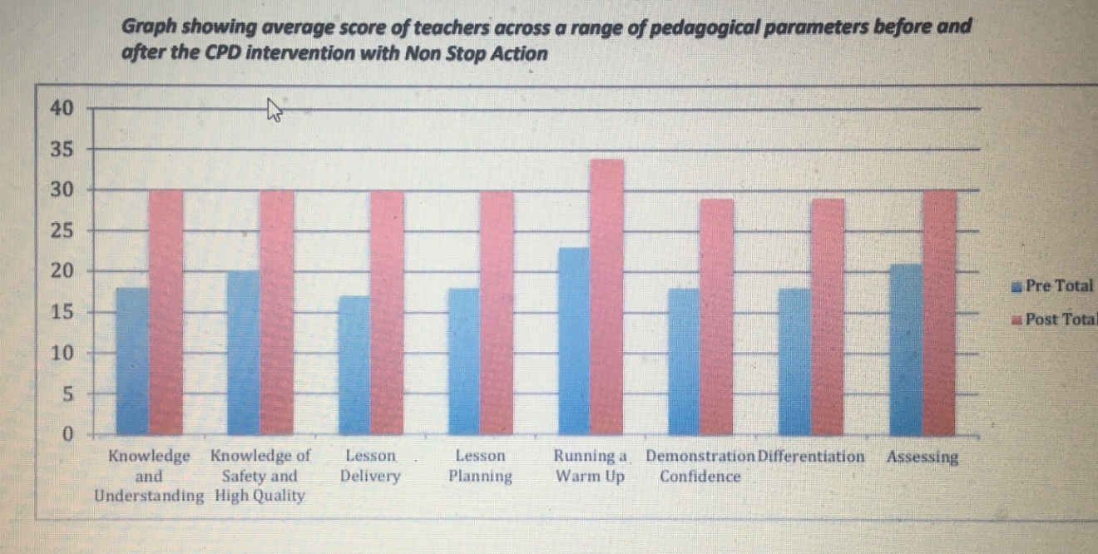

Football (Autumn 2)
Teachers showed a 58% increase in their ability to plan a stimulating Football lesson. From the findings shown in the chart below, the biggest area of improvement for most teachers has been a 61% increase in their confidence to run a Football related warm up for their class.
In the post teaching questionnaires one teacher said, "Seeing Non Stop Action teach the sequence of lessons has given me a lot of ideas and I have seen how the skills progress week by week." Other teachers said, "Seeing Non Stop Action teach the sequence of lessons has given me a lot of ideas and I have seen how the skills progress week by week."

Graph showing average score of teachers across a range of pedagogical parameters before and after the CPD intervention with Non Stop Action
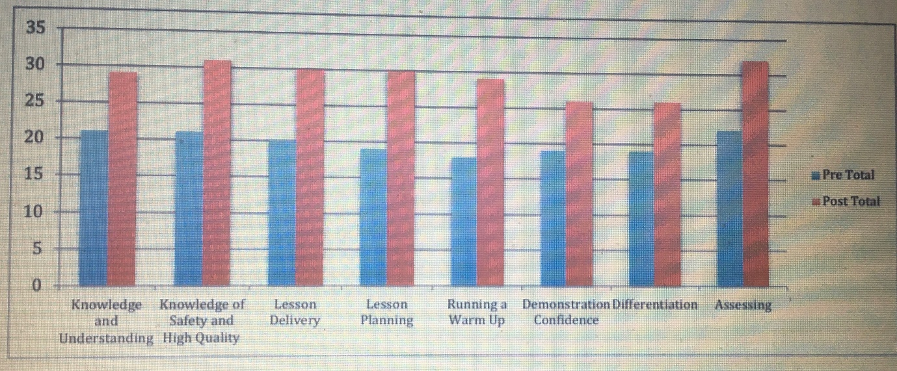

Developing Coordination and Agility (Spring 1)
Teachers showed a 48% increase in their ability to deliver a stimulating lesson focusing on agility and coordination. From the findings shown in the chart below, the biggest area of improvement for most teachers has been a 50% increase in their confidence to differentiate different skills for higher and lower ability children.
In the post teaching questionnaires one teacher said, "Each lesson had a good layout and plan with lots of activity ideas. At the start of each lesson, the sharing of Los and SCs helped solidify understanding and introduce vocabulary." Other teachers said, “Watching someone deliver the lessons has helped to understand the techniques and provided different ideas for activities." "Thank you, the children clearly enjoy your lessons and respect you and your knowledge."

Graph showing average score of teachers across a range of pedagogical parameters before and after the CPD intervention with Non Stop Action
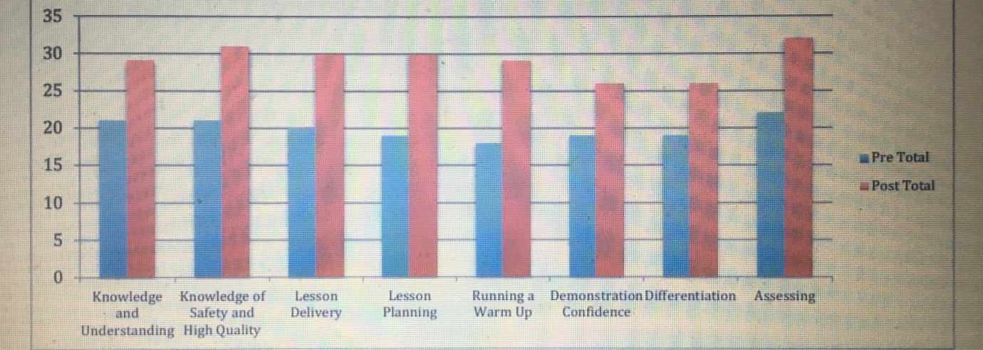

Spring Term 2 was Gymnastics with apparatus but this unit was not completed due to COVID 19 and lockdown
Pupil Data
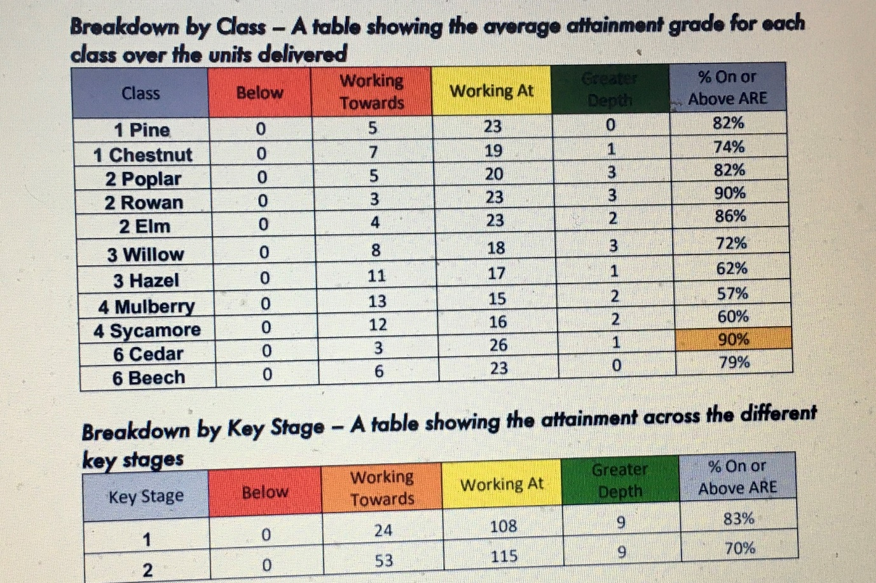
All activities were assisted/team-taught by the regular class teacher, many classes with additional support from teaching assistants.

Usually, we expect classes to have at least 75% of the children working at or above ARE; however, due to the disruption this school year, it is not unexpected that some classes are below this. We were expecting to deliver two units to each year group, one indoor and one outdoor, however, the only year group who were able to receive both these lessons were Year 6, which as you can see, has made a difference in their attainment compared to other classes. If all classes had received both units, you would expect to see data that skews more towards WA generally, as some children will be more competent in one aspect of PE e.g. competent at Outdoor Sports but they will find Dance and Gymnastics more difficult, and vice versa, and if the units haven’t been a balance of outdoor and indoor, the average of the assessments may reflect a lower grade overall. Another factor to bear in mind is that these assessments took part in the first half of the academic year, and you would usually expect to see children progress further and more rapidly as they mature throughout the year.

Barnet Partnership for School Sport
We use our Sports Grant to buy into the Barnet Partnership for School Sport. This allows us to take part in various competitions across Barnet. Last year we took part in many competitions with other schools – lots of football, netball and cross-country. We also participated in the Barnet School’s Dance Festival.
There were no competitions in the summer term due to COVID 19.

IMPACT –
This continued to keep the profile of sport high and kept the school community updated about it through the weekly newsletter, on the website and in the termly Holly Park highlights. Many pupils did well on an individual basis. Teams also did very well.
Our Cross Country Team competed against other Barnet schools, The school did well in the first round but the competition was not finished in the Spring term due to COVID 19 Our netball team and football teams continued to enjoy competing against other schools. No leagues were completed.

General Sport and Physical Activity Success 2019-20
IMPACT
We have been awarded the Silver School Games Mark.

We had bikeability for Year 3, 4 and Year 5& 6 children.

We encouraged Walk to School and Bike to School Weeks throughout the year.

Y4 took part in extra team games at the Y4 pyjama party

We have continued to run Forest Schools every week for our children. Year 5 and Year 1 children all had half a term of Forest School Learning

Year 4 completed their year of swimming. Year 3 began their swimming sessions before lockdown,

All year groups have continued doing the daily km for the Mayor of Barnet’s Golden Kilometre Challenge and take ten activities each day. Classes participated in the London Loop.

We took part in the Barnet Dance Festival with 20 Y6 children participating

We held a very successful virtual sports day despite lockdown and COVID 19 which resulted in an extraordinary number of children and parents participating in physical activity in parks, gardens, balconies, indoors etc
This enabled families to take part in a competitive way – still earning points for their house.

