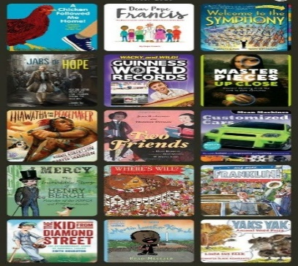

Year 5 English
Home-learning Non-Fiction Course

7th – 8th July 2020
Session 6 – To write a Non-Chronological Report.

So – today’s the day! Time for all your hard work to pay off! WATCH:

https://youtu.be/eZsXVnU8YBU

Task Summary:
- Look at the checklist you made on day 1 – check that you have included everything.
- Get a pencil, ruler, rubber, colouring pens… If you are using a computer, take a deep breath!
- Begin to carefully put together your report. Remember to refer to your plan and research. Use the examples, below…
- TAKE YOUR TIME! We are giving you 2 days. If you are not happy with something – correct it!
- Upload your work to Google Classroom on Wednesday so you can impress us!

