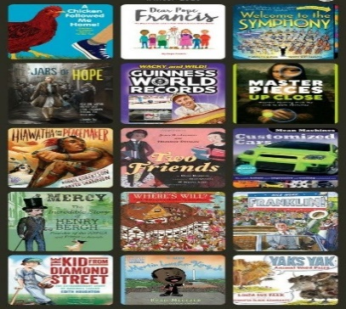

Year 5 English
Home-learning Non-Fiction Course

Monday 6th July 2020
Session 5 – To plan the layout for a Report.
So, I have had a go at starting my Report. Have a look at it (below). What do you think? Write down comments on what you think is good and bad about it. We will see if your thoughts match mine so watch the video at the bottom of this page, afterwards.
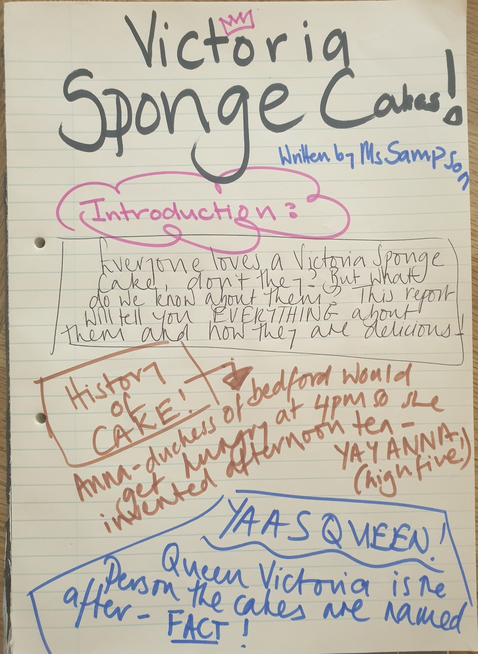

Now Watch:
https://youtu.be/-l8k3uJDZFE

Here is an example of what I SHOULD have done before I started:
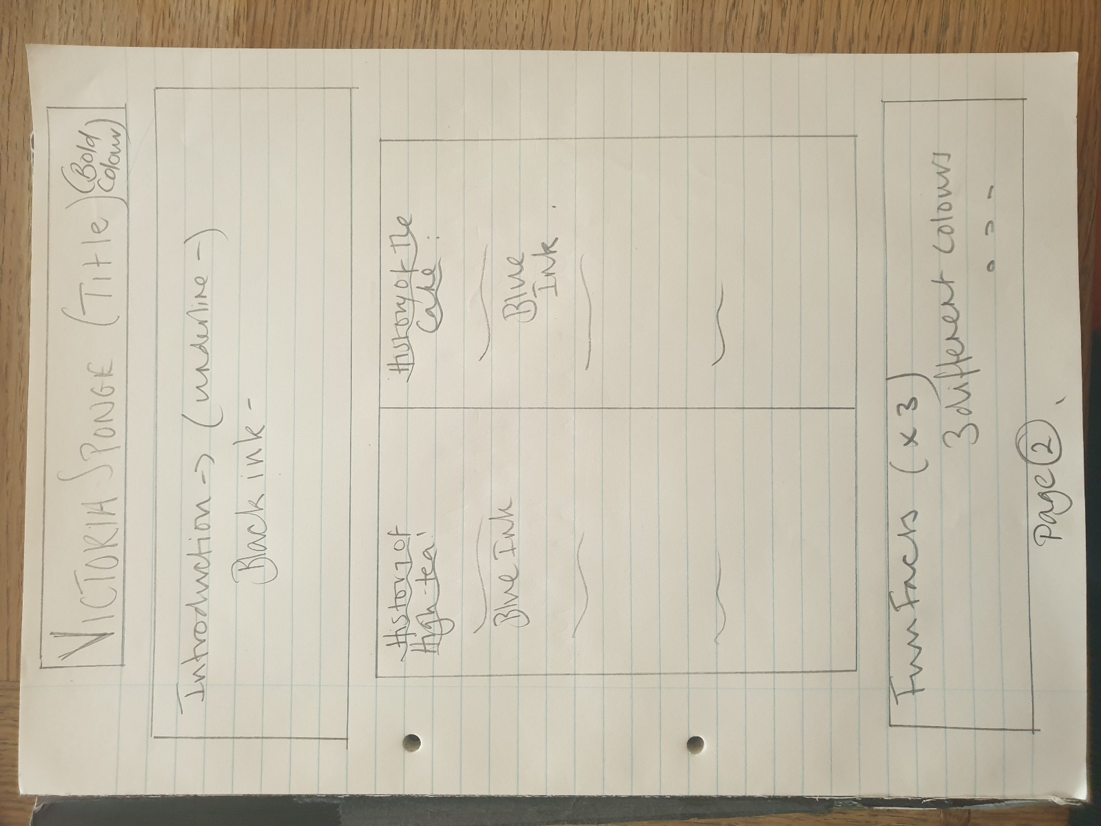

Task Summary:
- Finish your research – make sure you have enough.
- Look at the examples, below. Steal ideas!
- Map/sketch/plan your layout (even if you plan on using a computer). Use a ruler! Use pencil so you can amend it, if necessary.
- Think about – a cover page, contents page, the order, colours, how you will make it engaging to your audience. BE CREATIVE!
- Upload it to Google Classroom so Mr French and I can check it before you proceed…

