Describing the Reef
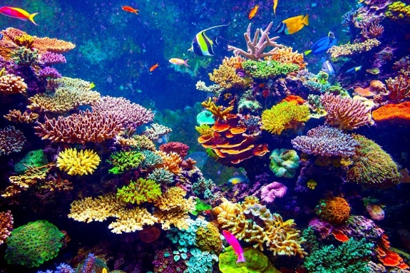
Watch the clip and describe what you can see. Think about colour, shape, movement of the coral and the fish. Try and use some of the new language that you have learnt reading this story. If you want to add extra information about the changes happening to the coral you can. For example:
The bright colours of the coral reef are dazzling. Sparkling oranges mix with sunny yellows as fish of all shapes and sizes dart in and out of crevices.
