Tuesday 14.07.2020 YEAR 4 ENGLISH

Hi Year 4! Let’s read more of our story.
Please WATCH the video: https://youtu.be/hO3FPvTADV8
Here are the pages for you to read:

TASK 1: SIMILES
There are so many similes in this chapter of the story.

Can you remember what a ‘simile’ is? Think of the word ‘similar’.

If something is similar to something, it is LIKE it, but not the same.
These are both similes:

- The moon is like a white chocolate button.
- The moon is as white as a milky chocolate button.

TASK 1: READ the pages and find all the similes you can.
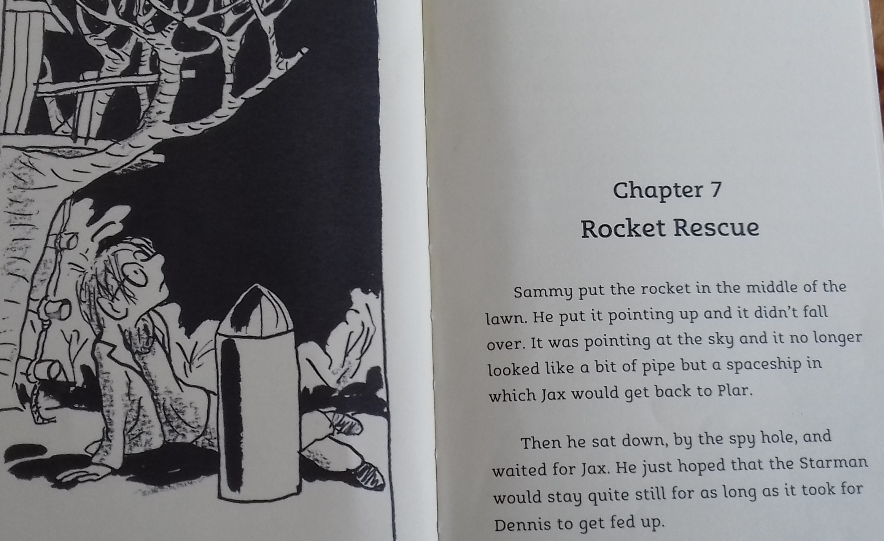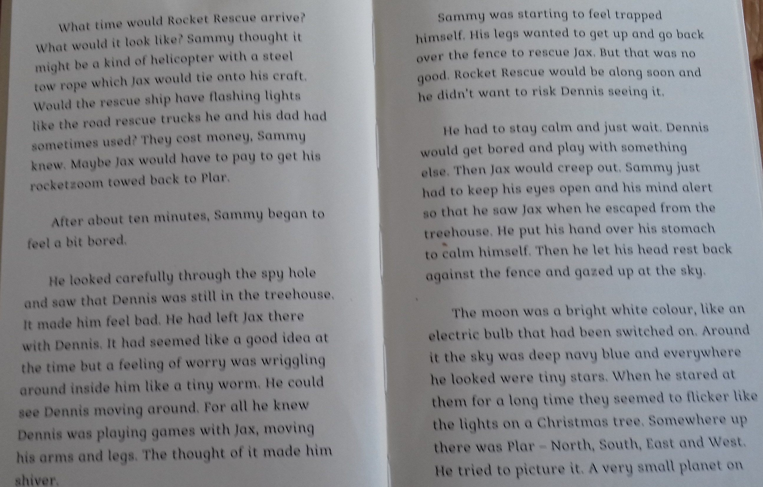

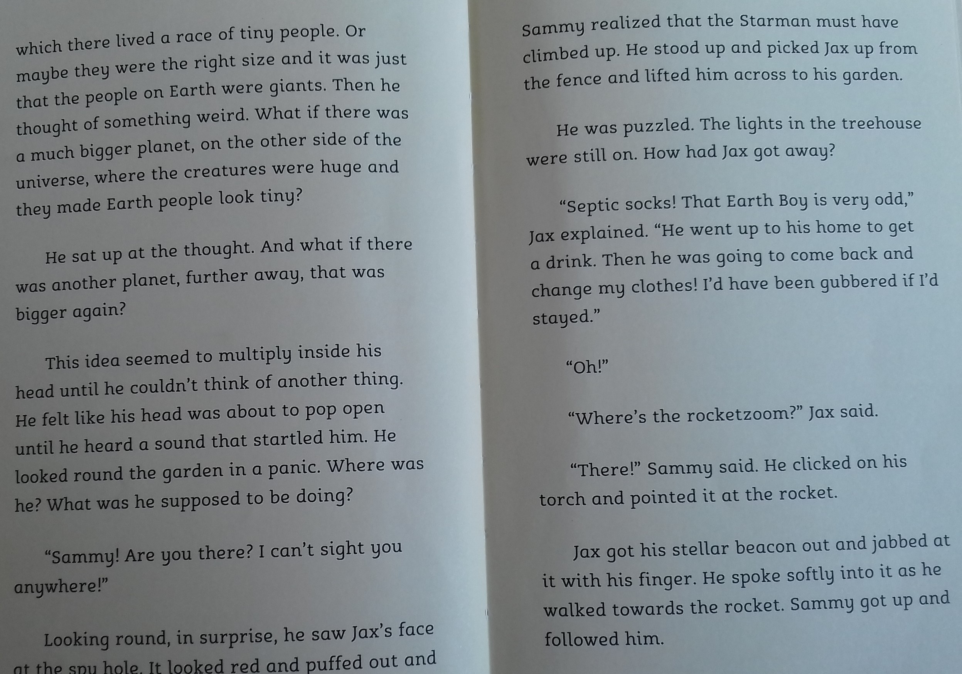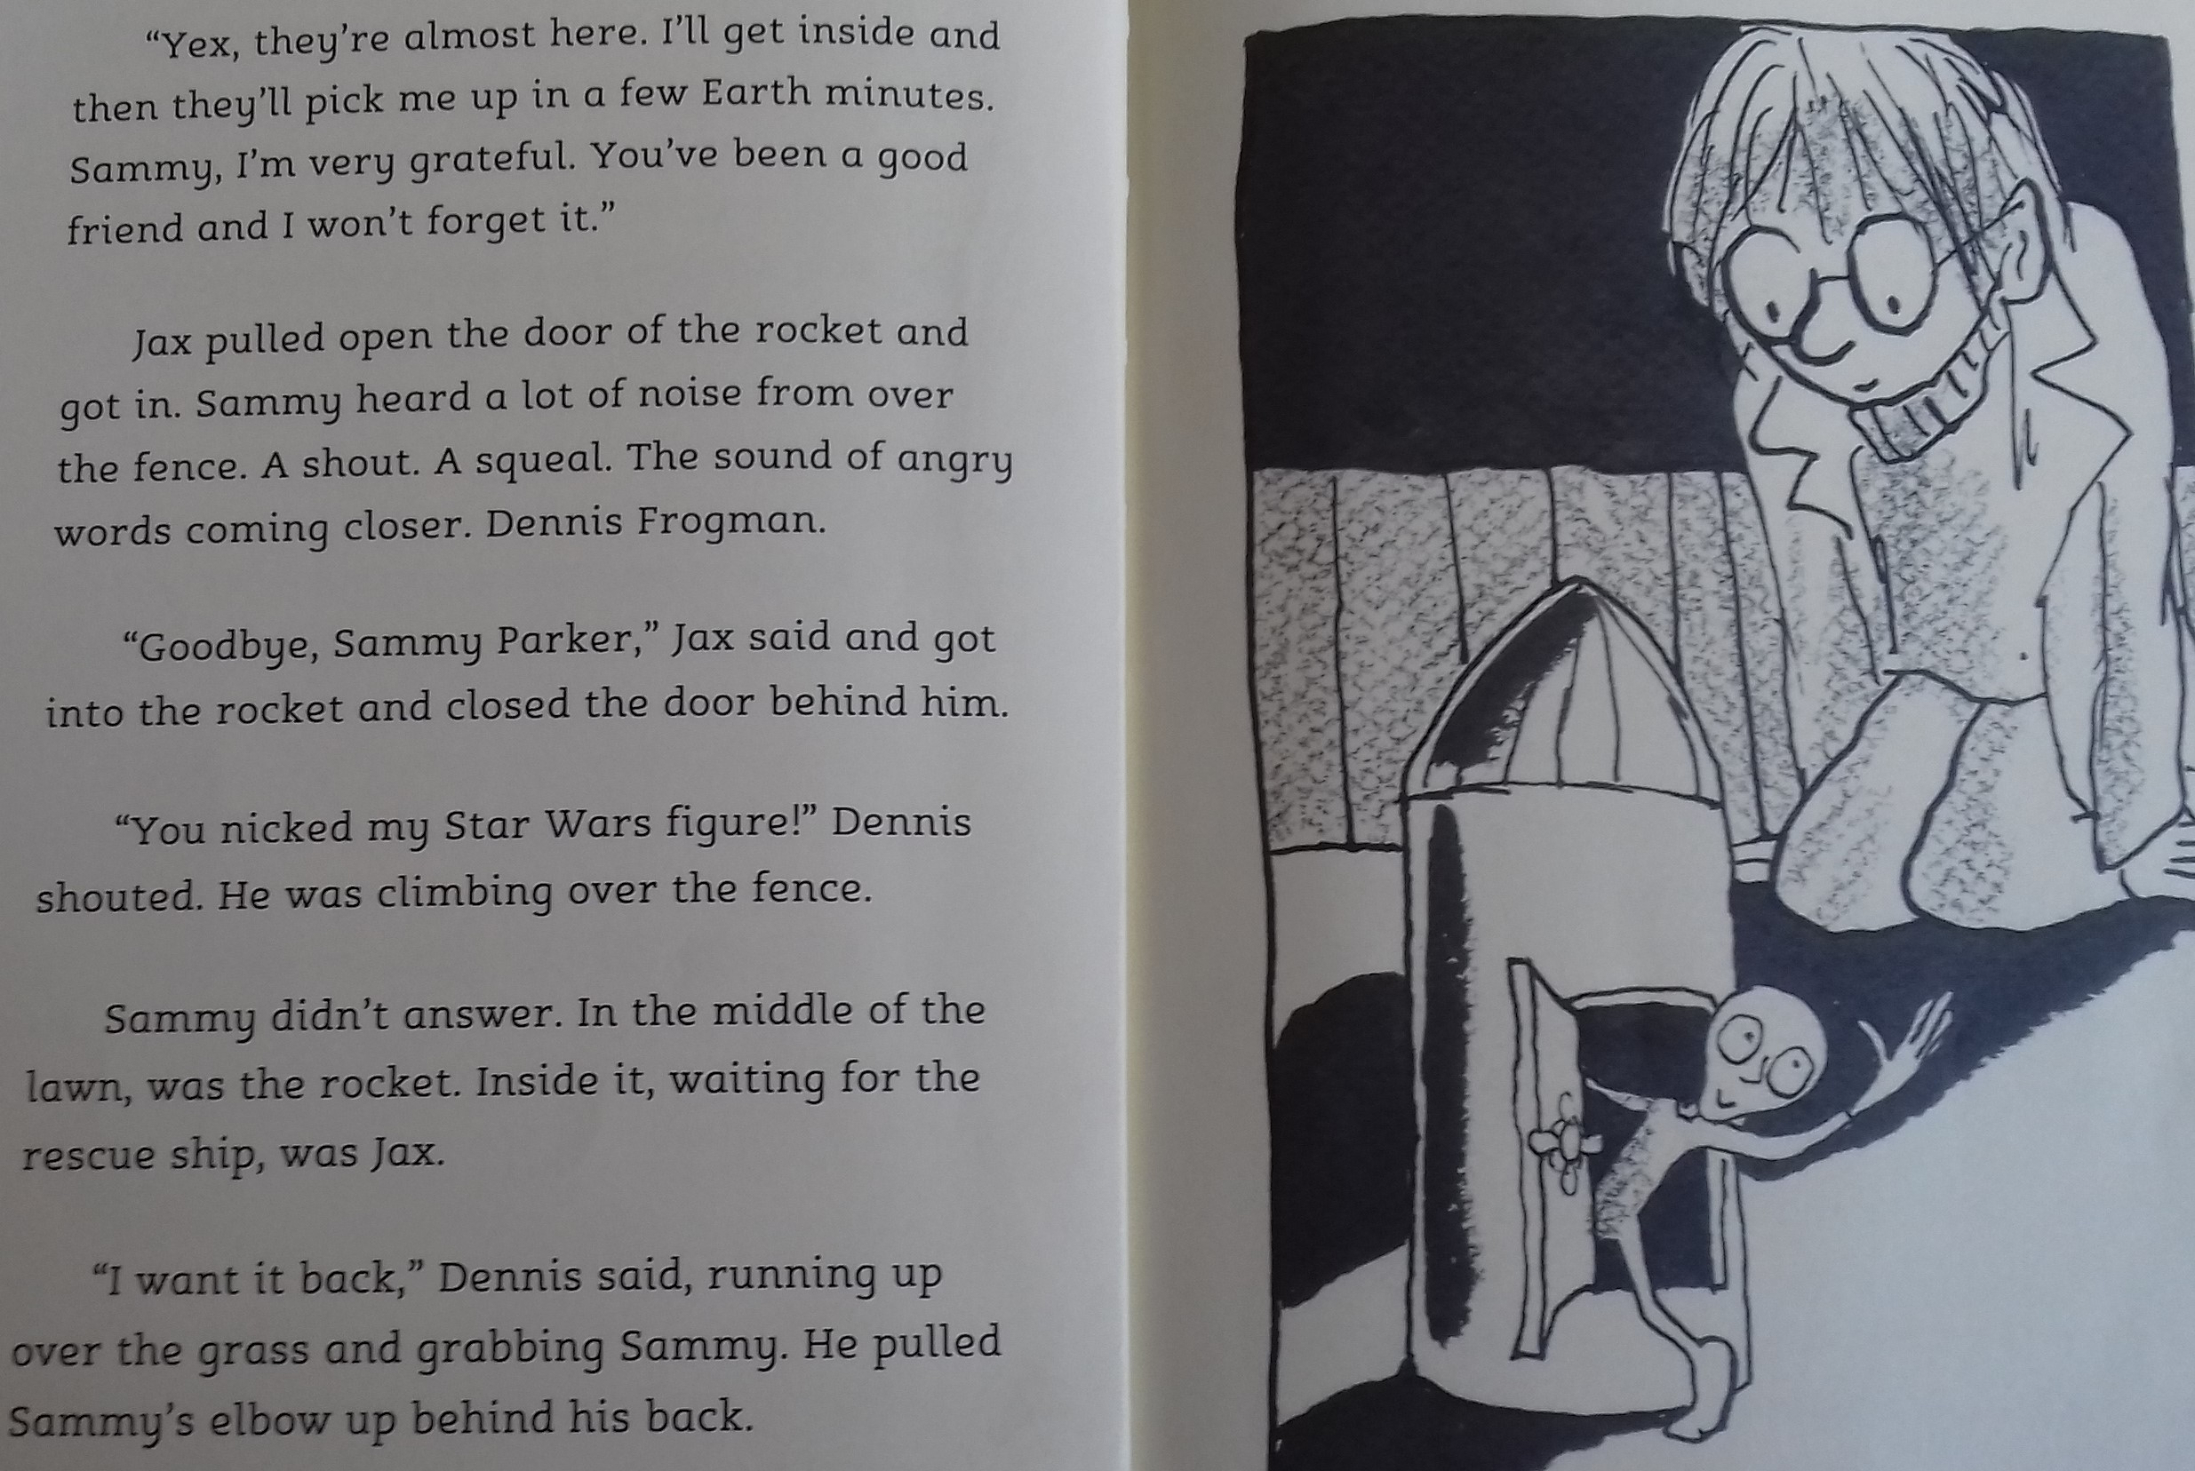
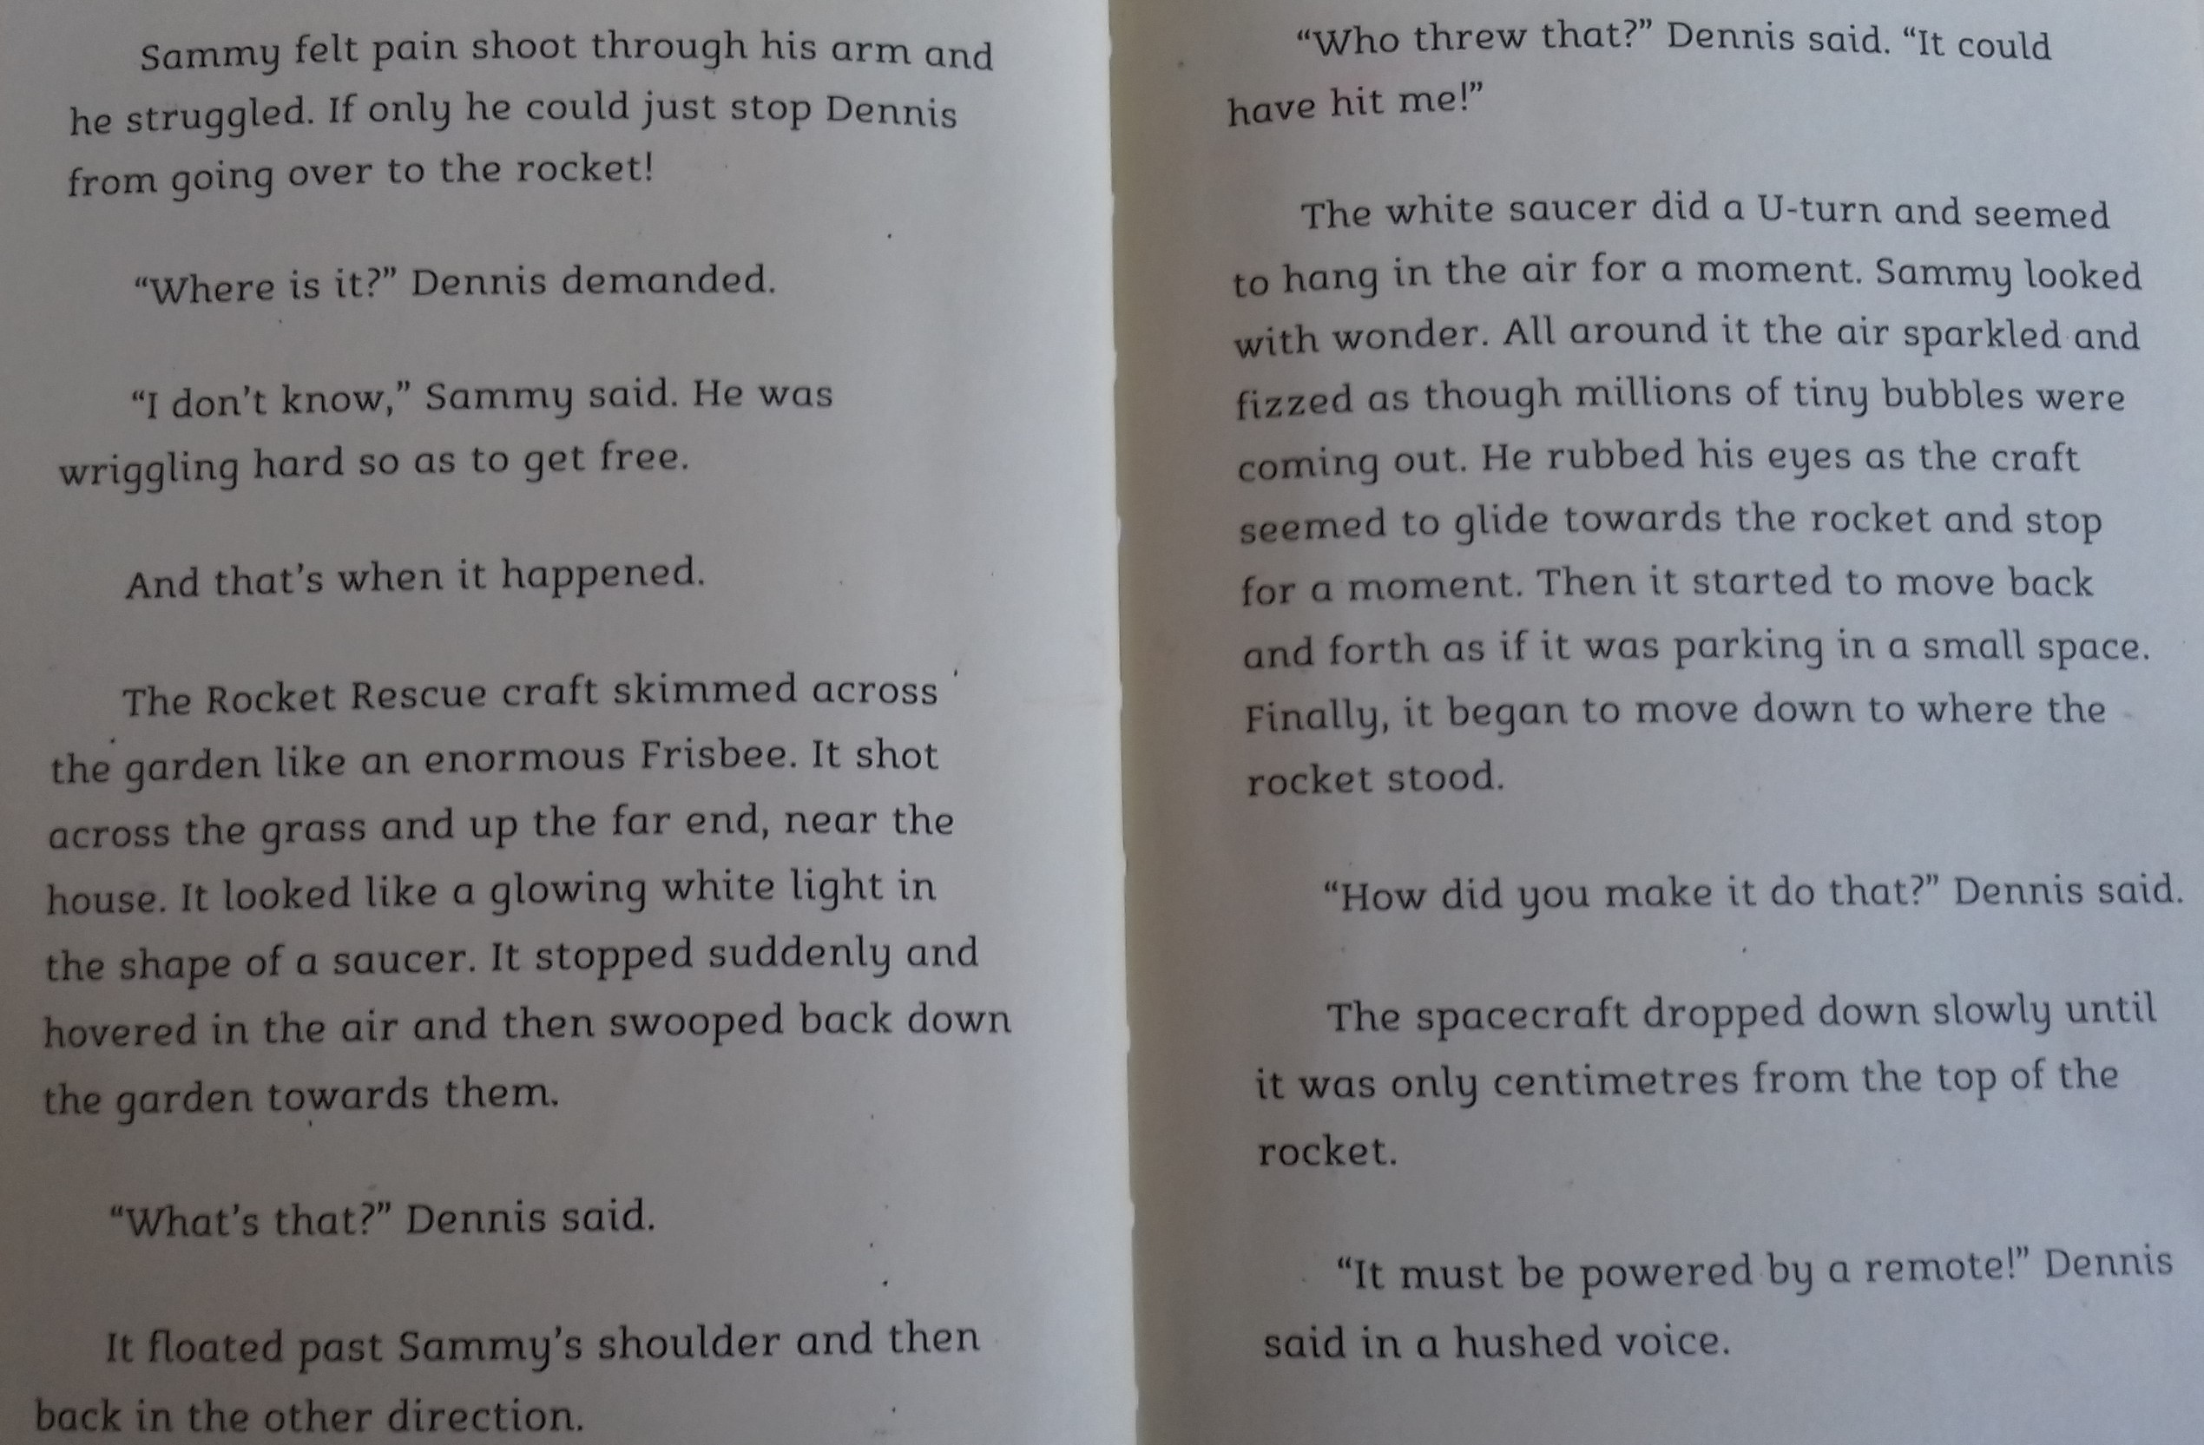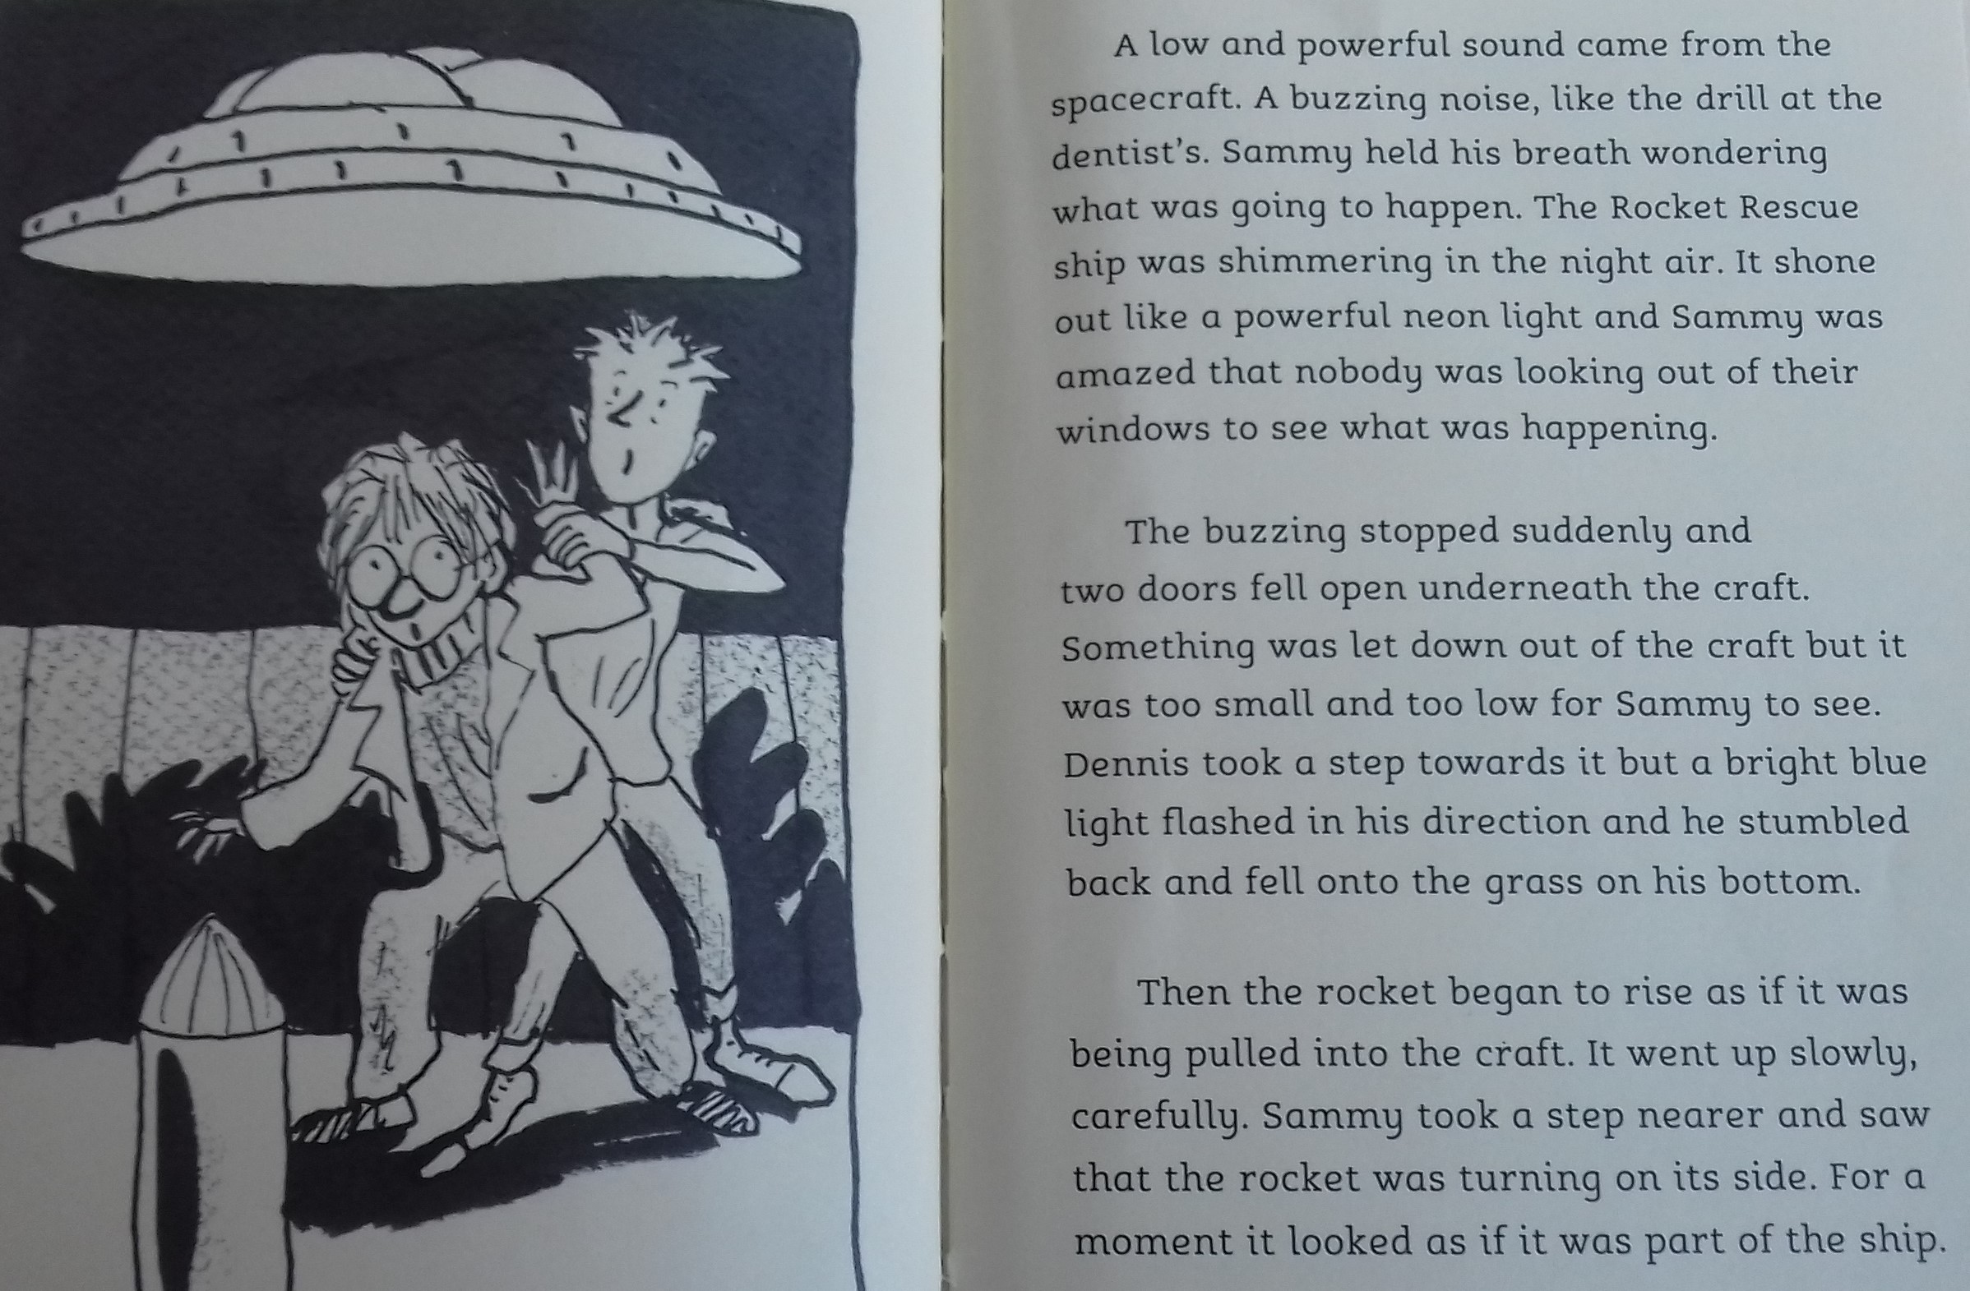
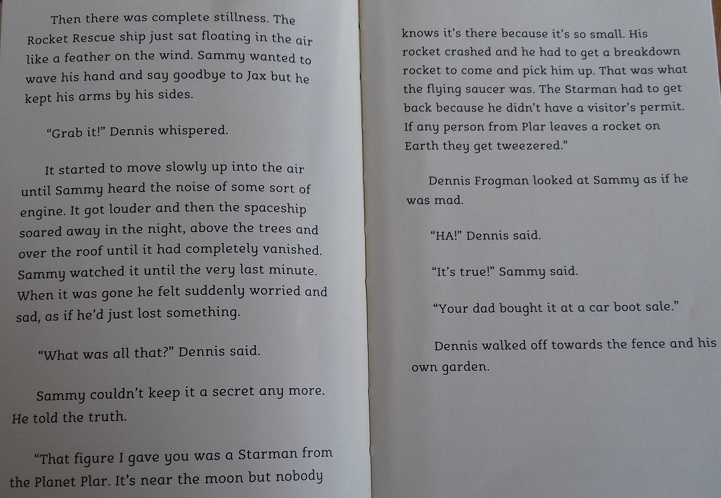 These are some of the similes I found in this chapter:

The moon was a bright white colour, LIKE an electric light bulb that had been switched on.
The Rocket Rescue craft skimmed across the garden LIKE an enormous Frisbee.
A buzzing noise, LIKE the drill at the dentist’s.
The Rocket Rescue ship just sat floating in the air LIKE a feather on the wind.

TASK 1: WRITE your own similes. You can link them to the story. Here are some of mine:
Jax ran across the grass LIKE a little white ghost.

Dennis was full of anger, LIKE a saucepan boiling over on the hob.

The Rocket Rescue ship flew across the garden LIKE a stone skimming over a pond.

The garden was AS dark AS a deep, deep cave.

The Rocket Rescue ship was lit up LIKE a fairground ride.

YOU CAN CHOOSE to either:
- use my sentence starters (highlighted in yellow) and add your own similes.
- create your own sentences about the story, including similes.
- write your own short story using similes.

TASK 2: DRAW a picture of the scene in this chapter, including all the characters and the Rocket Rescue ship.

Good luck! Ms Owen

