Tuesday 14.07.2020 YEAR 4 ART
Hello everyone,
Today we’ll find out about the artist known as ‘Banksy’.

Please EXPLORE this presentation using the link below.
READ the text. THINK about what it says. CLICK and WATCH each video.

(Please IGNORE the first two slides)
file:///C:/Users/User/Documents/2020%20covid19%20homework/Y4%20ART/181018-Banksy-KS2.pdf

NOTES about Banksy:
- Banksy is a ‘street artist’ or ‘graffiti artist’ because he paints on other people’s buildings.
- ‘Banksy’ is not his real name. He keeps his name a secret.
- He paints his pictures secretly. They appear on a wall or building overnight.
- Many of his pictures have a message, about war or politics or important events.
- Many people find his pictures interesting or clever. He has become very famous.
- Some people think he is bad because he should not paint on other people’s buildings.
- Some people think he is a ‘vandal’ because he spoils

LOOK carefully at these Banksy paintings:
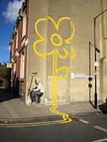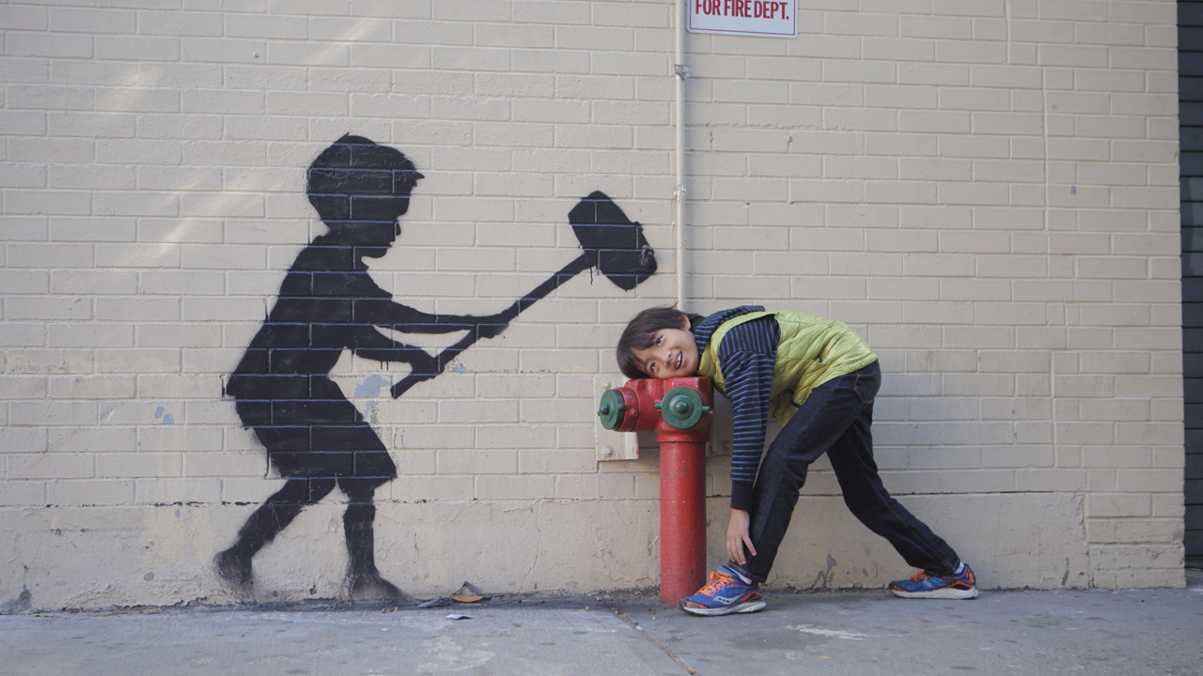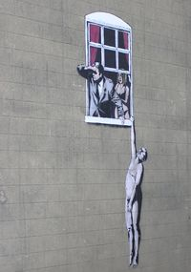
This one continues This painting became very popular with This picture is such a
the real double yellow children like the one in this photo. good joke. The window
lines up the wall. is fake but looks real.

We can’t start painting on walls in the street – it’s against the law!
So let’s create some graffiti art on paper.

TASK: Create graffiti art using your name.
Please WATCH this video and have a go at creating your name in graffiti style!
https://www.youtube.com/watch?v=IXm8LqHP5zw
I hope you enjoy this activity! Ms Owen

Here are some pictures of graffiti names to inspire you:
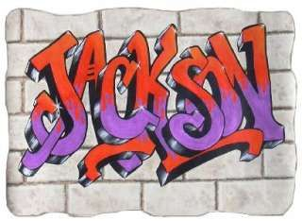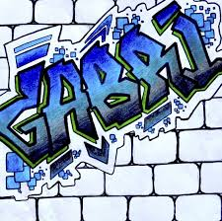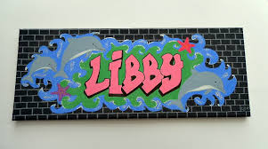

And a final Banksy painting just for fun . . .

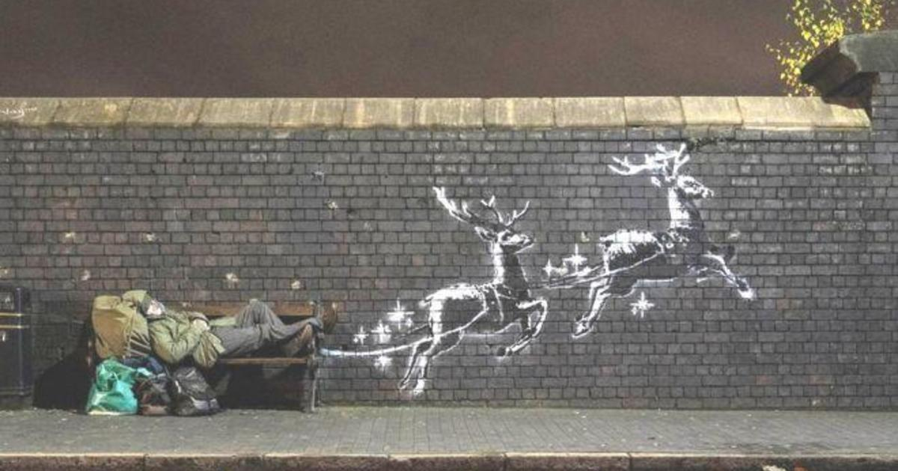

What do YOU think about Banksy??

