Monday 13.07.2020 YEAR 4 ART
Hi Year 4,
Today I want to focus on an interesting artist who uses collage, as well as painting, in his pictures - Chris Ofili.
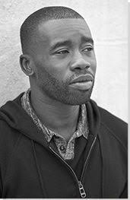 Please WATCH this presentation: https://prezi.com/mglxr302sonj/creating-a-chris-ofili-style-self-portrait/
- CLICK on the right hand triangle to start the presentation.
- On the third slide is a video of Tinie Tempah, the musician, talking about Chris Ofili’s artwork. PLAY the video.

Please CLICK on this link to read more about Chris Ofili:
https://www.tate.org.uk/kids/explore/who-is/who-chris-ofili#:~:text=Chris%20Ofili%20was%20born%20in,win%20the%20prestigious%20Turner%20Prize.

This is ‘No woman, no cry’, one of Chris Ofili’s most famous paintings:

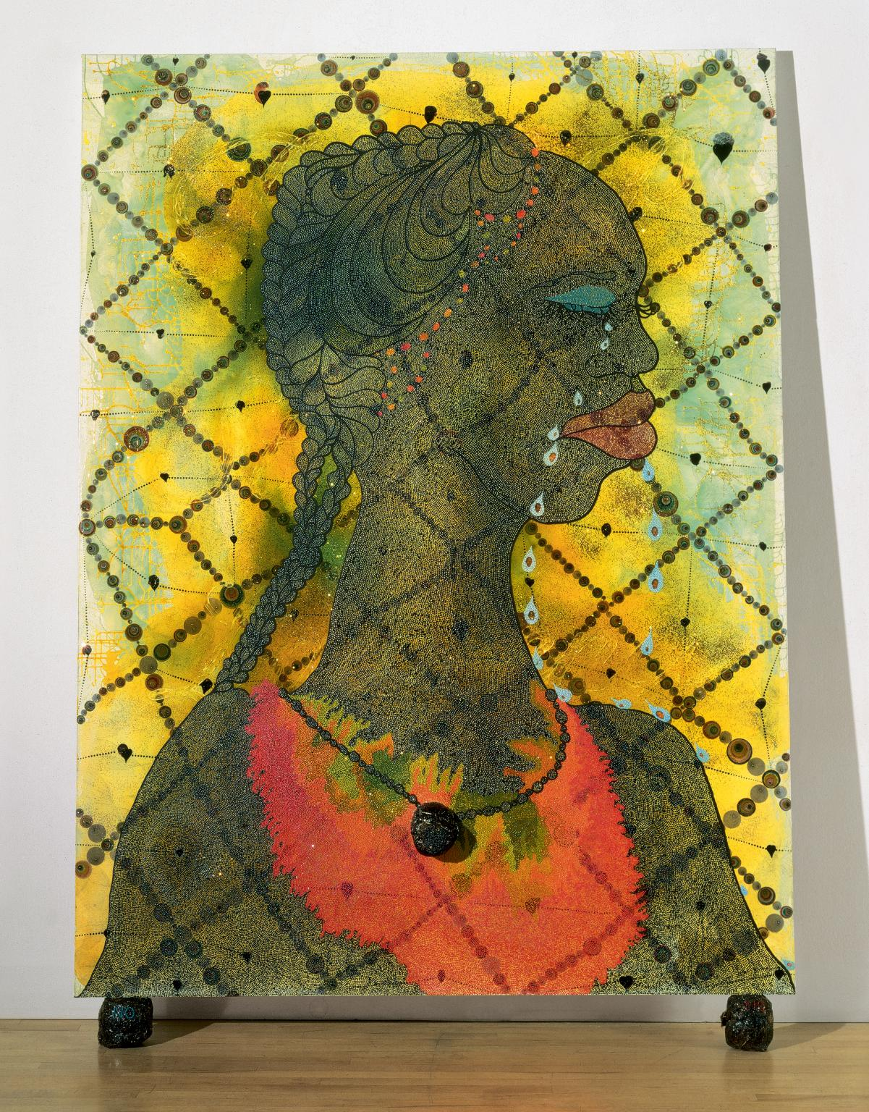
This is an enormous painting taller than a person.

What materials do you think the artist used?

The woman’s tears each contain a photo of her son, who died.

The paint is in thick layers.

The rows of dots going across the picture are made of thick drops of paint, but they could also be beads, lentils or any small round objects.

Under the paint, the artist wrote important messages that he wanted people to look for.

The dark balls that the picture stands on are dried elephant dung (poo)! The woman’s necklace is also made of elephant’s dung.

Here are some pictures by children in your age. Do you think they are effective?

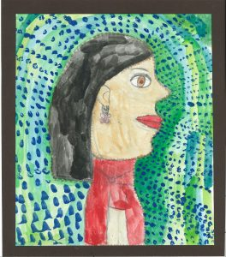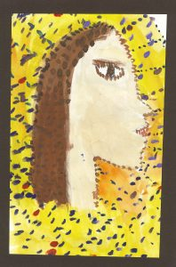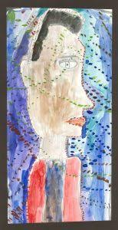

TASK: Create a picture in the style of Chris Ofili’s picture.

NOTES:
- You could create a picture of a man or a woman.
- You could create a self-portrait
- You could base it on someone you know, or a famous person.

BUT use the same style:
- Draw a person from the side. It’s called ‘In Profile’.
- Think about the skin colour you want to create.
- Create a colourful background
- These children have used paint. But you could add other materials, especially for the dots, and make it into a collage.

I hope you enjoy this task. Ms Owen

