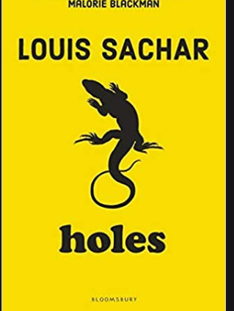

Y5 Guided Reading
Holes by Louis Sachar
Tuesday 7th July 2020

Key Questions (start)
- What do you think the after–effects of the poison will be on Mr Sir?
- Do you still think that Stanley did the right thing, taking the blame? Do you feel sympathy for Mr Sir?
Text:
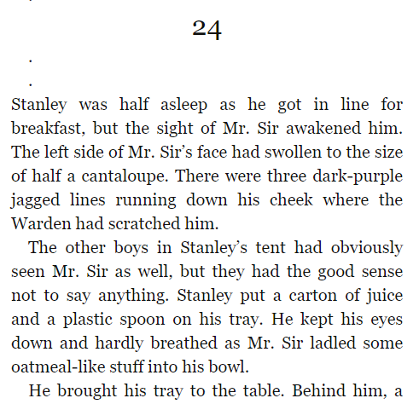
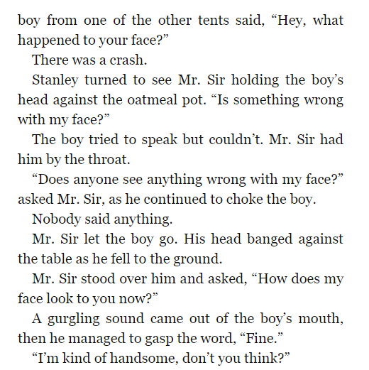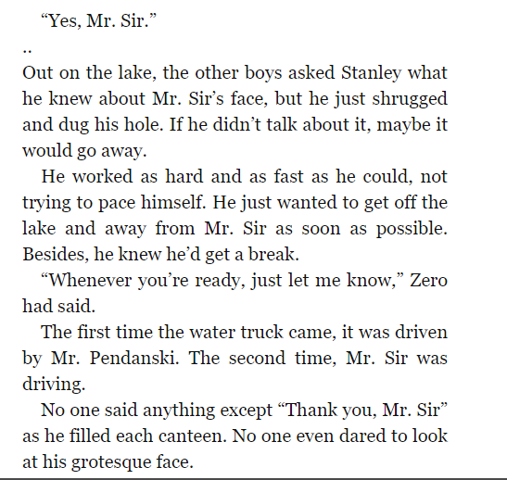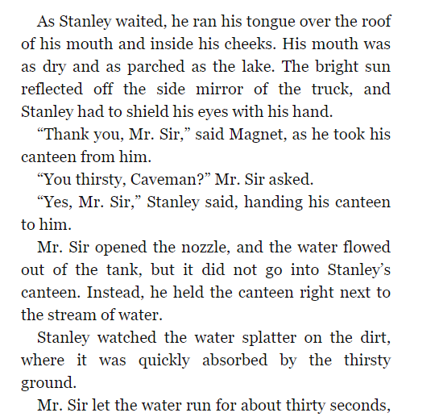
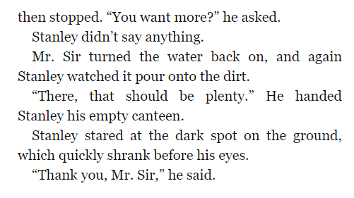

Video:
https://youtu.be/OLLgZtyjaB8

Key Questions – (end):
- Why do you think Mr Sir had such an extreme reaction to the boy in the canteen? Do you think anyone else will mention his face to him?
- Were you surprised how Mr Sir punished Stanley? Do you think it was effective revenge?
- Do you think that that is it? Will Mr Sir continue to punish Stanley?

**Well done! Time for a cool drink of water…**

