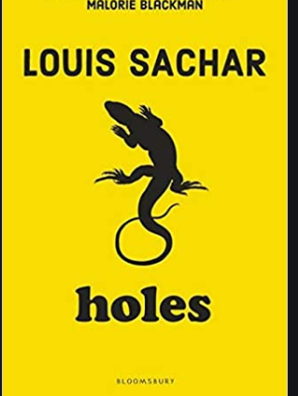

Y5 Guided Reading
Holes by Louis Sachar
Monday 6th July 2020

**Health Warning: today’s video contains Ms Sampson attempting a Texan accent – apologies in advance…**
Key Questions (start)
- What do you think Green Lake may have been like before the lake dried up?
- What do you remember about Kissin’ Kate Barlow?
- What do you think may have turned her (or anyone) in to an ‘outlaw’?

Text:
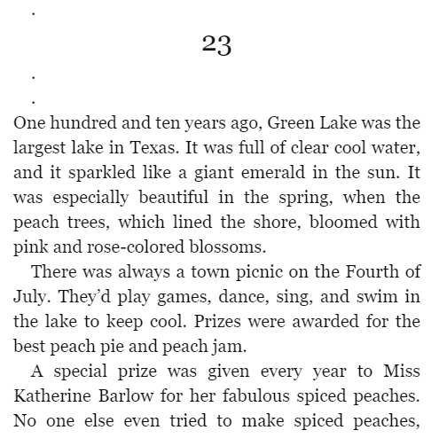
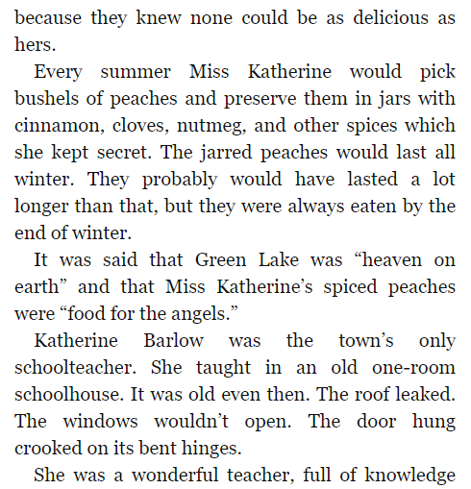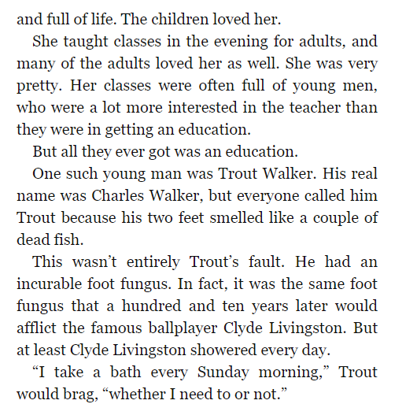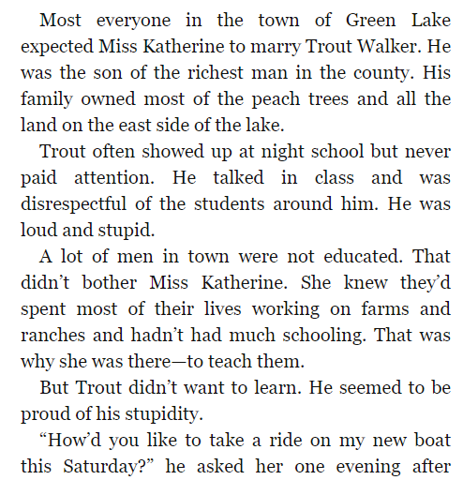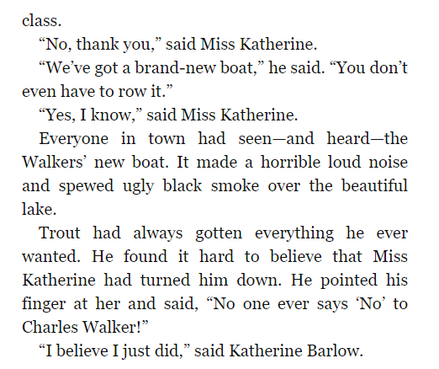

Video:

https://youtu.be/fw4yl_wKvm8

Key Questions – (end):
- Which words in the following text are the opposite of words you would use to describe Green Lake now? Select at least 3 and come up with antonyms for them:
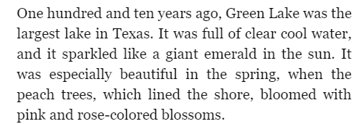

- Give at least 2 reasons why you think that Katherine does not want to ride on Trout Walker’s boat?
- Come up with 3 adjectives to describe Katherine. Give evidence from the text to support your choices.

**That’s it for Monday. Don’t know about you, but I’m going to spend the rest of the day preserving peaches!**

